

**COMMUNICATION AND WORKS DEPARTMENT**

**KHYBER PAKHTUNKHWA**

**Khyber Pakhtunkhwa Integrated Tourism Development (KITE) Project**

**ENVIRONMENTAL AND SOCIAL MANAGEMENT PLAN (ESMP)**

**ADDENDUM**

**REHABILITATION & REMOLDING OF MANKIAL ~ BEDA SARAI ROAD (LENGTH: 17.30 KM) DISTRICT SWAT ADP NO. 1867/170539 (2023-24)**

**LOT – I: MANKIAL ~ BADA ~ SARAI ROAD (KM 0+000 TO KM 09+300)**

**LOT – II: BADA ~ JABAI ROAD (KM 0+000 TO KM 08+000)**

**November, 2024**



**Khyber Pakhtunkhwa Integrated Tourism Development (KITE) Project**

**ADDENDUM TO THE ENVIRONMENTAL AND SOCIAL MANAGEMENT PLAN (ESMP)**

TABLE OF CONTENTS

**Page No.**

TABLE OF CONTENTS i

LIST OF TABLES iii

LIST OF FIGURES iv

LIST OF ABBREVIATONS v

**EXECUTIVE SUMMARY……………………………………………………………………………VI**

1 INTRODUCTION 1-1

1.1 Background 1-1

1.2 Project Location 1-2

1.3 Objectives of The Addendum esmp 1-2

1.4 LEGAL AND ADMINISTRATIVE FRAMEWORK 1-2

2 PROJECT DESCRIPTION 2-1

2.1 Description of the Revised Alignment 2-1

2.2 Salient Features of the Revised AligNment 2-2

2.2.1 Lot Wise Scope of Works 2-3

2.2.2 Methodology for the Construction of Bridge on the Swat River 2-4

3 Description of Environment 3-1

3.1 Physical Environment 3-1

3.2 Ecological Environment 3-1

3.3 Socio-economic Environment 3-2

4 Project Alternatives 4-1

4.1 Alignment Alternative (Realignment) 4-1

5 Public Consultation and Information Disclosure 5-1

6 Potential Environmental and Social Impacts and their Mitigations 6-1

6.1 Impacts due to the realigned portion of the proposed road and mitigation measures 6-2

6.1.1 Land Acquisition, Resettlement and Compensation 6-2

6.1.2 Impacts due to the proposed Bridge on Swat River 6-2

7 Environmental and Social MITIGATION AND MONITORING Plan 7-1

7.1 Cost for Implementation of ESMP 7-1

7.1.1 Cost for Training and Capacity Building/Strengthening 7-1

7.1.2 Cost for Personal Protective Equipment (PPE) 7-2

LIST OF TABLES

Table 3.1: Land use of the Realigned Portion under Lot-I 3-1

Table 4.1: Comparison of Land use of Previous and Realigned Portions for Lot-I 4-1

Table ‎4.2: Comparison of Land use of Previous and Realigned Portions for Lot-II 4-2

Table ‎6.1: Concerns of fresh Relevant Departments/Institutional Stakeholders 5-1

Table 6.1: Anticipated Adverse E&S Impacts due to the proposed Bridge on Swat River 6-3

Table 7.1: Additional Institutional Training for Implementation 7-1

Table 7.2: Break-up for Personal Protective Equipment Cost 7-2

Table 7.3: Total ESMP Cost and Additional Cost (Lot-I) 7-2

Table 7.4: Total ESMP Cost and Additional Cost (Lot-II) 7-3

LIST OF FIGURES

Figure 1‑1: Map showing the location of realigned portion of proposed road Lot-I 1-3

Figure 1‑2: Map showing the overall revised alignment of the proposed road both Lot-I and Lot-II 1-4

Figure 1‑2: Cross Section of the Proposed Bridge at RD 00+000 2-2

Figure 4‑1: Map showing the Comparison of Land use of Previous and Realigned Portions 4-3

LIST OF ABBREVIATONS

AMSL Above Mean Sea Level

C&W Communication & Work Department

CBO Community Based Organization

EHS Environmental, Health & Safety

ESMP Environmental & Social Management Plan

ESSU Environmental and Social Safeguard Unit

EPA Environment Protection Agency

GBV Gender Based Violence

GoP Government of Pakistan

GOKP Government of Khyber Pakhtunkhwa

IDA International Development Association

ITZ Integrated Tourism Zone

JHA Job Hazard Analysis

JPCP Jointed Plain Concrete Pavements

KITE Khyber Pakhtunkhwa Integrated Tourism Enterprise Project

KP Khyber Pakhtunkhwa

LAA Land Acquisition Act

M&E Monitoring and Evaluation

N-95 National Highway 95

NESPAK National Engineering Services Pakistan (Pvt.) Ltd.

NGO Non-governmental Organization

OHS Occupational Health and Safety

OPs Operation Policies

PAPs Project Affected Persons

PCC Plain Cement Concrete

PDMA Provincial Disaster Management Authority

PMU Project Management Unit

PPEs Personal Protective Equipment

RAP Resettlement Action Plan

RCC Reinforced Cement Concrete

ROW Right of Way

SC Supervision Consultant

SEA Sexual Exploitation and Abuse

SH Sexual Harassment

TBT Tool Box Talk

WB World Bank

**EXECUTIVE SUMMARY**

Communication & Works (C&W) Department, Government of Khyber Pakhtunkhwa (GoKP) intends to rehabilitate and remodel Mankial Road under KITE comprising of two (02) lots:

* Lot-I: Mankial-Bada-Serai Road; and
* Lot-II: Badai-Jabba Road.

Environment and Social Management Plans (ESMPs) have been prepared by the Communication & Works (C&W) Department, Government of Khyber Pakhtunkhwa (GoKP) for Lot-I and Lot-II separately. The Lot-I comprises of a 9km long stretch (details provided in the main ESMP document). In the Lot-1 from 00+000 RD to 00+420 RD has been realigned due to flooding aspect. In addition, a new bridge has been proposed on the Swat River in Lot-I. The realigned portion of the proposed road Lot-I starts from 00+000 RD at N-95 and ends at RD 00+420 of the previous alignment. However, the portion from 00+000 RD to 00+420 RD has been reduced to 230m. Therefore, the total length of the realigned portion is 230m. The length of the proposed bridge is 88m.

Similarly, the length of the road in Lot-II has been reduced from 12.70 Km to 8.0 Km (Km 00+000 To Km 08+000) by deleting portion of the road from Km 08+000 onwards as per requirement of the Provincial Government and decided in 8th Project Steering Committee meeting to restrict the length of road up to Integrated Tourism Zone (ITZ) only. The total length of the project has now been reduced from 23.0 Km to 17.30 Km.

This addendum covers the impacts of the realigned portion of proposed road.

The main objective of this Addendum ESMP study is the identification of the possible and induced impacts of the revised alignment of the proposed road on both short and long-term basis. Based on the level and nature of these observations the Addendum ESMP then delineates proper mitigation measures. An E&S screening checklist has been prepared for the Lot-I and Lot-II and attached as **Annex-01** in this addendum.

No route alternative to the project was considered as proposed Project involves remodeling of existing Mankial Road. However, a comparison was made by taking Alternative 1 as No Project Option and Alternative II as rehabilitation and remodeling of Mankial Road. Considering the environmental and socio-economic benefits of the proposed Project including lesser wear and tear of vehicles, lesser air emissions, reduced probability of accidents, improved access to local markets, educational and health facilities, increased tourism and business opportunities, Alternative-II was selected. The realignment of the proposed Project is discussed in this ESMP Addendum.

Keeping in view the realignment, it can be concluded that the realignment of the proposed road from N-95 to RD 00+420 has reduced the cost implications, less number of buildings to be affected and improved the operational safety scenario of the road due to avoidance of the curve. Therefore, the realignment of Lot-I is more economically, environmentally and socially feasible. The mitigation measures for the land acquisition involved are provided in the main ESMPs of both Lots as well as in the Chapter 6 of this document.

During the survey of realignment, stakeholder consultations were also carried out with the PAPs at five locations for the realigned portion of the proposed road to record their views and concerns in February and March 2024. The PAPs were of the view that the fair compensation as per the prevailing market rates must be determined for their land as the land falls in commercial category. Moreover, they demanded that the compensation should be given on time and before the commencement of the civil works. It was briefed to the PAPs that the price of their land will be determined by the district price assessment committee by considering the market value. Besides, the compensation to all affected persons will be given before commencement of the civil work.

The details of the impact assessment and mitigation measures have been provided in the main ESMPs of both Lots document and same applies to the realigned portion of the proposed road. However, following are the impacts related to the realignment which are discussed in detail in this addendum:

* Land Acquisition, Resettlement and Compensation
* Impacts due to the proposed Bridge on Swat River

This addendum also covers the additional cost estimates for institutional training, personal protective equipment (PPE) and overall ESMP cost due to change in the labor number during the construction phase of the proposed subproject.

The total cost required to effectively implement the mitigation measures was previously Rs. 39.16 Million and Rs. 48.06 Million for Lot-I and Lot-II respectively (provided in Main ESMP). The additional costs are 12.44 Million and Rs. 6.90 Million for Lot-I and Lot-II respectively and consolidated costs are 51.60 Million and Rs. 54.97 Million for Lot-I and Lot-II respectively. The details of the revised costs are provided in this addendum.

# INTRODUCTION

## Background

The GoKP has received a loan from International Development Association (administered by the World Bank) towards the KITE project. The KITE project aims to enhance under-utilized potential of KP’s tourism sector for generating income and revenues, by providing an enhanced tourism experience to domestic and international tourists, while focusing on preservation of environment, wildlife, culture and heritage.

The GoKP intends to utilize part of the IDA funding for KITE Project to explore sites which have access from main road and can be termed as Integrated Tourism Zone (ITZs). In this connection, four roads including Supat Valley Road in District Mansehra, Thandiani Road in District Abbottabad, Mankial Road in District Swat and Shishikoh Madaklast Road in district Chitral has been selected for improvement and up-gradation.

Communication & Works (C&W) Department, GoKP intends to rehabilitate and remodel Mankial Road[1] under KITE comprising of two (02) lots:

* Lot-I: Mankial-Bada-Serai Road; and
* Lot-II: Badai-Jabba Road.

Environment and Social Management Plans (ESMPs) have been prepared by the  
Communication & Works (C&W) Department, GoKP for Lot-I and Lot-II separately. The Lot-I comprises of a 9km long stretch (details provided in the main ESMP document). In the Lot-1 from 00+000 RD to 00+420 RD has been realigned due to flooding aspect. In addition, a new bridge has been proposed on the Swat River in Lot-I. The realigned portion of the proposed road Lot-I starts from 00+000 RD at N-95 and ends at RD 00+420 of the previous alignment. However, the portion from 00+000 RD to 00+420 RD has been reduced to 230m. Therefore, the total length of the realigned portion is 230m. The length of the proposed bridge is 88m.

Similarly, the length of the road in Lot-II has been reduced from 12.70 Km to 8.0 Km (Km 00+000 To Km 08+000) by deleting portion of the road from Km 08+000 onwards as per requirement of the Provincial Government and decided in 8th Project Steering Committee meeting to restrict the length of road up to Integrated Tourism Zone (ITZ) only. The total length of the project has now been reduced from 23.0 Km to 17.30 Km.

This addendum also covers the additional cost estimates for institutional training, personal protective equipment (PPE) and overall ESMP cost due to change in the labor number during the construction phase of the proposed subproject.

This addendum covers the impacts of the realigned portion of proposed road. According to the World Bank Operational Policy OP 4.01 ‘Environmental Assessment’ the proposed Project falls under Category ‘B’. These impacts are site-specific and most of them are reversible.

## Project Location

The realigned portion of the proposed road Lot-I has been shown as **Figure 1.1.** While the overall revised alignment of the proposed road is shown in **Figure 1.2.**

## Objectives of The Addendum esmp

The main objective of this Addendum ESMP study is the identification of the possible and induced impacts of the revised alignment of the proposed road on both short and long-term basis. Based on the level and nature of these observations the Addendum ESMP then delineates proper mitigation measures. An E&S screening checklist has been prepared for the Lot-I and Lot-II and attached as **Annex-01** in this addendum. As a planning tool, the Addendum ESMP aims to ensure that environmental, socio-economic and cultural issues throughout the entire project lifecycle are anticipated and considered by the project proponent. It also serves as a framework for establishing project controls to reduce or prevent adverse environmental or socio-economic impacts. A separate Resettlement Action Plan (RAP) has been prepared to deal with the land acquisition, resettlement and rehabilitation issues.

This addendum ESMP should be read along with the main ESMPs of Lot-I and Lot-II.

## LEGAL AND ADMINISTRATIVE FRAMEWORK

The applicable national policies, legislation and guidelines and World Bank Safeguard Policies related to the revised alignment of the proposed road are those which are applicable to the proposed Project and have been provided in the ESMP documents of Lot- I and Lot-II. The relevance of these national and provincial laws, regulations and policies and World Bank Safeguard Policies are also provided in the main ESMP document.

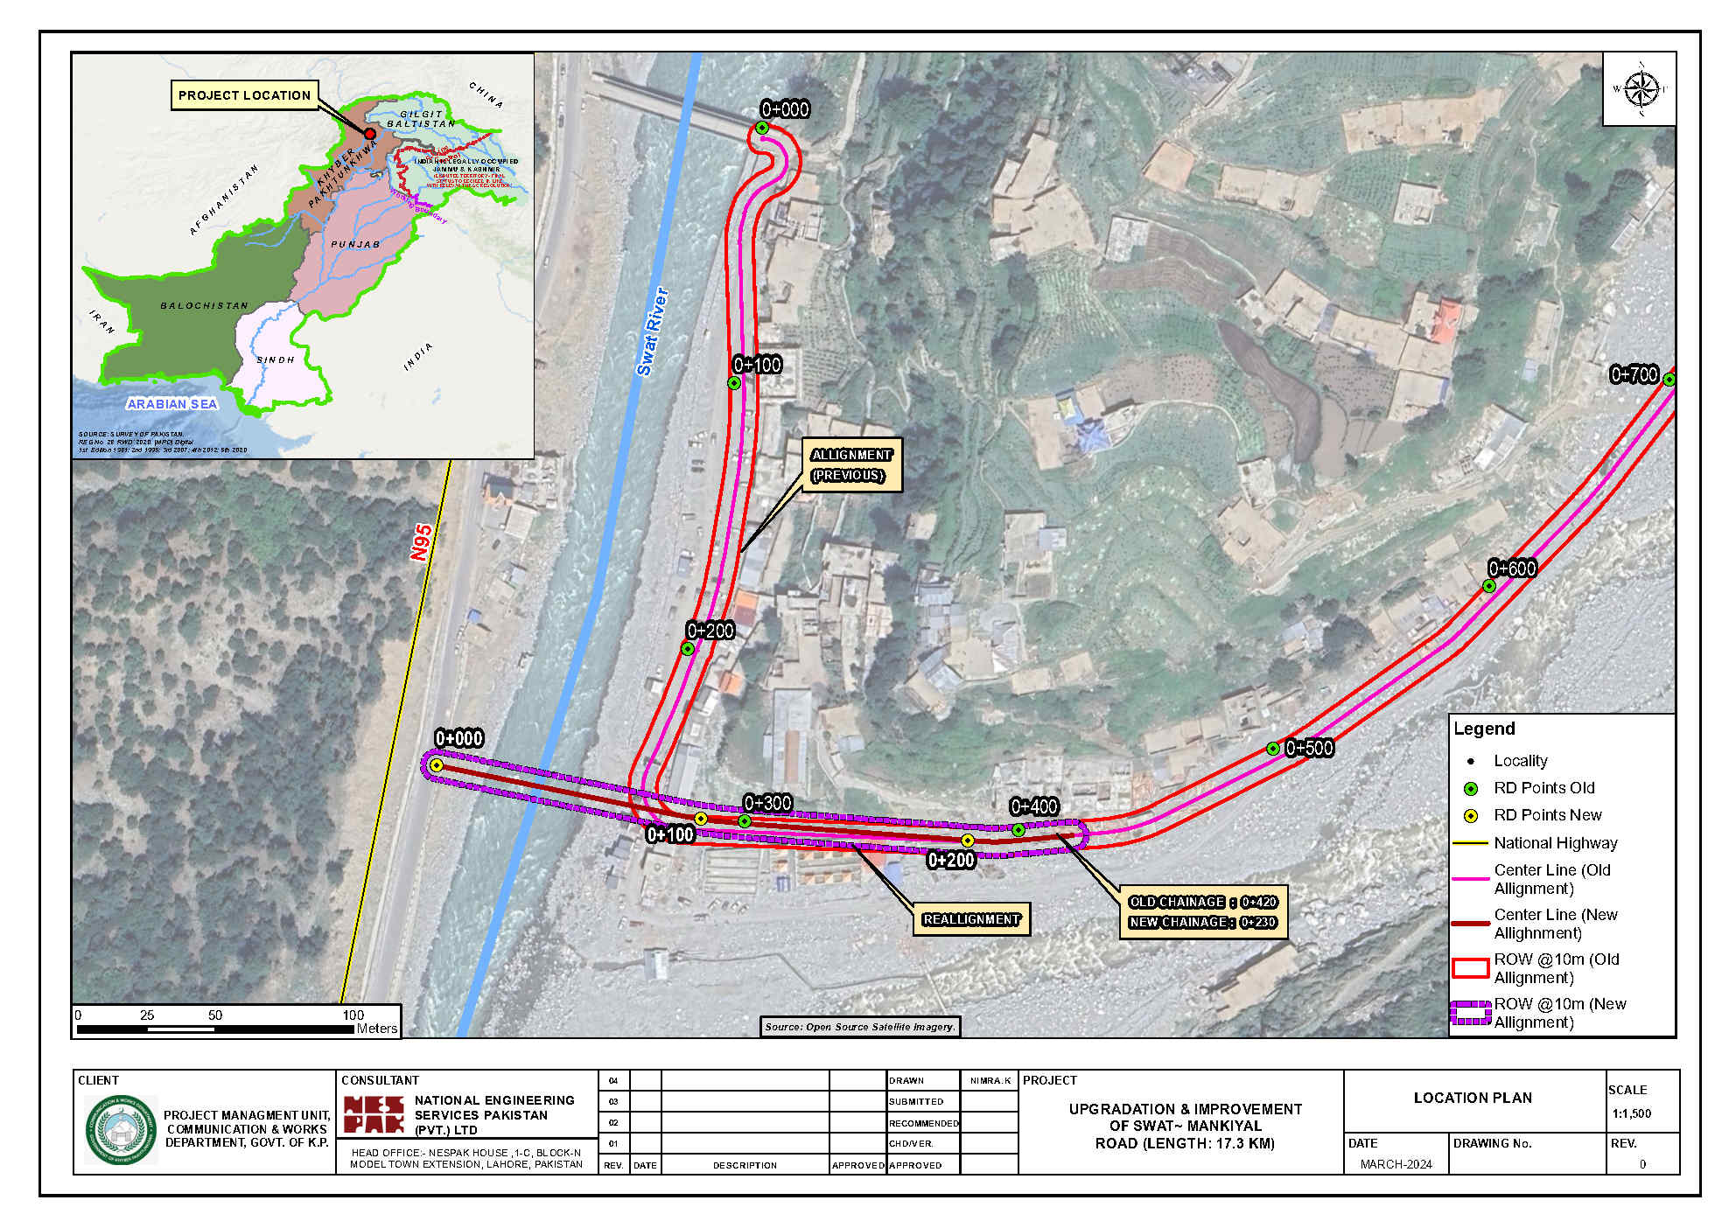**Figure 1‑1: Map showing the location of realigned portion of proposed road Lot-I**

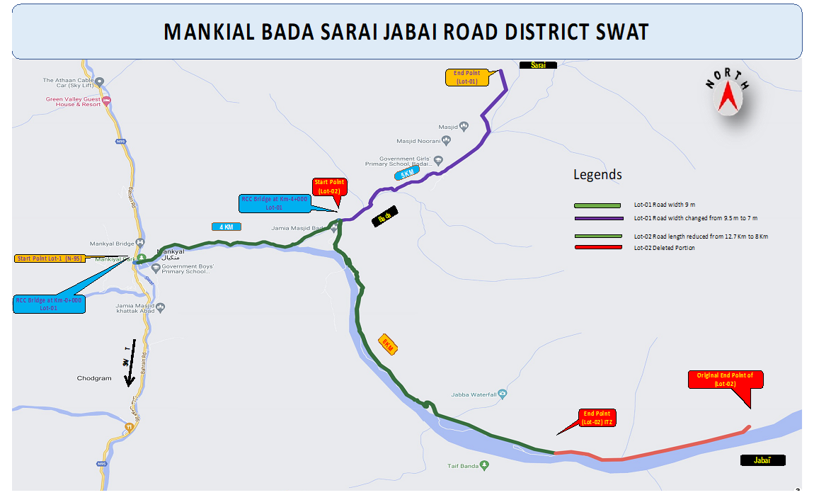**Figure 1‑2: Map showing the overall revised alignment of the proposed road both Lot-I and Lot-II**

# PROJECT DESCRIPTION

Double space between Chapter’s TOC

The project/ Mankial Road[2] is located in District Swat in Khyber Pakhtunkhwa (KP) Province. The proposed Project[3] is basically the rehabilitation and remodeling of Lot-I and Lot-II of Mankial Road. Project facilitates various population centers i.e. Mankial, Bair, Gun Patai, Badai, Serai, Jabba, etc. The whole project alignment passes through hilly / mountainous terrain. The scope of project is to construct two lane standard road as per C&W Department standards. Project also involves replacement of existing local wooden bridges with RCC bridges. Project also involves provision of causeways and slab / pipe culverts keeping in view the hydrological / hydraulic requirement. The salient features of the proposed Project are provided below. Need and purpose of the project, project location and accessibility, salient features of the project, typical cross sections, project implementation schedule, project administrative jurisdiction, construction materials, construction activities and required machinery, construction workforce, waste generation and disposal and construction camps in the main ESMP and same will be applicable to the revised alignment of the proposed road with certain changes provided in the subsequent sections.

## Description of the Revised Alignment

Initially, start point of Lot-I was from Mankial Bazar and ends point was at Sarai with total length of 9.30 km whereas start point of Lot-II was from Bada and end point was at Jabai with total length of 12.70 km. After decision by the Project Steering Committee, now the start point of Lot-I is from Main Bahrain Kalam Road (N-95) and ends point is at Sarai with total length of 9.30 Km whereas start point of Lot-I is from Bada and end point is at ITZ with total length of 8.0 km. Total Length of the project road is reduced from 23.00 km to 17.30 km. Presently there exists a jeepable single track, which needs upgradation.

The zero point of the project was located after crossing River Swat through a Bailey Bridge, owned by the Pak Army. After the torrential rains and devastating floods from August 23 to August 26, 2022, the main Mankial Bazar was completely washed away whereas abutments of the existing Bailey Bridge were also damaged. The Provincial Government decided to construct an additional Bridge over River Swat along the Main Bahrain Kalam Road (N-95) at RD 00+300. This project includes protection works to connect the bridge with the main road. The decision was made in response to recent severe floods and aims to ensure safe and uninterrupted access for local communities and tourists in the area. Construction of Bridge on River Swat was formally approved by the World Bank and 8th Project Steering Committee during meeting held on January 18, 2024. The cross section of the proposed bridge is provided below in **Figure 2.1**.

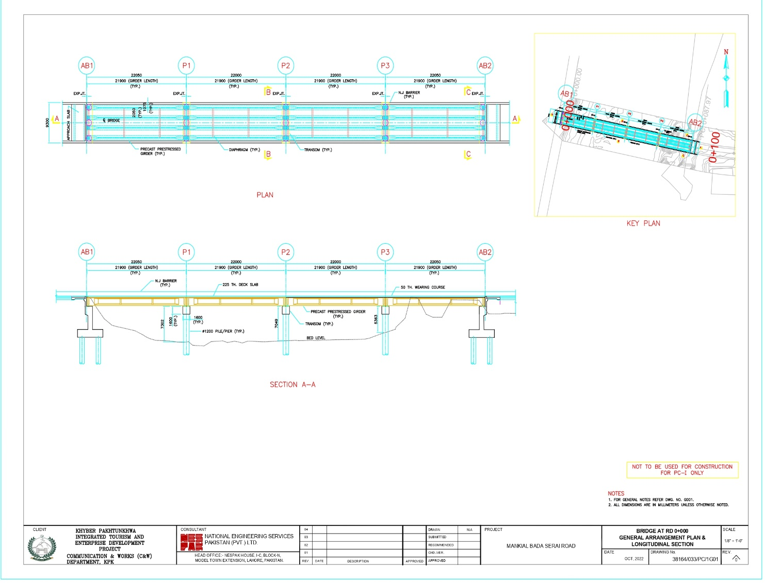

**Figure 1‑2: Cross Section of the Proposed Bridge at RD 00+000**

Since the Mankial Khwar is flowing very close to the captioned project in most of its alignment, therefore, the existing track was severely damaged during the unprecedented rains and devastating floods from August 23 to August 26, 2022. Considering the intensity of damage, it was decided to proceed for redesigning Lot-I of the road by raising the profile and shifting of center line at required locations.

## Salient Features of the Revised AligNment

**Design Speed** **:** 25 ~ 40 Kph

**Road Width** Formation Width **:** 7.0 - 9.5 m

Pavement Width **:** 6.5 m (Full JPCP Rigid)

PCC Shoulder Width **:** 2.0 m (1.0 m on each side)

Side Drain **:** 1.0 m lined drain

**Right of Way**

Total ROW **:** 20 m

**Gradient:**

Maximum (Existing) **:** 21%

Maximum (Provided) **:** 15%

**Design Life of Structures** :

Design Return Period:

Culverts **:** 25 Years

**Structures (Bridges)**

**Cross Section (2 Lane)**

Total Width : 8.6 m

No of Bridges : 04 Nos (New Construction)

: Total Length: 120m

**Additional Bridge at Km 00+000**

**Cross Section (2 Lane)**

Total Length : 88 m

Total Width : 9.3 m

### Lot Wise Scope of Works

1. **Lot / Package – 01: Mankial – Bada – Sarai (Km 00+000 To Km 09+300)**

* Length = 9300 m
* Formation Width (Km 00+000 To 04+000) = 9.5 m
* Formation Width (Km 04+000 To 09+300) = 7.0 m
* Pavement Width (Km 00+000 To 04+000) = 6.5 m
* Pavement Width (Km 04+000 To 09+300) = 4.0 m
* PCC Shoulders (Both Sides) = 9300 m (Each Side)
* PCC Drain (Hill Side) = 9300 m
* Rigid Pavement (JPCP) Length (00+000 – 09+300) = 9300 m
* Rigid Pavement (JPCP) Thickness (00+000 – 09+300) = 20 cm
* Retaining Walls / Breast Walls = As per site requirement
* Slab / Pipe Culverts = As per site requirement
* Ancillary Works = As per design & requirement
* Duct & Manholes For Fiber Optic / PTCL Lines = 4000 m
* No. of Bridges (Original Contract) = 04 No.
* Length of Bridges (Original Contract) = 120 m
* Width of Bridges (Original Contract) = 8.5 m
* **Additional Bridge Length at Km 00+000 = 88 m**
* **Additional Bridge Width at Km 00+000 = 9.5 m**
* Provisional Sum for Relocation of Utility Lines = As per site requirement

1. **LOT / Package - 02: BADA - JABAI ROAD (KM 0+000 TO KM 08+000)**

* Length = 8000 m
* Formation Width = 9.5 m
* Pavement Width = 6.5 m
* PCC Shoulders (Both Sides) = 8000 m (Each Side)
* PCC Drain (Hill Side) = 8000 m
* Rigid Pavement (JPCP) Length (00+000 – 08+000) = 8000 m
* Rigid Pavement (JPCP) Thickness (00+000 – 08+000) = 20 cm
* Retaining Walls / Breast Walls = As per site requirement
* Slab / Pipe Culverts = As per site requirement
* Ancillary Works = As per design & requirements
* Duct & Manholes for Fiber Optic / PTCL Lines = 8000 m
* Provisional Sum for Relocation of Utility Lines = As per site requirement

### Methodology for the Construction of Bridge on the Swat River

Major construction works/activities involves:

* Transportation of material for RCC bridge;
* Road works;
* Bridge (super structure);
* Bridge (Sub structure);
* Anti-Erosion/Protection works; and
* Ancillary Works

The environmental impacts associated with these construction activities are temporary and low in nature which will be mitigated through implementation of this Addendum ESMP. However, some further details are provided below:

**Materials**

* Stock pile adequate quantity of specified approved materials including Cement, Coarse & Fine aggregates, admixtures, bentonite, mixing water etc.

**Access to site**

* Set the alignment of the bridge;
* Read river bed level & flowing water level;
* Construct stable access with suitable soil wide enough to manage with the movement of heavy equipment; and
* Plan the access so as to avoid risk of obstructing the river flow, while taking care of seasonal changes in the river discharge.

**Equipment**

* Crane, welding units, concrete batching plant, transit mixers, lighting towers etc.

# Description of Environment

## Physical Environment

The project area lies in district Swat which is dominated by mountains and hills. The mountains of Swat are part of Hindukush Range. The elevation of the project route ranges from 1,554 meters Above Mean Sea Level (AMSL) near Mankial bazar to 5,160 meters AMSL at endpoint near Jabba. The project area is located in Seismic Zone 3, where 3 represents peak horizontal ground acceleration from 0.24g to 0.32g. The mean maximum and mean minimum temperatures from 1991 – 2015 are 16.74 0C and -3.22 0C respectively while the mean annual rainfall is 26.13 mm. In the project area, no conventional solid waste management system exists. Most of the solid waste is found to be stored in the form of heaps in households and is used as a source of burning. Similarly, no proper sewerage system exists in the realigned portion of the proposed road. The sewage through open drains is discharged into the Mankial Nallah which ends up draining in Swat River. The land use of the realigned portion of the proposed road Lot-I has been provided in the **Table 3.1** below. The land use of the Lot-II is provided in the main ESMP and since there is no change in the alignment so the same will be applicable for this addendum.

Table 3.1: Land use of the Realigned Portion under Lot-I

|  |  |  |  |
| --- | --- | --- | --- |
| **Sr. No.** | **Land Use** | **Area (Acre)** | **Percentage** |
| 1 | Built up | 0.09 | 14% |
| 2 | Open Land | 0.41 | 69% |
| 3 | River | 0.09 | 15% |
| 4 | Road | 0.01 | 2% |
| **Total** | | 0.60 | 100% |

## Ecological Environment

The realigned portion of the proposed road under Lot-I requires no additional land clearance/tree cutting. However, the main tree species of the overall proposed Project includes Apricot (*Prunus armeniaca*); Walnut *Juglans regia*; Acorn *Quercus balloot*); Pine Nut *Pinus gerardiana*; Cumin Bunium persicum; Wild Rose *Rosa* *webbiana*; Sea Buckthorn *Hippopi rhamnoides*; Ephedra species, Horse Chesnut *Aesculus indica*; Morrel Mushroom (*Morchella conica and esculanta*) etc. Currently, small oasis of plant life (small scrubby bushes belonging to different taxonomic groups), flourishing at the different patches along the proposed road strip.

Significant faunal species are; are Ermine, Kashmir Flying Squirrel, Yellow Throated Marten, and Common Otter Long-tailed Marmot. The birds (Common birds detail provided in Baseline) such jungle crow, kite and common sparrow, King Fisher, Monal, Little brown dove can be seen. The bird population is thin in project area. Monal and koklas pheasant may also found in the study area. Goshawk, Himalayan Snow Cock, Chukar, Golden eagle, Common Kestrel, Alpine Chough and several birds.

Among reptiles and amphibians, [Kashmir Rock Agama](https://en.wikipedia.org/wiki/Laudakia_tuberculata), [Striped Grass Skink](https://en.wikipedia.org/wiki/Eutropis_dissimilis) and [Himalayan Pit Viper](https://en.wikipedia.org/wiki/Gloydius_himalayanus) Chequered Keel-back Snake, Natrix piscator-Dark-bellied marsh Snake, Xenochrophis cerasogaster Indian Monitor, Lizard Veranus bengalensis, Field Lizard Uromastrix hardwickir , House Lizard Geko geko. In amphibians Frogs-Rana Tigrina and common toad can also be encountered in the area.

As per the fisheries department brown trout, swati fish (*shycizothorax spp*), bresheri (*Triphysa spp*) and rainbow trout can be found in the local waters. Apart from the above no major fish and fisheries are native to the Mankial nullah.

## Socio-economic Environment

The socio-economic profile of the realigned portion of the proposed road is same as of the whole proposed Project and detailed information has been provided in the main ESMP. During the socio-economic surveys, people were informed about the project objective, its location and basic design features etc. Administratively the project area falls in Tehsil Bahrain of District Swat. The census and socio-economic survey results reveal that majority (37%) of the respondents were aged between 26-35 years of age, 25% were aged between 36 – 45 years, 11% were aged between 11 – 25 years and 26% were above 46 years of age. Out of the total 11% of the respondents/HHs Heads were matriculate, 29% were educated up to primary level, and 21% were Illiterate. Based on the field survey, major occupations in the villages along the road are doing jobs in private sector and business, Labor, agriculture and livestock rearing. Majority of the respondents, 96% were married and only 04% were unmarried. 97% of the respondents were living in joint family system, whereas 3% were living in the nuclear family system. As per socio-economic survey main language spoken in the study area was Torwali and Gojri. Out of total, 20% of the respondents fall in the low-income group below Rupees 32,000, majority of the respondents (45%) fall in the range of Rupees 35,500 to 50,000, and 15% were earning more than 50,000 per month. Sampled respondents were asked about the ownership status of the houses. All the respondents/ PAPs were owners of the houses. Health facilities are generally inadequate in the villages along the road route. No Non-Governmental Organization (NGO) or Community Based Organization (CBO) is identified working in the villages along the road.

# Project Alternatives

No route alternative to the project was considered as proposed Project involves remodeling of existing Mankial Road. However, a comparison was made by taking Alternative 1 as No Project Option and Alternative II as rehabilitation and remodeling of Mankial Road. Considering the environmental and socio-economic benefits of the proposed Project including lesser wear & tear of vehicles, lesser air emissions, reduced probability of accidents, improved access to local markets, educational and health facilities, increased tourism and business opportunities, Alternative-II was selected. The details of the alternative assessment have been provided in the main ESMP document and same assessment applies to the realigned portion of the proposed road. However, the realignment of the proposed Project is discussed below as an additional alternative.

## Alignment Alternative (Realignment)

**Lot-I**

The proposed Project’s previous alignment was selected based on the remodeling and upgradation of Mankial road. The scope of works included the construction of a two-lane standard road as per C&W Department standards as well a bridge over Swat River. However, from RD 00+000 to RD 00+420 of the previously proposed alignment encountered cost implications, one (01) No. of curves on the road, and the road was present on the bank of River Swat which makes it vulnerable to floods. Considering these reasons, the portion of the proposed road was realigned as shown in the **Figure 1-1** and **Figure 3-1**. The realigned portion (Lot-I) of the proposed road has the following considerations:

1. Less cost implication due to reduced length.
2. Avoidance of one (01) No. of curve in original alignment.
3. Avoidance of River bank with a risk of Flooding
4. Less land acquisition will be involved in the realigned portion of the proposed road (details provided in **Section 6.1.1**).

A comparison of the land use of the previous and realigned portions is provided below in **Table 4.1** and **Figure 4.1**.

Table 4.1: Comparison of Land use of Previous and Realigned Portions for Lot-I

| **Sr. No.** | **Land Use** | **Previous Alignment** | | **Realignment** | |
| --- | --- | --- | --- | --- | --- |
| **Count** | **Area (Acre)** | **Count** | **Area (Acre)** |
| 1 | Built up | 4 | 0.12 | 3 | 0.09 |
| 2 | Open Land | 2 | 0.94 | 4 | 0.41 |
| 3 | River | 1 | 0.00 | 1 | 0.09 |
| 4 | Road | 0 | 0.00 | 1 | 0.01 |
| 5 | Bridge | 1 | 0.02 | 0 | 0.00 |
| **Total** | | **2.64** | | **1.08** | |

**Lot-II**

The length of the Lot-II has been reduced and the detailed land use comparison is provided below in **Table 4.2**.

Table ‎4.2: Comparison of Land use of Previous and Realigned Portions for Lot-II

|  |  |  |  |  |  |
| --- | --- | --- | --- | --- | --- |
| **Sr No.** | **Land use** | **Lot-II Old Alignment** | | **Lot-II New Alignment** | |
| **Count** | **Area (acre)** | **Count** | **Area (acre)** |
| 1 | Bridge | 0 | 0.00 | 2 | 0.03 |
| 2 | Built up | 1 | 0.03 | 10 | 0.20 |
| 3 | Cultivated | 2 | 0.29 | 15 | 2.94 |
| 4 | Hilly Terrain | 29 | 26.42 | 4 | 0.18 |
| 5 | Open Land | 4 | 1.45 | 11 | 12.39 |
| 6 | River | 3 | 0.65 | 9 | 2.48 |
| 7 | Track | 10 | 2.66 | 12 | 1.61 |
|  | **TOTAL** |  | 31.50 |  | 19.60 |

From the above comparison of Lot-I and Lot-II, it is evident that the realigned portion of the proposed road has less environmental and social impacts as compared to the previous alignment.

Keeping in view the above considerations, it can be concluded that the realignment of the proposed road from N-95 to RD 00+420 has reduced the cost implications, less number of buildings to be affected and improved the operational safety scenario of the road due to avoidance of the curve. Therefore, the realignment of Lot-I is more economically, environmentally and socially feasible. The mitigation measures for the land acquisition involved are provided in the main ESMPs of both Lots as well as in the **Chapter 6** of this document.

**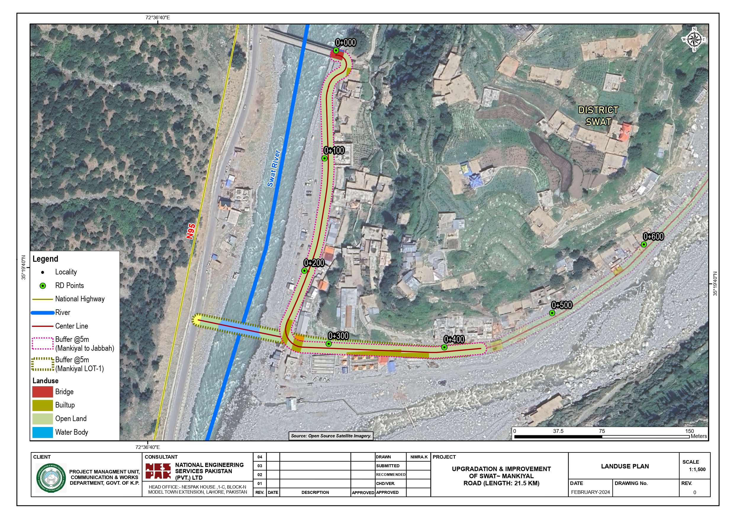****Figure 4‑1: Map showing the Comparison of Land use of Previous and Realignedd Portions**

# Public Consultation and Information Disclosure

The consultation and information disclosure to the Project Affected Persons (PAPs) and other stakeholders including KP-EPA, EPA, Swat (regional office of KP-EPA), Forest Department, Irrigation Department, C&W Department, Galiyat Development Authority, Agriculture Department and Wildlife Department, were involved from the early stages of the planning and design of the project. Furthermore, fresh consultations were also conducted with EPA, Fisheries department and NHA regarding the addition of new bridge on Swat River and realigned portion of Mankial road. The summary of the fresh departmental consultations are provided in Table 6.1:

Table ‎6.1: Concerns of fresh Relevant Departments/Institutional Stakeholders

| **Sr. No.** | **Department** | **Name, Designation & Contact No.** | **Stakeholder Views/Concerns** | **Response on Concerns** |
| --- | --- | --- | --- | --- |
| During the meetings with institutional stakeholders, NESPAK team briefed the proposed KITE Project, addition of new bridge and realigned portion of Mankial road, as being part of KITE in Swat. The institutional stakeholders appreciated the project and considered it of vital importance for the facilitation of tourist’s up to Bada Serai and Jabba and ensured their full cooperation for the execution of the project. The detailed concerns raised by different government departments and their responses are given below; | | | | |
| 1 | EPA, Saidu Sharif | Assistant Director -EPA, | The construction and demolition (C&D) waste should be disposed of at the EPA approved site.  PAPs should be given proper land compensation;  Trees should be planted as per approved Tree plantation plan in consultation with the Forest department. | All of the concerns were recorded and it was briefed that all concerns will be addressed during the construction supervision of the proposed subproject. |
| 2 | Fisheries Department, Madyan and Mingora | Deputy Directors | Before the start of construction activities on the proposed bridge on Swat River, Fish department should be informed and taken on board.  Labor should not be allowed to dump C&D waste in the river.  Hunting of fisheries should be prohibited.  Trout has a breeding season of November-March, as construction activities will be carried out in low flow season, NESPAK should ensure the easy migration of these species. If possible, fish ladder can be provided. | It was responded that all concerns will be addressed. |
| 3 | NHA | Design Wing, NHA Head Quarter,  Islamabad | NESPAK Environment and Design team briefed NHA officials about addition of bridge on Swat river which will be connecting N-95 and the proposed Mankial road. NHA is the custodian of N-95. The NHA official requested to share the detailed engineering design of the bridge, so that NHA can engage the relevant regional team for collaboration with the project team of the proposed bridge. | Written response from the NHA Design team is awaited and shall be updated upon receipt. Moreover, NESPAK Islamabad office is in coordination with the NHA. |

Furthermore, stakeholder consultations were also carried out with the PAPs for the additional bridge on Swat River and the realigned portion of Mankial road. Seven (07) consultations with 105 male community members were conducted in Mankiyal, Bair and Badai villages in March and July 2024. Moreover, Two (02) gender consultations with 43 female members were also conducted in June and July 2024. The PAPs were of the view that the fair compensation as per the prevailing market rates must be determined for their land as the land falls in commercial category. Moreover, they demanded that the compensation should be given on time and before the commencement of the civil works. It was briefed to the PAPs that the price of their land will be determined by the district price assessment committee by considering the market value. Besides, the compensation to all affected persons will be given before commencement of the civil work.

Major concerns of the men in the project area were about the satisfactory compensation in case of acquisition of their assets, enhancement of tourism activities (resulting in increasing the commercial activities like parking requirements for the vehicles, hotels for night stays, tuck shops, roadside restaurants etc. in the project area), early completion of road, lack of trust on local government, special provision of jobs to poor people etc. While, the concerns of the women in the project area were about the presence of outside labor that may restrict the movement of local women. They shared that there is no platform or forum at the village level through which women can voice their problems. The female participants also expressed that civil work activities of the project will create dust and noise pollution during construction due to movement of heavy machinery. On the other hand, they were satisfied that construction activities will also boost commercial activities in the project area.

The details of the public consultation and information disclosure have been provided in the main ESMP document and same applies to the realigned portion of the proposed road.

# Potential Environmental and Social Impacts and their Mitigations

The details of the impact assessment and mitigation measures have been provided in the main ESMPs of both Lots document and same applies to the realigned portion of the proposed road. The impacts provided below are only for the realigned portion. However, for rest of the impacts and mitigations, please refer to main ESMP. The summary of the other impacts is discussed below:

In general the proposed project will have both positive and negative impacts during the construction and operational phases. Major impacts identified during construction are maintaining slope stability, shifting of public utilities such as electric generators that are built up in the area by the locals to provide for electricity needs, generation of 45.5 kg[4] of municipal solid waste and hazardous waste, disturbance of drainage, soil erosion, surface and groundwater contamination, construction camps/camp sites, deterioration of air quality, noise and vibrations, waste and hazardous waste, traffic management, cutting of trees, habitat disturbance of fauna, social conflicts due to labor influx, land acquisition and resettlement and Destruction of a mosque present in RoW.

Negative impacts anticipated during operational phase include increase in air pollution in the long run (although improved road condition will improve the air quality but in the long run traffic will increase due to improved accessibility, hence resulting in increase in air pollution) and noise level due to increase of traffic, generation of solid waste due to increase in number of tourists and road safety issues due to increase in traffic and speed of vehicles due to improved road condition.

Mitigation measures include maintaining natural angle of cut slopes and embankments during design to avoid land sliding, avoid use of heavy machinery on wet soil to prevent damage to soil structure, provision of temporary runoff collection system to contain the construction runoff, safe storage of oil, lubricants, chemical and other hazardous substances removal of left-over material from site, use of Personal Protective Equipment (PPEs) like masks, goggles and gloves, regular water sprinkling, restrict construction vehicles movement during night time; prohibition of hunting, poaching and harassing of animals and birds, provision of pedestrian bridge/underpasses for crossing of pedestrian and domestic animals, provision of special corridors for movement of wild animals, signs or warning notices of the presence of animals, adoption of work safety measures and good workmanship practices.

Positive impacts during construction and operation are employment opportunity, increase in land value, increase in trade, business and access to educational and health facilities.

## Impacts due to the realigned portion of the proposed road and mitigation measures

All of the impacts are already mentioned in the main ESMP document. However, the impact related to permanent land acquisition has been updated based on the realignment of the proposed project. Also, the impacts related to the bridge that is to be constructed over Swat River are provided in Table 6.1.

### Land Acquisition, Resettlement and Compensation

**Potential Impact**

The proposed project involves the rehabilitation and remodeling of Mankial Road. Therefore, project interventions will require land acquisition throughout the alignment because the existing ROW doesn’t fulfill the construction requirements. Moreover, the involuntary resettlement will result in loss of shelters, economic displacement, and loss of livelihoods. During social impact assessment and land identification it was observed that, that 426.80 kanal (previously 826.64 kanal) land acquisition will be involved in Moza Mankial and Moza Badai. However, out of 426.80 kanal land, almost 236.56 kanal land belongs forest department. Hence, 190.24 kanal land will be acquired from private landholders (for both lots of Mankial road).

According to the inventory of losses survey of the sub-project affected assets, the sub-project will impact 27 structures including 08 houses, 18 shops and 01 mosque, all affected structures fall under Lot-I, however, the segregated data regarding private land acquisition will be provided by the Revenue Department once the land acquisition process proceeds under LAA 1894.

**Mitigation Measures**

* Careful alignment and route selection by the designer to minimize the impact by avoiding the residences of these families and shops.
* A detailed Resettlement Action Plan will be prepared as per World bank OP 4.12 and Land Acquisition 1894 including later amendments.
* The compensation for the structures, houses, shops, trees, private and public properties etc. has to be made as per Resettlement Action Plan prior to commencement of work onsite.
* Mitigation measures will involve land management and providing judicious compensation to the affected person by providing sufficient budget in the project cost. The process of land acquisition and compensation will be followed in a transparent manner along with full documentation to minimize the impacts. Full Documentation will be maintained by the PIU.

### Impacts due to the proposed Bridge on Swat River

Few anticipated adverse impacts are envisaged which are listed in **Table 2.1.**

Table 6.1: Anticipated Adverse E&S Impacts due to the proposed Bridge on Swat River

| Sr. No | Environmental and Social Impacts | Mitigation Measures |
| --- | --- | --- |
|  | **Climate Risks**  The construction activities of the proposed bridge can be affected due to the climate risks during the severe vulnerable conditions such as heavy rains and floods. | * Construction work will be started and planned considering the weather forecast and special attention will be required for monsoon season. |
|  | **Deterioration of surface and drinking water quality**  Construction activities and the wastewater including oil/chemical spills from the construction camp (preferably away from the residential areas and sensitive receptors, having proper access, must have proper drainage arrangement to avoid impact on nearby water body and public water supply and will be finalized and dully approved from Supervision Consultant and PMU) can contain harmful substances which may deteriorate the water quality of the river. | * Campsites will be located at least 500m away from the distributary and settlement. * No waste stream will be allowed to enter river without treatment where it can affect downstream water quality and human health. Wastewater will be disposed after treatment by using septic tank. Similarly, no spillage will be allowed near the river. * Adequate sanitary facilities and drainage in the worker’s camps will help to avoid this possibility. * Construction materials will be properly covered and stored to prevent runoff of construction material and waste into the river. The Erosion Control Blankets and Mats can be used to control the sediment runoff. |
|  | **Noise Pollution and Vibration Impact**  Noise and vibration are envisaged due to general construction activities and machinery movement. | * Construction Contractor will ensure that; (i) machinery is adequately silenced and (ii) machinery operations close to urban areas will be restricted to day time only. |
|  | **Deterioration of Air Quality**  Dust and fugitive emission will be generated due to the construction activities (clearing, excavation, pilling etc.) and movement of construction vehicles in the proposed bridge site. | * Dust control measures such as water spraying or dust suppressants will be used to reduce airborne dust particles. * Properly tuned vehicles and regular maintenance and inspection of vehicles must be ensured. * Effort will be made to use the best quality fuel with low emission potential. |
|  | **Occupational Health and Safety Impacts**  Construction labor, construction staff hired during the construction period and the visitors will be subject to various occupational health and safety risks. Following risks are anticipated due to proposed project:  **Physical Hazards:** Bridge construction personnel may be exposed to a variety of physical hazards, principally from operating machinery and moving vehicles but also working at elevation on bridges. The physical hazards may include:   * Struck by moving vehicles * Fall from height * Risk of falling objects * Eye injury caused by stone or metal particles * Major hand-arm and whole body vibration hazards * Skin and respiratory tract irritation from exposure to cement dust, * Exposure to extreme Weather events * Drowning in river (Occupational Safety and Health Administration (OSHA) does not provide specific criteria to determine when the risk of drowning is present. It is considered to exist at any time the depth of water exceeds 5 ft (1.5 m)[5] (or is subject to sudden depth fluctuations to 5 ft (1.5 m) or greater). For depths less than 5 ft (1.5 m), the risk of drowning may exist if swift currents are present, or if a fall into the water may result in the person becoming unconscious or otherwise disabled. Even for depths as shallow as 2 ft (0.6 m) or less, drowning protection may be required under some conditions.   **Chemical Hazards** in proposed Bridge construction may be principally associated with exposures to dust during construction and paving activities; exhaust emissions from heavy equipment and motor vehicles during all construction activities; diesel fuel used as a release and cleaning agent for paving equipment and in generators; and handling and storage of bitumen.  **Noise:** Construction and maintenance personnel may be potentially exposed to extremely high levels of noise from heavy equipment. As most of these noise sources cannot be prevented, control measures should include the use of personal hearing protection by exposed personnel and implementation of work rotation programs to reduce cumulative exposure.   * Risk of Non-compliance with respect to monitoring, recording and reporting of OHS measures. | Following mitigation measures will be taken by Contractor to avoid/minimize the OHS impacts:  **Physical Hazards**   * Moving vehicles and machineries fitness certificate will be ensured prior to the start of work. * Use of protective barriers to shield workers from traffic vehicles, or installation of channeling devices (e.g. traffic cones and barrels) to delineate the work zone; * Training of workers in safety issues related to their activities, such as the hazards of working on foot around equipment and vehicles; and safe practices for work at night and in other low-visibility conditions, including use of high-visibility safety apparel and proper illumination for the work space (while controlling glare so as not to blind workers and passing motorists). * Flagman will be positioned to manage the flow of traffic and safe movement of heavy machinery specifically considering the blind spot areas of heavy machinery. * Implementation of a fall protection program that includes training in climbing techniques and use of fall protection measures; inspection, maintenance, and replacement of fall protection equipment; and rescue of fall-arrested workers, among others; * Establishment of criteria for use of 100 percent fall protection (typically when working over 2[6] meters above the working surface, but sometimes extended to 7 meters, depending on the activity). The fall protection system should be appropriate for the structure and necessary movements, including ascent, descent, and moving from point to point; * Safety belts should be not less than 16 millimeters (mm) (5/8 inch) two-in-one nylon or material of equivalent strength. Rope safety belts should be replaced before signs of aging or fraying of fibers become evident; * When operating power tools at height, workers should use a second (backup) safety strap. * The area around which elevated work is taking place should be barricaded to prevent unauthorized access; * Hoisting and lifting equipment should be rated and properly maintained, and operators trained in their use. Elevating platforms should be maintained and operated according to established safety procedures including use of fall protection measures (e.g. railings); equipment movement protocols (e.g. movement only when the lift is in a retracted position); repair by qualified individuals; and installation of locks to avoid unauthorized use by untrained individuals; * Ladders and scaffolding should be used according to pre-established safety procedures for proper placement, climbing, standing, as well as the use of extensions; and * Provide appropriate Personal Protective Equipment (PPE) in conjunction with training, use, and maintenance of the PPE. * Avoid working or walking under a suspended load * Scaffolding standards will be followed to prevent the falling objects. * Cordon off the working areas where the hazard of falling objects exist * Position flagman to prevent the entrance of labor and visitor in the cordon off area * Provide Safety Helmets along with other appropriate PPEs. * Shielding arrangements will be ensured in cutting and drilling machinery and equipment. * Safety goggles along with other necessary PPEs will be provided. * Machinery and tools will be well maintained and properly lubricated * Anti-vibration features may be used in equipment * Train workers against the risk of hand-harm and whole body vibration hazards * Reduce the time spent on vibratory equipment and rotate the labor when possible * Appropriate masks and gloves along with other necessary PPEs will be provided, * Construction work will be started and planned considering the weather forecast and special attention will be required for monsoon as well as snowfall season * Appropriate heating and ventilation measures will be taken at offices and labor camps during extreme weather conditions. * Effective PPEs and shelters will be provided to the labor during rain and snowfall. * Employees should not work alone, where practical, in situations where a drowning hazard exists; * Drowning protection must be provided for workers in areas where the danger of drowning exists and passive fall protection (OSHA-specified nets or railing) are not present to prevent workers from entering the water. When active fall protection (lanyards, etc.) is provided, or the workers must work outside the railing, drowning protection is required; and * A skiff or boat for emergency rescue operations, equipped with paddle or oars, a ring buoy or other life preserver and a reach extension device. Where water current exists, the skiff or boat must be motorized or occupied at all times. Under all conditions, the skiff or boat must be located such that it is available for immediate use if an emergency arises.   **Chemical hazards**   * Use of millers and pavers with exhaust ventilation systems and proper maintenance of such systems to maintain worker exposure to crystalline silica (millers and grinders) and asphalt fumes (pavers) below applicable occupational exposure levels; * Use of the correct asphalt product for each specific application, and ensuring application at the correct temperature to reduce the fuming of bitumen during normal handling; * Maintenance of work vehicles and machinery to minimize air emissions; * Reduction of engine idling time at active construction sites; * Use of extenders or other means to direct diesel exhaust away from the operator; * Use of protective clothing when working with cutbacks (a mixture of asphalt and solvents for the laying of pavement), diesel fuel, or other solvents; and * Provide appropriate PPE in conjunction with training, use, and maintenance of the PPE.   **Noise reduction:**   * Selecting equipment with lower sound power levels; * Installing suitable mufflers on engine exhausts and compressor components; * Installing vibration isolation for mechanical equipment; * Providing noise protection PPEs (ear plugs/ear muffs) to the construction workers; * Re-locating noise sources away from sensitive areas (labor temporary rest areas) to take advantage of distance and shielding; * Regular monitoring of noise levels at active sites or near noise producing equipment/machinery and compare it to the available occupational noise standards; and * No employee should be exposed to a noise level greater than 85 dB(A) for a duration of more than 8 hours per day without hearing protection. Furthermore, the rule of 3 dB(A) will also be considered for the noise of above 85 dB(A).   **Monitoring of OHS Activities:**   * An OHS expert of Contractor(s) as well as Supervision Consultant will be deputed at site to actively monitor the OHS activities. * Regular inspection and testing of all safety features and hazard control measures focusing on engineering and personal protective features, work procedures, places of work, installations, equipment, and tools used; * Ensure the hiring of skilled drivers and ensure the rescue related arrangements at site; * Surveillance of the working environment: The contractors should document compliance using an appropriate combination of portable and stationary sampling and monitoring instruments. Monitoring and analyses should be conducted according to internationally recognized methods and standards. Monitoring methodology, locations, frequencies, and parameters should be established individually for each project following a review of the hazards; * Continuous and efficient surveillance of worker’s health during the entire construction phase by the nominated officials of contractors; and * Training activities for employees (construction contractor & supervision consultant staff) and visitors should be adequately monitored and documented (curriculum, duration, and participants). Emergency exercises, including fire and other relevant drills, should be documented adequately. Contractors should be contractually required to submit to the employer adequate training documentation before start of their assignment. * A separate GRM register will be maintained to record and proceed the grievance of workers. * Workers will be trained on the established GRM procedures and GRC. * Contractor(s) shall prepare a comprehensive OHS Plan including work method statements to avoid incidents during construction stage. A guideline OHS Plan is already provided in ESMP. * These requirements will be incorporated into the bidding specification and contract documents, and will be binding on the contractor, at risk of penalty for noncompliance, as charges to be recovered from contractor for unsafe act or condition |
|  | **Community Health and Safety**   * Increase risk of illicit behavior and crimes * Increased risk of communicable diseases * Conflicts between locals and workers related to religious, cultural or ethnic differences * Child abuse, drug/substance abuse and Sexual Harassment (SH) and Sexual Exploitation and Abuse (SEA) * Non awareness of communicating local concerns and grievances | * A regular inspection and maintenance program will be ensured to identify and address any potential vulnerabilities or issues that could affect the wall during a flood. * Flood warning systems must be ensured which will provide timely information about rising water levels or impending flood events. Work during construction as well as travelling during operation will be halted during such emergencies. * Comprehensive emergency response plans in compliance with Provincial Disaster Management Authority (PDMA) specific to the flood events will be developed and updated regularly. * GRM boxes will be placed in project offices and at various locations of proposed road. * GRM awareness sessions will be conducted to sensitize locals regarding GRM procedures and GRC. * GRM awareness leaflets and flyers in local language will be prepared and disseminated to locals for creating awareness regarding GRM. * Communicable disease associated with the influx of temporary construction labor which will be reduced by implementing Worker Code of Conduct, ensure minimum to no interaction of workers with local community, health awareness initiatives; immunization program and providing health service. * Trainings will be given to construction workers, alongside the implementation of strict measures and punishments in case of any child abuse, drug/substance abuse and SEA/SH. Child and other abuses are unacceptable and will be reported immediately and action taken following the WB Guidelines on GBV and Child Abuse. |
|  | **Soil Erosion and Contamination**  Construction activities and the use of construction machinery at the site will leads to soil erosion | * Best management practices will be adopted during construction activities. * Septic tanks of adequate capacities will be designed and constructed by contractor(s) for receiving and treating wastewater from all temporary worksite toilets and other facilities. The wastewater will not be discharged untreated onto the adjacent lands or nearby water body. * Erosion control measures will be adopted to prevent soil erosion and sediment runoff. |
|  | **Impacts on Flora, Fauna and Aquatic life**  There is no direct impact on flora and fauna. However, construction activities, stockpiling of material and the wastewater discharge including oil/chemical spills from the camps can contain harmful substances which may cause impact on aquatic life. | * Cutting of trees and shooting, hunting, trapping or poaching of animals and birds will totally be banned within the project area by the contractor and project personnel, so as to minimize indirect impact of flora and fauna. * Storage of (construction) material confined to work sites. * Direct discharge of wastewater into water body will be avoided. * Construction materials will be properly covered and stored to prevent runoff of concrete additives and construction waste into the water body. * Good housekeeping will further reduce the likelihood and severity of this impact. * Restoring temporarily disturbed areas / land take to pre-construction conditions |
|  | **Social and Cultural Conflicts**  Use of local resources and products by the construction workers and differences in cultural values may cause discomfort to local residents. | * Local labor especially from nearby communities will be given preference for the construction works. However, the outside labour will be resided in the Construction camp established for the overall Mankial project and mitigations provided in the ESMPs of Lot-I and Lot-II will be applicable for these labourers. * Avoid use of local resources (especially community water supply sources) to reduce the social conflicts. Contractor will ensure the availability of drinking water (preferably reusable large bottled container water) at site. * Strict implementation of Worker Code of Conduct will be ensured to eliminate such social and cultural issues. |
|  | **Child Labor and Gender Based Violence (GBV)**  The impact of child labor and gender-based violence may arise during the construction stage of the proposed bridge. | * Child labor will be prohibited. * It will be ensured that contractor will have its employment policy in accordance with relevant act and labor policies of Khyber Pakhtunkhwa and Pakistan. * Provision related to GBV, SEA/SH will be incorporated worker’s code of conduct. * Trainings will be given to construction workers, alongside the implementation of strict measures and punishments in case of any sexual assaults, or GBV. GBV is unacceptable and will be reported immediately and action taken following the WB Guidelines on GBV and Child Abuse. |

# Environmental and Social MITIGATION AND MONITORING Plan

Environmental and Social Management Plan (ESMP) provides institutional arrangement for the implementation of the proposed mitigation measures during the construction and operational phases of the proposed project. The ESMP defines roles and responsibilities, reporting mechanism, training needs and schedules and budget to implement the ESMP. The impacts, mitigation measures, monitoring indicators, frequency and responsibility has been documented in main ESMP and same will be applicable to the realigned portion of the proposed road.

The Project Steering Committee will be responsible for overall project implementation while PMU Communication & Works Department will be responsible for the overall implementation of the ESMP of the project. Environmental and Social Safeguard Unit (ESSU) consisting of environment, social and occupation health and safety specialist has been established in PMU to ensure compliance of ESMP by the contractor. Monitoring and Evaluation consultant will carry out third party monitoring on yearly basis for implementation of ESMP. The Contractor will be responsible for the implementation of ESMP for the proposed project.

Environmental Monitoring will be undertaken during pre-construction, construction and operational phases to ensure the effectiveness of the proposed mitigation measures. Certain environmental parameters will be selected and quantitative analysis will be carried out. The monitoring plan provided in the ESMP will be considered for the realignment also.

The additional cost estimates for Lot-I and Lot-II have been discussed in subsequent sections.

## Cost for Implementation of ESMP

### Cost for Training and Capacity Building/Strengthening

In order to ensure that the ESMP provisions are implemented efficiently and effectively, training and capacity building and strengthening are required. The broad areas of capacity building/strengthening have been identified in the main ESMP document and recommended for the PMU for effective implementation of the ESMP. However, one additional training has been recommended for both lots which details are provided in **Table 7.1** below.

Table 7.1: Additional Institutional Training for Implementation

| **Training Activity** | **Participants** | **Type of Training** | **Content** | **Scheduling** | **Cost Estimates**  **Rs.** |
| --- | --- | --- | --- | --- | --- |
| Local and International Guidelines | Contractor and Managerial Staff | Presentation | Awareness on Local and International E&S Guidelines | Biannually | 2,500,000/- |
| **Total (for each Lot)** | | | | | **2,500,000/-** |

### Cost for Personal Protective Equipment (PPE)

The cost required for PPEs for one hundred fifty (150) staff including skilled and unskilled during the whole construction period of twenty-four (24) months is given in the **Table 7.2.**

Table 7.2: Break-up for Personal Protective Equipment Cost

| **Items** | **Quantity (Yearly)** | **Cost / Item (Rs.)** | **Total Cost (Rs.)** |
| --- | --- | --- | --- |
| Dust masks | 7,200 | 20 | 144,000 |
| Safety Shoes | 300 | 2,000 | 600,000 |
| Gloves | 3,600 | 300 | 1,080,000 |
| First Aid Box | 2 | 7,000 | 14,000 |
| Ear Plugs | 1,800 | 30 | 54,000 |
| Safety Helmets | 150 | 1,500 | 225,000 |
| Safety Jackets (Hi Vis) | 300 | 600 | 180,000 |
| **Total (for each Lot)** | | | **4,594,000** |
| **Total for Lot-I in Main ESMP** | | | **588,360** |
| **Additional for Lot-I** | | | **4,005,640** |
| **Total for Lot-II in Main ESMP** | | | **816,660** |
| **Additional for Lot-II** | | | **3,777,340** |
| **Time required for Construction = 24 months** | | |  |
| **Estimated No. of labor required during construction = 150 (for each lot)** | | |  |

The cost required to effectively implement the mitigation measures is important for the sustainability of the subproject. The Contractor will be paid against only those (mitigation) measures that actually executed at site. The estimated cost for the implementation of ESMP is summarized as under:

Table 7.3: Total ESMP Cost and Additional Cost (Lot-I)

| **Items** | **Unit** | **Cost (Provided in Main ESMP)** | **Additional Cost** |
| --- | --- | --- | --- |
| Personal Protective Equipment cost | Rs. | 588,360/- | 4,005,640/- |
| Environmental Monitoring and Testing Cost | Rs. | 752,000 /- | - |
| Tree Plantation Cost | Rs. | 18,663,000/- | - |
| Institutional Strengthening Cost | Rs. | 10,800,000/- | - |
| Institutional Training Cost | Rs. | 1,800,000/- | 2,500,000/- |
| Hiring of Monitoring and Evaluation Consultant (MEC) by Client/PMU[7] | Rs. | 3,000,000/- | - |
| Cost of OHS Expert for the implementation of ESMP during construction phase (one expert @ 200,000/- per month salary for a period of 02 years, this expert will also be responsible for overseeing Lot-II) | Rs. | - | 4,800,000/- |
| **Sub Total** | **Rs.** | **35,603,480/-** | **11,305,640/-** |
| **Contingencies @10%** | **Rs.** | **3,560,348/-** | **1,130,564/-** |
| **Total** | **Rs.** | **39,163,828/-** | **12,436,204/-** |
| **Consolidated Cost (Lot-I)** | **Rs.** | **51,600,032/-** | |

Table 7.4: Total ESMP Cost and Additional Cost (Lot-II)

| **Items** | **Unit** | **Cost (Provided in Main ESMP)** | **Additional Cost** |
| --- | --- | --- | --- |
| Personal Protective Equipment cost | Rs. | 816,660/- | 3,777,340/- |
| Environmental Monitoring and Testing Cost | Rs. | 1,504,000 /- | - |
| Tree Plantation Cost | Rs. | 25,772,880/- | - |
| Institutional Strengthening Cost | Rs. | 10,800,000/- | - |
| Institutional Training Cost | Rs. | 1,800,000/- | 2,500,000/- |
| Hiring of Monitoring and Evaluation Consultant (MEC) by Client/PMU[8] | Rs. | 3,000,000/- | - |
| Cost of OHS Expert for the implementation of ESMP during construction phase (one expert @ 200,000/- per month salary for a period of 02 years, this expert will also be responsible for overseeing Lot-I) | Rs. | - | (Cost covered under Lot-I) |
| **Sub Total** | **Rs.** | **43,693,540/-** | **6,277,340/-** |
| **Contingencies @10%** | **Rs.** | **4,369,354/-** | **627,734/-** |
| **Total** | **Rs.** | **48,062,894/-** | **6,905,074/-** |
| **Consolidated Cost (Lot-II)** | **Rs.** | **54,967,968/-** | |

**ANNEX-01: E&S SCREENING CHECKLISTS**

**E&S Screening Checklist Lot-I**

**Dated:** April 10, 2024

| **PARAMETERS** | **ENVIRONMENTAL AND SOCIAL SCREENING CHECKLIST IMPACTS** | | | |
| --- | --- | --- | --- | --- |
|  | | | | |
| **Physical Parameters** | **None** | **Minor / Small** | **Moderate/ Medium** | **Significant/large** |
| **1- Surface water, Groundwater and sediments** |  |  |  |  |
| **1.1** Would the project pose the risk of clearance of vegetation that may result an increase in level of suspended solids washing into the rivers / surface water bodies? |  |  | Moderate/ Medium |  |
| Yes. Swat River crossing the Mankial Bada Serai Road may be temporarily impacted and will be mitigated. Additionally, a bridge of 88m length has been proposed on the Swat River. | | | | |
| **1.2** Would the project contaminate the surface water, catchment boundaries and overland flow paths? |  | Minor/ Small |  |  |
| A bridge of 88m length has been proposed on the Swat River. During the construction of the bridge, surface water body may get contaminated. | | | | |
| **13** Will the proposed project involve the application of chemicals that may have a negative effect on the environment or human health? | None |  |  |  |
| No. | | | | |
| **1.4** Will the project have potential negative impacts on groundwater? | None |  |  |  |
| No. | | | | |
| **1.5** Will the project make large scale spillage by the movements of vehicles that may results in fuel and oil leaking in to underlying soil resulting contamination of water table? |  | Minor/ Small |  |  |
| A bridge of 88m length has been proposed on the Swat River. During the construction of the bridge, spillage may occur. | | | | |
| **1.6** Would the project pose a risk of contaminating drinking water sources | None |  |  |  |
| No. | | | | |
| **1.7** Would the project deplete the ground water if it is not properly disposed? | None |  |  |  |
| No. | | | | |
| **2- Air Emissions and Ambient Air Quality** |  |  |  |  |
| **2.1** Would the project result in an increase in the level of dust and particulate matter in the air surrounding the site? |  | Minor/ Small |  |  |
| Yes. Temporary impact due to certain construction activities which will be mitigated. | | | | |
| **2.2** Would the project result in indoor air pollution? | N.A. | N.A. | N.A. | N.A. |
| N.A. | | | | |
| **2.3** Will there be any impact upon air quality during the decommissioning phase? | None |  |  |  |
| No. |  |  |  |  |
| **2.4** Would the project release the greenhouse gases? |  | Minor/ Small |  |  |
| Low level emissions are expected during the construction activities. | | | | |
| **3- Noise and Vibration** |  |  |  |  |
| **3.1** Would the project increase the ambient noise level and vibrations? |  | Minor/ Small |  |  |
| Yes. | | | | |
| **4- Landscape and Visual Amenity** |  |  |  |  |
| **4.1** Would the project include above ground installation that may alter the views to, from or beyond the site? |  | Minor/ Small |  |  |
| A bridge of 88m length has been proposed on the Swat River. | | | | |
| **5- Soil and land use** |  |  |  |  |
| **5.1** Would the project result in the clearance of the vegetation that may increase soil erosion? |  | Minor/ Small |  |  |
| Yes. Limited impact. | | | | |
| **5.2** Would the project affect agricultural land? | None |  |  |  |
| No. | | | | |
| **5.3** Would the project lead to landslides hazard? |  | Minor/ Small |  |  |
| Yes. The project area is a hilly terrain and may be prone to land sliding. However, mitigation will be adopted. | | | | |
| **6- Climate Change Mitigation and Adaptation** |  |  |  |  |
| **6.1** Will the proposed project result in significant greenhouse gas emissions or exacerbate climate change? | None |  |  |  |
| No. | | | | |
| **6.2** Would the potential outcomes of the project be sensitive or vulnerable to potential impacts of climate change? |  | Minor/ Small |  |  |
| Flooding in River Swat may cause destruction of the proposed bridge. | | | | |
| **6.3** Is the proposed project likely to directly or indirectly increase social and environmental vulnerability to climate change now or in the future? | None |  |  |  |
| No. | | | | |
|  | | | | |
| **7.1** Does the project pose high risk to the workers/laborers? |  | Minor/ Small |  |  |
| OHS related risks may be expected, but manageable through the implementation of mitigation measures. | | | | |
|  | | | | |
| **8.1** Would the project potentially result in the release of pollutants to the environment due to routine or non‐routine circumstances with the potential for adverse local, regional, and/or trans boundary impacts? | None |  |  |  |
| No. | | | | |
| **8.2** Would the proposed project potentially result in the generation of waste (both hazardous and non‐hazardous)? |  | Minor / Small |  |  |
| Yes. Small quantity of Wastewater and solid waste will be generated from the construction camps and related construction activities. | | | | |
| **8.3** Will the proposed project potentially involve the manufacture, trade, release, and/or use of hazardous chemicals and/or materials? | None |  |  |  |
| No. The project will not involve any chemical that requires special approval. | | | | |
| **8.4** Does the project include activities that require significant consumption of raw materials, energy, and/or water? |  |  | Moderate |  |
| Yes. The materials used in construction of this road would include coarse aggregates (crush), fine aggregates (sand), soil, water, energy, asphalt, reinforcement, cement etc. | | | | |
|  | | | | |
| **9.1** Would the project pose potential risks to community health and safety due to the transport, storage, and use and/or disposal of hazardous or dangerous materials (e.g. explosives, fuel and other chemicals during construction)? |  | Minor /small |  |  |
| Yes. During construction stage the project may pose limited potential risks while transporting which will be mitigated. | | | | |
| **9.2** Would the project result in potential increased health risks (e.g. from water‐borne or other vector‐borne diseases or communicable infections such as HIV/AIDS, COVID-19)? |  | Minor/ Small |  |  |
| Yes, these aspects shall be managed through the implementation of mitigation measures provided for community health and safety. | | | | |
| **9.5** Would elements of project construction pose potential safety risks to local communities? |  | Minor /small |  |  |
| Yes. Limited potential safety risks to the locals are anticipated. | | | | |
| **9.6** Does the project engage security personnel that may pose a potential risk to health and safety of communities and/or individuals (e.g. due to a lack of adequate training or accountability)? | None |  |  |  |
| No. | | | | |
|  | | | | |
| **10.1** Would the project potentially involve temporary or permanent and full or partial physical displacement? |  |  | Moderate |  |
| Yes. The project would involve some permanent land acquisition which may result in physical displacement. | | | | |
| **10.2** Would the project possibly result in economic displacement? |  |  | Moderate |  |
| Yes. The project would result in economic displacement. | | | | |
| 10.3 Would the proposed project possibly affect land tenure arrangements and/or community-based property rights or resources? | None |  |  |  |
| No. | | | | |
|  | | | | |
| **11.1** Would the project potentially cause adverse impacts to habitats (e.g. modified, natural, and critical habitats) and/or ecosystems and ecosystem services? |  |  | Moderate |  |
| Yes. The project interventions will be undertaken in areas with presence of rich biodiversity and natural habitats as the proposed sub project may passes through protected forests along the Mankial Road namely Kamar Khwa Protected forest, Badai Protected forest, Maskoon Protected Forest, Chail Protected Forest, Jabba Protected Forest and Tape Protected Forest. Project construction activities might create disturbance to these rich biodiversity and natural habitats as the existing RoW is 5- 6 m and proposed RoW is 20 m which may involve the tree cutting. However, since the Mankial Road is already existing and in operational phase, therefore, the habitat has been already modified due to the anthropogenic activities. Hence, minor/ small to moderate level impacts are anticipated. However, no direct impact on natural and critical habitat is anticipated on the realigned portion. | | | | |
| **11.2** Is there any project activity that may have potential impacts on parks, natural reserve or local community) |  |  | Moderate |  |
| Yes. The proposed project may passes through protected forests along the Mankial Road namely Kamar khwa Protected forest, Badai Protected forest, Maskoon Protected forest, Chail Protected forest, Jabba Protected forest and Tape Protected forest. Therefore, the proposed project may pose limited potential impacts on the natural reserve. However, no direct impact is anticipated on the realigned portion. | | | | |
| **11.3** Would the project activities pose risks to endangered species? | None |  |  |  |
| No. The proposed project activities pose no risks to endangered species. | | | | |
|  | | | | |
| **12.1** Are indigenous peoples present in the project area (including project area of influence)? Any health impact to them? | None |  |  |  |
| No. There are no indigenous people in the project area. | | | | |
| **12.2** Is it likely that the project or portions of the project will be located on lands and territories claimed by indigenous peoples? | None |  |  |  |
| No. The project will not be operating on land or territories claimed by IPs. | | | | |
| **12.3** Would the proposed project potentially affect the rights, lands and territories of indigenous peoples? | None |  |  |  |
| No. The project will not affect the rights, land, and territories of IPs. | | | | |
| **12.4** Does the proposed project involve the utilization and/or commercial development of natural resources on lands and territories claimed by indigenous peoples? | None |  |  |  |
| No. The project will not be utilizing or commercially developing natural resources on lands and territories claimed by IPs | | | | |
| **12.5** Would the project potentially affect the traditional livelihoods, physical and cultural survival of indigenous peoples? | None |  |  |  |
| No. The project will not be affecting the traditional livelihoods, physical and cultural survival of IPs. | | | | |
|  | | | | |
| **13.1** Will the proposed project result in interventions that would potentially adversely impact the Religious / Cultural Heritage sites / values? |  |  | Moderate |  |
| Yes. During field survey, community level mosques and graveyards were identified in various settlements along the existing Mankial Road. However, no direct impact on Religious / Cultural Heritage sites is anticipated on the realigned portion. | | | | |
|  | | | | |
|  | | | | |
| **14.1** Would the project help to improve information flows between proponents and different stakeholder groups, improving the understanding and ‘ownership’ of a project? | N. A | N. A | N. A | N. A |
| Yes, the project will improve information flows between proponents and different stakeholder groups. It’s a positive impact. | | | | |
| **14.2** Would the engagement enable project proponents to better respond to different stakeholders’ needs? | N. A | N. A | N. A | N. A |
| Yes,the engagement will enable better responses to stakeholder needs. It’s a positive impact. | | | | |
| **14.3** Would the project help to identify important environmental characteristics or mitigation opportunities that might be overlooked? | N. A | N. A | N. A | N. A |
| Yes,the project will help to identify important environmental characteristics or mitigation opportunities that might be overlooked. It’s a positive impact. | | | | |
| **14.4** Would the project ensure that the magnitude and significance of impacts has been properly assessed and improves the acceptability and quality of mitigation and monitoring process? | N. A | N. A | N. A | N. A |
| Yes,the project will ensure that the magnitude and significance of impacts has been properly assessed. It’s a positive impact. | | | | |
| **14.5** Would the project potentially engage the stakeholders, implementing agencies and local communities while implementing the information disclosure | N. A | N. A | N. A | N. A |
| Yes, the project willengage the stakeholders, implementing agencies and local communities while implementing the information disclosure. It’s a positive impact. | | | | |

**E&S Screening Checklist Lot-II**

**Dated:** April 10, 2024

| **PARAMETERS** | **ENVIRONMENTAL AND SOCIAL SCREENING CHECKLIST IMPACTS** | | | |
| --- | --- | --- | --- | --- |
|  | | | | |
| **Physical Parameters** | **None** | **Minor / Small** | **Moderate/ Medium** | **Significant/large** |
| **1- Surface water, Groundwater and sediments** |  |  |  |  |
| **1.1** Would the project pose the risk of clearance of vegetation that may result an increase in level of suspended solids washing into the rivers / surface water bodies? |  | Minor / Small |  |  |
| Yes. Swat River crossing the Mankial Road may be temporarily impacted and will be mitigated. | | | | |
| **1.2** Would the project contaminate the surface water, catchment boundaries and overland flow paths? |  | Minor/ Small |  |  |
| Yes, nearby nullahs may be impacted during the project implementation. | | | | |
| **13** Will the proposed project involve the application of chemicals that may have a negative effect on the environment or human health? | None |  |  |  |
| No. | | | | |
| **1.4** Will the project have potential negative impacts on groundwater? | None |  |  |  |
| No. | | | | |
| **1.5** Will the project make large scale spillage by the movements of vehicles that may results in fuel and oil leaking in to underlying soil resulting contamination of water table? | None |  |  |  |
| No. | | | | |
| **1.6** Would the project pose a risk of contaminating drinking water sources | None |  |  |  |
| No. | | | | |
| **1.7** Would the project deplete the ground water if it is not properly disposed? | None |  |  |  |
| No. | | | | |
| **2- Air Emissions and Ambient Air Quality** |  |  |  |  |
| **2.1** Would the project result in an increase in the level of dust and particulate matter in the air surrounding the site? |  | Minor/ Small |  |  |
| Yes. Temporary impact due to certain construction activities which will be mitigated. | | | | |
| **2.2** Would the project result in indoor air pollution? | N.A. | N.A. | N.A. | N.A. |
| N.A. | | | | |
| **2.3** Will there be any impact upon air quality during the decommissioning phase? | None |  |  |  |
| No. |  |  |  |  |
| **2.4** Would the project release the greenhouse gases? |  | Minor/ Small |  |  |
| Low level emissions are expected during the construction activities. | | | | |
| **3- Noise and Vibration** |  |  |  |  |
| **3.1** Would the project increase the ambient noise level and vibrations? |  | Minor/ Small |  |  |
| Yes. | | | | |
| **4- Landscape and Visual Amenity** |  |  |  |  |
| **4.1** Would the project include above ground installation that may alter the views to, from or beyond the site? | None |  |  |  |
| No. rehabilitation and remodeling of an existing Road. | | | | |
| **5- Soil and land use** |  |  |  |  |
| **5.1** Would the project result in the clearance of the vegetation that may increase soil erosion? |  | Minor/ Small |  |  |
| Yes. Limited impact. | | | | |
| **5.2** Would the project affect agricultural land? | None |  |  |  |
| No. | | | | |
| **5.3** Would the project lead to landslides hazard? |  | Minor/ Small |  |  |
| Yes. The project area is a hilly terrain and may be prone to land sliding. However, mitigation will be adopted. | | | | |
| **6- Climate Change Mitigation and Adaptation** |  |  |  |  |
| **6.1** Will the proposed project result in significant greenhouse gas emissions or exacerbate climate change? | None |  |  |  |
| No. | | | | |
| **6.2** Would the potential outcomes of the project be sensitive or vulnerable to potential impacts of climate change? | None |  |  |  |
| No. |  |  |  |  |
| **6.3** Is the proposed project likely to directly or indirectly increase social and environmental vulnerability to climate change now or in the future? | None |  |  |  |
| No. | | | | |
|  | | | | |
| **7.1** Does the project pose high risk to the workers/laborers? |  | Minor/ Small |  |  |
| OHS related risks may be expected, but manageable through the implementation of mitigation measures | | | | |
|  | | | | |
| **8.1** Would the project potentially result in the release of pollutants to the environment due to routine or non‐routine circumstances with the potential for adverse local, regional, and/or trans boundary impacts? | None |  |  |  |
| No. | | | | |
| **8.2** Would the proposed project potentially result in the generation of waste (both hazardous and non‐hazardous)? |  | Minor / Small |  |  |
| Yes. Small quantity of Wastewater and solid waste will be generated from the construction camps and related construction activities. | | | | |
| **8.3** Will the proposed project potentially involve the manufacture, trade, release, and/or use of hazardous chemicals and/or materials? | None |  |  |  |
| No. The project will not involve any chemical that requires special approval. | | | | |
| **8.4** Does the project include activities that require significant consumption of raw materials, energy, and/or water? |  |  | Moderate |  |
| Yes. The materials used in construction of this road would include coarse aggregates (crush), fine aggregates (sand), soil, water, energy, asphalt, reinforcement, cement etc. | | | | |
|  | | | | |
| **9.1** Would the project pose potential risks to community health and safety due to the transport, storage, and use and/or disposal of hazardous or dangerous materials (e.g. explosives, fuel and other chemicals during construction)? |  | Minor /small |  |  |
| Yes. During construction stage the project may pose limited potential risks while transporting which will be mitigated. | | | | |
| **9.2** Would the project result in potential increased health risks (e.g. from water‐borne or other vector‐borne diseases or communicable infections such as HIV/AIDS, COVID-19)? |  | Minor /small |  |  |
| Yes, these aspects shall be managed through the implementation of mitigation measures provided for community health and safety. | | | | |
| **9.5** Would elements of project construction pose potential safety risks to local communities? |  | Minor /small |  |  |
| Yes. Limited potential safety risks to the locals are anticipated. | | | | |
| **9.6** Does the project engage security personnel that may pose a potential risk to health and safety of communities and/or individuals (e.g. due to a lack of adequate training or accountability)? | None |  |  |  |
| No. | | | | |
|  | | | | |
| **10.1** Would the project potentially involve temporary or permanent and full or partial physical displacement? |  |  | Moderate |  |
| Yes. The project would involve some permanent land acquisition which may result in physical displacement. | | | | |
| **10.2** Would the project possibly result in economic displacement? |  |  | Moderate |  |
| Yes. The project would result in economic displacement. | | | | |
| 10.3 Would the proposed project possibly affect land tenure arrangements and/or community-based property rights or resources? | None |  |  |  |
| No. | | | | |
|  | | | | |
| **11.1** Would the project potentially cause adverse impacts to habitats (e.g. modified, natural, and critical habitats) and/or ecosystems and ecosystem services? |  |  | Moderate |  |
| Yes. The project interventions will be undertaken in areas with presence of rich biodiversity and natural habitats as the proposed sub project may passes through protected forests along the Mankial Road namely Kamar khwa Protected forest, Badai Protected forest, Maskoon Protected forest, Chail Protected forest, Jabba Protected forest and Tape Protected forest. Project construction activities might create disturbance to these rich biodiversity and natural habitats as the existing RoW is 5- 6 m and proposed RoW is 20 m which may involve the tree cutting. However, since the Mankial Road is already existing and in operational phase, therefore, the habitat has been already modified due to the anthropogenic activities. Hence, minor/ small to moderate level impacts are anticipated. However, there is positive impact dur to the realignment, as the length of the road has been reduced. | | | | |
| **11.2** Is there any project activity that may have potential impacts on parks, natural reserve or local community) |  |  | Moderate |  |
| Yes. The proposed sub project may passes through protected forests along the Mankial Road namely Kamar khwa Protected forest, Badai Protected forest, Maskoon Protected forest, Chail Protected forest, Jabba Protected forest and Tape Protected forest. Therefore, the proposed project may pose limited potential impacts on the natural reserve. However, there is positive impact dur to the realignment, as the length of the road has been reduced. | | | | |
| **11.3** Would the project activities pose risks to endangered species? | None |  |  |  |
| No. The proposed project activities pose no risks to endangered species. | | | | |
|  | | | | |
| **12.1** Are indigenous peoples present in the project area (including project area of influence)? Any health impact to them? | None |  |  |  |
| No. There are no indigenous people in the project area. | | | | |
| **12.2** Is it likely that the project or portions of the project will be located on lands and territories claimed by indigenous peoples? | None |  |  |  |
| No. The project will not be operating on land or territories claimed by IPs. | | | | |
| **12.3** Would the proposed project potentially affect the rights, lands and territories of indigenous peoples? | None |  |  |  |
| No. The project will not affect the rights, land, and territories of IPs. | | | | |
| **12.4** Does the proposed project involve the utilization and/or commercial development of natural resources on lands and territories claimed by indigenous peoples? | None |  |  |  |
| No. The project will not be utilizing or commercially developing natural resources on lands and territories claimed by IPs | | | | |
| **12.5** Would the project potentially affect the traditional livelihoods, physical and cultural survival of indigenous peoples? | None |  |  |  |
| No. The project will not be affecting the traditional livelihoods, physical and cultural survival of IPs. | | | | |
|  | | | | |
| **13.1** Will the proposed project result in interventions that would potentially adversely impact the Religious / Cultural Heritage sites / values? |  |  | Moderate |  |
| Yes. During field survey, community level mosques and graveyards were identified in various settlements along the existing Mankial Road. However, there is positive impact due to the realignment, as the length of the road has been reduced. | | | | |
|  | | | | |
| **14.1** Would the project help to improve information flows between proponents and different stakeholder groups, improving the understanding and ‘ownership’ of a project? | N. A | N. A | N. A | N. A |
| Yes, the project will improve information flows between proponents and different stakeholder groups. It’s a positive impact. | | | | |
| **14.2** Would the engagement enable project proponents to better respond to different stakeholders’ needs? | N. A | N. A | N. A | N. A |
| Yes,the engagement will enable better responses to stakeholder needs. It’s a positive impact. | | | | |
| **14.3** Would the project help to identify important environmental characteristics or mitigation opportunities that might be overlooked? | N. A | N. A | N. A | N. A |
| Yes,the project will help to identify important environmental characteristics or mitigation opportunities that might be overlooked. It’s a positive impact. | | | | |
| **14.4** Would the project ensure that the magnitude and significance of impacts has been properly assessed and improves the acceptability and quality of mitigation and monitoring process? | N. A | N. A | N. A | N. A |
| Yes,the project will ensure that the magnitude and significance of impacts has been properly assessed. It’s a positive impact. | | | | |
| **14.5** Would the project potentially engage the stakeholders, implementing agencies and local communities while implementing the information disclosure | N. A | N. A | N. A | N. A |
| Yes, the project willengage the stakeholders, implementing agencies and local communities while implementing the information disclosure. It’s a positive impact. | | | | |

1. *The word* ***Mankial Road/Project/Project area/study area/proposed road*** *in this document means an entire Project Lot-I and Lot-II.*
2. *The word* ***Mankial Road/Project/Project area/study area*** *in this document means an entire Project including Lot-I & Lot-II.*
3. *Subproject means Lot-I.*
4. Considering the labourers (about 91 in numbers) residing in the construction camp and the locally available labour, an average solid waste generation rate of 0.5 kg/capita/day is adopted for the estimation of solid waste generation. Based on this assumption, a total of about 45.5 kg of solid waste will be generated from construction camps on daily basis. (for both lots)
5. Safety and Health on Bridge Repair, Renovation and Demolition Projects. U.S Department of Transportation. Publication Number: FHWA-RD-98-180.
6. IFC Environmental, Health, and Safety Guidelines-TOLL ROADS
7. This M&E cost is for overall Project and will be borne by the Client/PMU.
8. This M&E cost is for overall Project and will be borne by the Client/PMU.