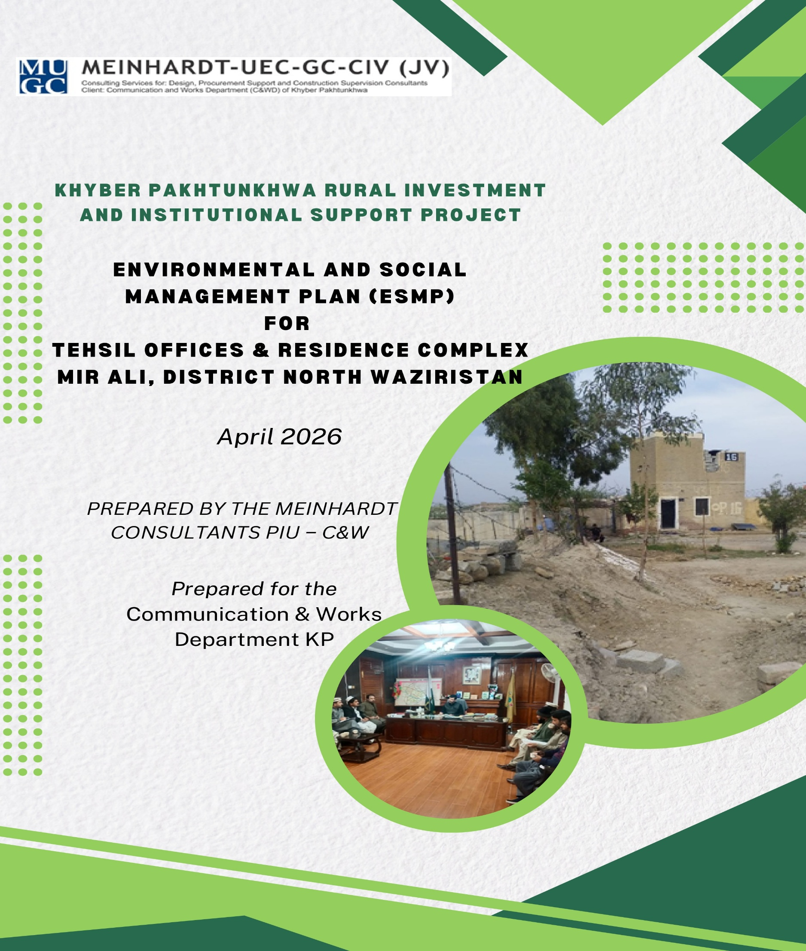
Table of Contents
Executive Summary 5
1. INTRODUCTION 6
1.1 Project Description with scope of work 6
1.2 Project Development Objective 6
1.3 Project Components 6
1.4 Area of Influence of the Subproject 7
2. LEGAL, POLICY FRAMEWORK, AND REGULATORY REQUIREMENTS 8
2.1 Applicable Environmental and Social Policies 8
2.2 National and Provincial Legal and Regulatory Framework 8
2.3 Institutional Responsibilities 8
3. ENVIRONMENTAL AND SOCIAL BASELINE 9
3.1 Environmental Baseline 9
3.2 Social Baseline 10
4. STAKEHOLDER ENGAGEMENT AND INFORMATION DISCLOSURE 12
4.1 Stakeholder Identification and Public Consultation 12
4.2 Stakeholder Analysis 13
4.3 Stakeholder Engagement Plan & Disclosure 15
5. ENVIRONMENTAL AND SOCIAL MONITORING PLAN 16
5.1 Potential Environmental and Social Impacts, Mitigation Measures, and Monitoring Plan 16
5.2 Relocation of Employees 35
5.3 Grievance Redress Mechanism (GRM) 36
5.4 Capacity Building and Training 39
5.5 Institutional Arrangements and Roles 40
5.5.1 Project Implementation Unit (PIU) 42
5.5.2 Responsibilities of the Environmental Engineer of the Supervision Consultant 42
5.5.3 Responsibilities of the Environmental Engineer of the Construction Contractor 43
5.6 Labor Camp Management 43
5.7 Occupational Health and Safety 43
5.8 GBV/SEA/SH Risk Mitigation: 43
5.9 Budget for ESMP Implementation 44
5.10 Reporting Requirements 49
5.10.1 Monitoring and Reporting Responsibilities 49
5.10.2. Types of Reports Required 49
5.10.3. Stakeholder Reporting 50
5.10.4. Emergency and Contingency Reporting 50

Annexes

Annex 1. Land Coordinates of the Proposed Site
Annex 2. Environmental and Social Screening Form
Annex 3. Maps and Architectural Diagrams
Annex 4. EPA No Objection Certificate (NOC)
Annex 5. Water Quality, Ambient Air, Noise, test reports
Annex 6. Participants’ List of Stakeholders’ Consultation
Annex 7. Photos (with captions) of the Site and the Consultations
Annex 8: Labor Camp Management Details
Annex 9: Components of Site Specific OH&S Plan
Annex 10: KPRIISP Code of Conduct
Annex 11: Sample Monitoring Checklist
Annex 12: Incident Reporting Format (ESIRT) Form

List of Acronyms

Communication & Works Department C&W Department
Construction Contractors CC
Contractor Environmental and Social Management Plan CESMP
Environmental Engineer EE
Environmental Impact Assessment EIA
Environmental Protection Agency EPA
Environmental Protection Ordinance EPO
Environmental and Social Framework ESF
Environmental and Social Management Plan ESMP
Environmental and Social Standards ESS
Federally Administered Tribal Area FATA
Frontier Regions FRs
General Environmental Assessment GEA
Government of Khyber Pakhtunkhwa GoKP
Government of Pakistan GOP
Grievance Redress Mechanism GRM
Initial Environmental Examination IEE
Khyber Pakhtunkhwa KP
KP Rural Infrastructure and Institutional Support Project KPRIISP
Newly Merged Districts NMDs
National Environmental Quality Standards NEQS
Planning & Development Department P&D Department
Pakistan Environmental Protection Act PEPA
Pakistan Environment Protection Agency Pak-EPA
Personal Protective Equipment PPEs
Project Coordination & Management Unit PCMU
Project Director PD
Project Implementation Unit PIU
Pakistani Rupees PKR
Supervision Consultants SC

Executive Summary
The Khyber Pakhtunkhwa Rural Infrastructure and Institutional Support Project (KPRIISP), funded by the World Bank, strengthens governance and service delivery in Pakistan’s historically underserved Newly Merged Districts (NMDs). It aligns with the Tribal Decade Strategy (2020–2030) to build citizen-centric institutions and uplift vulnerable groups, particularly women. The subproject, the proposed new Tehsil complex, Mir Ali, District North Waziristan, will be built on a total area of 4.38 Kanals of land within the existing Government compound to fulfill administrative offices and residential accommodation needs of the present and future staff. The complex will consist of the Tehsil administration Offices and residential apartments for the staff.
Social challenges exist in Mir Ali Town, including low female literacy, inadequate health care facilities, and limited local economic opportunities. However, on the environmental side, things seem okay, as the water is safe to drink and the air quality is reasonable in the town.

The ESMP ensures compliance with the World Bank’s Environmental and Social Framework (ESF) and the KP’s Environmental Protection Act (2014) and adopts proactive measures to mitigate risks. A stakeholder consultation, involving key Tehsil-level stakeholders, was held at the Tehsil level to evaluate the site's accessibility, safety, and sustainability. Stakeholders suggested that laborers be properly vetted, housed in designated areas, and instructed to use separate access routes to avoid unnecessary interaction with families and women visiting the compound. They also stressed the need to plant trees on the site, as it currently lacks them, to improve the area's aesthetics and environmental quality, and to establish a well-organized one-window service hub where citizens can access administrative, legal, and public welfare services without unnecessary delays. They also emphasized the importance of including a First Aid room to address minor medical needs, particularly as the compound receives significant public footfall. Continuous stakeholder consultations via community briefings and a Grievance Redress Mechanism (GRM) accessible via phone, email, or in-person (resolution within 15 days) are part of the ESMP.
The ESMP provides a structured framework for potential environmental and social risks, defining mitigation targets, assigning responsibilities, and ensuring adequate resource allocation. Key focus areas during the design/pre-construction phase include compliance with seismic and structural design standards, sustainable drainage planning, solid waste management, and detailed health and safety measures. In the construction phase, it addresses critical concerns such as air and water pollution control, noise and vibration mitigation, soil conservation, traffic management, labor safety, communicable disease prevention, and preservation of flora and fauna. It emphasizes proactive planning, continual monitoring, and strict adherence to environmental safety protocols.
A Capacity Building and Training component provides support to the effective implementation of the ESMP by enhancing the skills and environmental awareness of project personnel. This includes targeted training programs for the contractor’s workforce and client-side professionals. A well-defined institutional framework that assigns clear roles and responsibilities across project stakeholders. The primary entities responsible include the Project Implementation Unit (PIU), the Supervision Consultant’s Environmental Engineer, the Contractor’s Site Environmental Engineer, and the Khyber Pakhtunkhwa Environmental Protection Agency (EPA) as the regulatory authority. A project's reporting framework is developed to ensure transparency, accountability, and timely communication with all relevant stakeholders, particularly concerning environmental and social performance.
The total budget of the ESMP is PKR 7,667,200/-, covering mitigation measures, GRM operation, community engagement, and monitoring. This integrated approach prioritizes sustainability, social inclusion, and transparency throughout the project lifecycle.

1. INTRODUCTION

1.1 Project Description with scope of work
The Tribal Decade Strategy (2020 2030) points to the extension of administrative and service delivery systems as a critical pre-requisite for improving development outcomes for areas facing some of the highest poverty rates in Pakistan. In this context, the Government of Pakistan (GOP) and GoKP have requested World Bank financing to support the first phase of the Tribal Decade Strategy, with a strategic focus on building responsive and accountable institutions for service delivery and development in the Newly Merged Districts (NMD) and Frontier Regions (FRs). The World Bank-funded KP Rural Infrastructure and Institutional Support Project (KPRIISP) will provide complementary and foundational investments in infrastructure and institutional systems to strengthen the Government’s investments, both recurring and development, in the merged areas. The KPRIISP aims to enhance service delivery and socio-economic development in the NMD and FRs of KP, addressing long-standing disparities resulting from historical governance gaps and inadequate infrastructure. Aligned with the Tribal Decade Strategy (2020–2030), the project focuses on strengthening integrated service delivery centers at district, sub-divisional, and Tehsil levels, building local government capacity for inclusive and participatory planning, and investing in critical public services, particularly benefiting poor and vulnerable households. Spanning eight NMDs and six FRs, the project emphasizes responsive and accountable institutions, improved infrastructure, and active citizen participation, including empowering women at the grassroots level, to foster sustainable development and reduce multidimensional poverty.

1.2 Project Development Objective
The proposed new Tehsil complex site at Mir Ali, District North Waziristan, is situated approximately 1 km from the main Mir Ali Bazaar near the Mir Ali bypass road. The site is located inside the existing Tehsil Administration compound. The site coordinates and site pictures showing the existing site conditions are provided in Annexure-1 with the ESMP. The overall aim of the proposed subproject complex is to fulfill the office and residential accommodation needs of government officials and employees at the tehsil headquarters. The specific objectives are:
- To provide the office accommodation requirements for the Tehsil Administration, Tehsil Municipal Administration, and Line Departments with all required basic and allied facilities, and
ii) To meet the residential demands of Government Officers and associated staff, with allied services.

While preparing the E&S screening checklist of the subproject, placed at Annexure -2, it has been observed that the construction activities of the proposed Tehsil Complex will have some moderate level concerns/impacts, within the site and immediate surrounding areas, such as air and water pollution, noise and vibration, soil conservation, generation of construction and solid waste, traffic management, labor safety, and preservation of flora and fauna can arise. In view of this, the ESMP places a strong focus on air and water pollution control, noise and vibration mitigation, soil conservation measures, sustainable drainage planning, solid waste management, and detailed health and safety measures.

1.3 Project Components
The proposed new Tehsil complex will be built on 4.38 Kanals of land within the existing Government compound. The proposed complex has the following components:
- The new Tehsil Office building is a ground+1-story building that provides Offices with allied facilities for the Tehsil Administration staff and visiting general public, Map 4 of the Annexure-3.
- The residential facilities will include a 2-bedroom apartment building with ground +1 story, Map 12 of the Annexure-3.
In addition to constructing buildings, the subproject will improve a 100-meter internal road within the complex.
The proposed new Tehsil building will include Offices, public waiting areas (for both male and female visitors), public washrooms (for both males and females), a kitchen on each floor, and circulation areas to facilitate the movement of officials and the public.

The proposed accommodation facilities will include a 2-bedroom apartment building for Tehsil Administration staff and a house for the Official.

Open spaces are provided within the buildings, and landscaping areas are proposed in the surrounding areas and along the roads to improve air circulation and enhance the area's aesthetics. Also, proper parking facilities are proposed for each building, Maps 4,12, and 13 of Annexure-3.

The land for the proposed subproject has been in the District Government's possession for the past 25 years. Therefore, no land acquisition is required to construct the proposed tehsil Complex at the proposed site.

1.4 Area of Influence of the Subproject
The proposed subproject site’s influence area, within a range of 500 meters, includes the Army Public School at 100 meters and a mosque within the compound at 50 meters distance. A DHQ Hospital is situated at I km from the subproject site. The area of influence of the subproject is shown in Map 2 of Annexure-3.

2. LEGAL, POLICY FRAMEWORK, AND REGULATORY REQUIREMENTS

2.1 Applicable Environmental and Social Policies
The World Bank Environmental and Social Framework sets out the World Bank’s commitment to sustainable development, through a Bank Policy and a set of Environmental and Social Standards that are designed to support Borrowers’ projects, with the aim of ending extreme poverty and promoting shared prosperity. The WB’s ESF Environmental and Social Standards related to this subproject are as follows:

• Environmental and Social Standard 1: Assessment and Management of Environmental and Social Risks and Impacts;
• Environmental and Social Standard 2: Labor and Working Conditions;
• Environmental and Social Standard 3: Resource Efficiency and Pollution Prevention and Management;
• Environmental and Social Standard 4: Community Health and Safety;
• Environmental and Social Standard 10: Stakeholder Engagement and Information Disclosure.

These Standards establish objectives and requirements to avoid, minimize, reduce, and mitigate risks and impacts, and where significant residual impacts remain, to compensate for or offset such impacts.

2.2 National and Provincial Legal and Regulatory Framework
Environmental governance in Pakistan has evolved significantly since the introduction of the Environmental Protection Ordinance (EPO) of 1983, providing a legal framework for addressing pollution and environmental degradation. The EPO 1983 was improved after an extensive and prolonged consultative process with all stakeholders, and a new law, the Pakistan Environmental Protection Act (PEPA), was promulgated in December 1997. In 2000, the Pakistan Environmental Protection Agency (Review of IEE and EIA) PEPA Rules were prepared for the operationalization and application of the Act. The 18th Constitutional Amendment devolved environmental governance to the provincial level, allowing provinces to legislate and enforce their environmental laws. Under the 18th Amendment, the Provincial Government enacted the Khyber Pakhtunkhwa Environmental Protection Act of 2014 to protect, conserve, rehabilitate, and improve the environment within the province. Under section 31 of the Khyber Pakhtunkhwa Environmental Protection Act, 2014, the Government of Khyber Pakhtunkhwa makes the Khyber Pakhtunkhwa Environmental Assessment Rules 2022. The KP Environmental Assessment Rules in Section 2 provide the rules for the proposed assessment of projects. The details of the rules are as under:

4. Projects requiring an EIA or IEE, or GEA. ---Where the project falls within the categories mentioned in Schedules II, III, and IV, the proponent shall file EIA or IEE, or GEA, respectively, with the Agency.

5. 6. Preparation of guidelines for EIA, IEE and GEA. --- Guidelines for the preparation of EIA or IEE, or GEA of general and sectoral applicability may be specified by the Agency, provided that such guidelines may indicate specific assessment requirements for planning, construction, and operation of a project relating to a particular sector.
This subproject has low to moderate environmental and social risks and therefore falls in the General Environment Assessment category.

2.3 Institutional Responsibilities
While the Pak-EPA is the federal agency, each province also has its own Environmental Protection Agency (EPA), which works independently within its respective jurisdiction. Khyber Pakhtunkhwa (KP) has its EPA. The KPRIISP project operates in the NMAs, and they are now part of the KP, so the regulatory authority for the KPRIISP and its subprojects is the EPA, KP.

The subproject is committed to ensuring environmental compliance. Accordingly, General Environmental Approval (GEA) will be obtained from the EPA-KP, in line with the Environmental Protection Act, 2014, and the Environmental Assessment Rules, 2021, before initiating any construction activities under the proposed subprojects.” The relevant section of the EPA Environmental Assessment Rules, 2021, is placed at Annexure 4.

3. ENVIRONMENTAL AND SOCIAL BASELINE
Mir Ali or Mirali (Pashto: میرعلي) is a town in North Waziristan District, in Pakistan's Khyber Pakhtunkhwa province. It is a major town and tehsil headquarters in the North Waziristan District of Pakistan's Khyber Pakhtunkhwa province. It is situated in the northern part of the Waziristan region, serving as a key commercial hub between the district capital, Miranshah, and the city of Bannu. Mirali is in the Tochi Valley, about 12 kilometers east of Miranshah (capital of North Waziristan).

3.1 Environmental Baseline
The environmental baseline of Mir Ali Town includes its Biological and Environmental characteristics, potential sources of pollution, and its challenges.

Biological Environment
The biological environment of Mir Ali Town in North Waziristan District, Khyber Pakhtunkhwa, is characterized by a subtropical climate, high phytodiversity (plant life), and significant anthropogenic pressure, and the area falls within the Irano-Turanian phytogeographical region. The area is fertile, located within the Tochi Valley, and is surrounded by mountains connected to the Koh-e-Sufaid and Koh-e-Sulaiman ranges.

Flora and Fauna: Mir Ali is a semi-arid area, and the flora is dominated by herbs (57%), followed by trees (28%), shrubs (10%), and climbers (5%). The species present in the area are Shrubby Seablite (Sueada fructicosa), Pig Weed or Bathua (Chenopodium album), Phulai Kikar (Acacia modesta), White Mulberry (Morus alba), Black Mulberry (M. nigra), Long Mulberry (Morus laevigata), Sun Spurge (Euphorbia heliscopia), Indian Dill (Anethum sowa), Dhamasa (Fagonia indica), Ratanjot (Arva javanica), Aak (Calotropis procera), and Bitter Weed (Parthenium hysterophorus). The fauna in the area includes Golden Jackals (Canis aureus), Red Foxes (Vulpes vulpes), Cattle (Bos taurus), Buffalo (Bubalus bubalis), Sheep (Ovis aries), Hedgehog (Erinaceinae), Goats (Capra aegagrus hircus), Camel (Camelus), and Wildcat (Felis chaus). In reptiles, the Rat eating snake (Colubrinae), and the House gecko (Hemidactylus frenatus) are commonly found in the area.

Physical Environment
The water, air, and soil quality in Mir Ali Town are reasonably good and have no major concerns.

Topography: The town is situated at an altitude of 655 m (feet) and lies in a relatively flat, fertile valley surrounded by higher mountainous terrain. The region is flanked by offshoots of the Koh-e-Sufaid to the north and the Koh-e-Sulaiman range to the south, forming part of the mountains' western border. The area is traversed by three major rivers: the Tochi, Katu, and Kurram Rivers, which provide water for agriculture.

Climate: Mir Ali Town experiences a continental arid to semi-arid climate, characterized by hot summers, cold winters, and moderate to low rainfall. The summer season (May to September) is hot, with temperatures frequently reaching high levels. It starts in May and lasts until September. Winters (October to April) are cold, with temperatures dropping significantly. In high-altitude parts of North Waziristan, temperatures can drop below freezing.

Flood Risks: Mir Ali Town faces severe flood risks, primarily driven by flash floods and the overflowing Tuchi River. Recent flooding has caused extensive damage to agricultural lands, submerged orchards, and collapsed vital connecting bridges, severing land access and disrupting daily life for residents.

Soil Morphology: The soil in and around Mir Ali, North Waziristan, is characterized as a low-permeability, arid to semi-arid soil type, likely featuring silt loam textures. It exhibits a moisture content of roughly 12.78%, a specific gravity of 2.79%, and low permeability, with alkaline tendencies and low organic matter. The soil often requires specialized agricultural management to increase organic matter and nutrients for sustainable agricultural production.

Water Quality and Resources: Mir Ali town and Tehsil rely primarily on groundwater, such as tube wells and dug wells, supplemented by the Tochi River. Water infrastructure has historically been limited. The majority of the population relies on groundwater extracted via tube wells, hand pumps, and dug wells. The existing compound is currently served by a tube well, which isn’t government-owned and is at 800-1000 meters from the site. The water is available only for 2-3 days a week. The existing tube well utilized by the Tehsil Administration will not be sufficient to meet the water demand of the proposed new buildings. Therefore, a new tube well or any other arrangements would be required for the new buildings. The water quality results show that most of the measured physical, chemical, and biological parameter concentrations of water samples fall within the permissible limits as prescribed by Pakistan Standard & Quality Control Authority Standards (PSQCA Standards). The water quality test results are provided in Annexure 5. The data provided in Annexure 5 is from a secondary source; however, the contractor will conduct water quality tests before construction starts from an EPA, KP-registered laboratory to establish a baseline for later-stage monitoring.

In Mir Ali Tehsil, sanitation services are limited, with an open drainage system. The overall sanitation system, as well as any infrastructure, is almost non-existent in the area. At present, sewage disposal at the site is managed through septic tanks for the existing buildings; however, new arrangements would be required for the construction of new buildings. The site terrain is sloppy and would require land surfacing for the construction of the tehsil and residential building complexes. The site is naturally drained in the direction from North to South. The site is not vulnerable to flash flooding, as there is no record or history of flash flooding or flood-related issues at the site or within the existing colony.

Ambient Air and Noise Quality: The results of the air quality indicated that the PM2.5 values obtained are at the moderate level; there may be a moderate health concern for a very small number of people who are unusually sensitive to air pollution. Whereas the PM10 concentrations are observed in the area that falls within the recommended permissible limits, i.e., 150µg/m3. The quality of noise in Mir Ali and the surrounding areas is within the prescribed limits of NEQS. The test results of ambient air quality and noise levels are placed in Annexure-5. The data provided in Annexure 5 is from a secondary source; however, the contractor will conduct ambient air quality and Noise level tests before construction starts from an EPA, KP-registered laboratory, for establishing a baseline for later stage monitoring.

Geology and Soil Quality: The soil command area of Mir Ali is of piedmont plain, coarse to medium in texture, and light brown in colour. The profile depth is shallow and mostly immature soil development, gently to moderately sloping and well-drained. The pH and electrical conductivity are 8.60 and 0.21 ds/m, respectively. The soil is light-textured, i.e., sandy loam, with low organic matter and NPK. The surface soil is loam and sandy loam, while the subsurface soil is loamy sand. The limitations in the area are irregular topography, gravel, and rapid permeability.

Seismic Risks: Mir Ali Town is located in Seismic Zone 2B. This indicates a moderate to high seismic hazard, equivalent to a peak ground acceleration (PGA) of 0.16g to 0.24g, making the area vulnerable to tectonic shifts and frequent tremors originating from the nearby Hindu Kush fault lines

3.2 Social Baseline
Mir Ali is the second-largest subdivision of North Waziristan. Its socio-economic baseline is shaped by a heavily rural demographic, deep-rooted Pashtun tribal traditions, and extensive economic rehabilitation following past regional conflicts. Society is heavily conservative, adhering to the traditional Pakhtunwali code. Local governance and dispute resolution are largely overseen by the tribal Jirga (assembly of village elders). The Mir Ali social form represents very low female literacy in education, inadequate health care facilities, and limited economic opportunities at the local level, as the main reliance is on agriculture. Addressing the socio-economic challenges, particularly in education, remains crucial for sustainable development.

Population: The total population of Tehsil Mir Ali, according to the 2023 census, is 229,647 persons, including 119,081 males, 110,563 females, and 3 transgender persons, with a sex ratio of 107.70. The average population density of Mir Ali Tehsil is 379.6 /km². The annual population growth rate of Mir Ali Tehsil is 3.7%. The average household size in Mir Ali Tehsil is 6.6 persons.
Literacy Rate: According to the 2023 census, in Mir Ali Tehsil, the overall literacy rate is 38.31%, a low literacy rate among the newly merged areas. A significant gender disparity exists, with male literacy at 54.20% and female literacy at 21.17%. Females face severe barriers due to patriarchal culture, limited schools, and a lack of female teachers, leading to very low female literacy rates.
Healthcare Challenges: Healthcare facilities in Mir Ali tehsil of North Waziristan (NW) consist of a mix of government-run hospitals, specialized rehabilitation centers, and private clinics, often supported by military or specialized NGO initiatives. Tehsil Head Quarter Hospital (THQ), Mir Ali, is a major public healthcare facility in the region, serving the local population. It is sometimes supported through outsourcing to private partners (SARHAD) to improve service delivery. Mobile Health Units (MHUs), as part of broader community support, operate in the region to provide free consultation, diagnostics, and medicines to areas including Mir Ali, Shewa, and Spinwam.

Economic and livelihood: The majority of the people in Mir Ali choose farming and trade as their occupation. Many people living there are migrants. Some of them came there to uplift their standard of living, a few of them because of education and health facilities, but most of them are due to security issues. People living in Mir Ali and Miran Shah are not well-equipped with financial resources. The mineral sectors of Mir Ali and Miran Shah contain Chromite, Copper, Granite, Magnesite, and Manganese. It is also rich in oil and gas.

Linguistic Diversity: The residents of Mirali are the Dawars and the Utmanzai Wazirs. The Wazirs reside in the mountainous areas of North Waziristan, such as Spinwam, Shawa, and Khiasur, while the Dawars reside in the plains on both sides of the Tochi River. Most of the people in the Tehsil are Pushto-speaking; however, Balochi is also spoken in the area.

4. STAKEHOLDER ENGAGEMENT AND INFORMATION DISCLOSURE

4.1 Stakeholder Identification and Public Consultation

The potential stakeholders and the beneficiaries for the subproject were identified in a consultation with the respective Tehsil Administration at the inception stage, when the requirements of the Tehsil Administration were obtained for the subproject. The main beneficiaries of the subproject are the employees of Tehsil Administration, who will get better office spaces and residential accommodation from the completion of the subproject. The main stakeholders are the local Tehsil residents, who will benefit from the improved facilities of the proposed Tehsil Complex. The approach adopted for the consultation process in newly merged areas is to first consult with the relevant District /Tehsil administration to get their views and understanding of the process, and later, with their advice, hold a broad-level consultation for the subproject. This approach has been adopted in view of the prevailing vulnerable security environment and has worked well for the C&W component of KPRIIP. A consultation session was conducted on January 09, 2026, in the Tehsil Administration Office with various offices of the stakeholders and community representatives. The list of participants is in Annex 6, and photographs of the consultation and site area are in Annex-7. The objectives of the consultation were to inform stakeholders about the subproject design and its environmental and social impacts during the project implementation. Suggestions and concerns were recorded and addressed in this ESMP for compliance during the execution phase. Stakeholder consultations will be a continuous process under the subproject, and more sessions will be carried out as per the guidelines given in SEP. Consistent with the KPRIISP SEP, this subproject adopts the principles of openness, cultural appropriateness, and inclusiveness. Special attention is paid to vulnerable groups to ensure they are not disproportionately affected. In the consultation, the stakeholders provided their feedback regarding the subproject and also gave their suggestions to further improve the subproject functionality. Stakeholder feedback is presented below:

- Most stakeholders from line departments and community representatives expressed strong consensus that the selected site within the Tehsil Administration Compound is highly suitable for the establishment of the Tehsil Office and Residential Complex. Its proximity to the Main Bannu–Mir Ali–Miranshah Road (approximately 700–800 meters) and Mir Ali Bypass Road (200 meters) further enhances its accessibility for both staff and public visitors coming from surrounding areas.
- Stakeholders noted that situating the complex within an already functional administrative compound will strengthen coordination among departments and reduce travel time for the public seeking multiple services in one location.

The suggestions that the stakeholders made in the consultation and their respective responses are presented in the following table:
Table 1: Stakeholder Recommendations and the Respective Response

Serial No. | Stakeholder Recommendation | Response to the Recommendation
1. | Stakeholders suggested to include uninterrupted drinking water supply, reliable electricity with preference for solarization, adequate sanitation facilities, designated parking spaces, proper security arrangements, waiting areas, a canteen or tuck shop, and clear internal signage. The provision of these services within one compound is expected to significantly reduce the burden on citizens who currently travel long distances to access different government departments separately. | The suggested services are integrated into the proposed design of the complex.
2. | Additional facilitative measures were proposed for women and children, including separate and secure waiting areas for women, help desks managed by female staff where possible, separate washrooms, and child-friendly spaces where feasible. Clear signage, security presence, and appropriate lighting were also highlighted as critical elements to promote safety and ease of navigation within the complex. | The suggested facilities and measures are included in the proposed design of the complex.
3. | The Forest Department recommended that plantation and landscaping activities be integrated into the site development plan to improve environmental aesthetics, provide shade, and contribute to a healthier environment within the compound | The proposed complex design has a landscaping component, and financial provisions are made in the project document for suggested plantations.
4. | The participants recommended strict security screening and clearance of workers, adherence to a workers’ code of conduct, provision of proper sanitation facilities within worker camps, and effective waste management practices.  These measures were considered important to ensure that construction activities proceed smoothly without creating social disturbances or safety concerns for the surrounding administrative offices and the nearby community. | The suggested measures will be strictly followed and monitored by the PIU during the construction stage.

4.2 Stakeholder Analysis
The purpose of stakeholder analysis is to systematically identify individuals, groups, and organizations who may be affected by or have an interest in the proposed subproject activities, and to assess their interest and roles. This ensures that engagement efforts are inclusive, contextually appropriate, and effective in addressing both risks and opportunities. Stakeholders have been categorized based on their relationship to the subproject. They are the primary stakeholders: those individuals and groups directly affected, positively or negatively, by the subproject. Secondary stakeholders are those who have an interest in the project but are not directly affected. The following Table represents the identified stakeholders and their potential interest in the project.
Table 2: Stakeholders Identification and their respective Interest and roles
Serial No. | Stakeholders | Project Impact, their Interest, and role
Primary Stakeholders
 | Assistant Commissioner, Mir Ali Tehsil | Concerned about potential impacts, such as noise, dust, and disruption to area activities, due to construction.  Benefit from improved Office accommodation and facilities.
 | District Sports Officer, North Waziristan | Concerned about potential impacts, such as noise, dust, and disruption to area activities, due to construction.
 | Senior District Education Officer, North Waziristan | Concerned about potential impacts such as noise, dust, land use, water access, and disturbance in routine activities due to construction.
 | Regional Forest Officer, Mir Ali | Concerned about potential impacts such as noise, dust, land, and disturbance to area activities, due to construction.
 | Tehsil Municipal Officer, TMA Mir Ali | Concerned about potential impacts, such as noise, dust, and disruption to area activities, due to construction.  Benefit from improved Office accommodation and facilities.
 | SDO Highway, Mir Ali Tehsil | Concerned about potential impacts, such as noise, dust, and disruption to area activities, due to construction.
 | Sub Engineer Buildings, Mir Ali | Concerned about potential impacts, such as noise, dust, and disruption to area activities, due to construction.  Benefit from improved Office accommodation and facilities.
 | Sub Engineer, Mir Ali | Concerned about potential impacts, such as noise, dust, and disruption to area activities, due to construction.  Benefit from improved Office accommodation and facilities.
 | Field Assistant Agriculture, Mir Ali | Concerned about potential impacts, such as noise, dust, and disruption to area activities, due to construction.  Benefit from improved Office accommodation and facilities.
 | Supervisor Livestock, Mir Ali | Concerned about potential impacts, such as noise, dust, and disruption to area activities, due to construction.  Benefit from improved Office accommodation and facilities.
 | Supervisor, Agriculture Engineering Department, Mir Ali | Concerned about potential impacts, such as noise, dust, and disruption to area activities, due to construction.  Benefit from improved Office accommodation and facilities.
 | Line Superintendent, TESCO, Mir Ali | Concerned about potential impacts, such as noise, dust, and disruption to area activities, due to construction.
 | Steno to AC, Mir Ali | Concerned about potential impacts, such as noise, dust, and disruption to area activities, due to construction.  Benefit from improved Office accommodation and facilities.
 | Elders of the Area | Concerned about potential impacts, such as noise, dust, and disruption to area activities, due to construction.  Benefit from improved Office accommodation and facilities.
 | 8 Number of Community Members (including 2 males and 6 females) | Concerned about potential impacts, such as noise, dust, and disruption to area activities, due to construction.  Benefit from improved Office accommodation and facilities.
Secondary Stakeholders
 | Local Religious Leaders (Imams, Pesh Imams) | Hold moral authority and can influence public perception of the project.
 | Local Administrative Authorities (Tehsil Level) | Involved in need assessments, land coordination, law and order, and service delivery.
 | Environmental Protection Agency, Khyber Pakhtunkhwa (EPA-KP) | Regulatory authority responsible for ensuring environmental compliance and reviewing ESMP documentation.
 | Contractor (s) and Construction Workers | Involved in implementation, it requires clear orientation on social and environmental safeguards.
 | Media and Information Channels (Local Radio Channels) | Important for public disclosure, awareness-raising, and helping to spread accurate information.

4.3 Stakeholder Engagement Plan & Disclosure
This Stakeholder Engagement and Disclosure Plan outlines how stakeholders will be involved and informed during the construction phase of the project under the ESMP in Mir Ali, District North Waziristan. Its purpose is to ensure continuous two-way communication, enhance social accountability, reduce conflicts, and foster community support through timely and culturally appropriate engagement. Consultations with women will be held in "private spaces" or "gender-neutral spaces" by female staff (as noted in SEP Section 2.3). Communication materials will use images/infographics for those with low literacy (as per SEP Section 6.3).
Table 3: Engagement Activities and Methods (During Construction)
Activity | Target Stakeholders | Frequency | Communication Method | Responsibility
Community Briefings | Residents (male & female), tribal elders, local community-based organizations | Monthly | Public meetings, mosque announcements, and community centers | Contractor’s social staff, Supervision Consultant Social Staff
Information Disclosure | General public | Quarterly | Posters, noticeboards, Urdu & Pashto pamphlets. Disclosure on C&W/P&D Websites, Announcements via local Mosques (for construction timing/safety), Social Media updates | Communication Officer, PIU C&W
Focused Group Discussions (FGDs) | Local Residents | Bi-monthly | Small group meetings, female outreach through the Gender staff | Social and Gender Staff
Grievance Redress Mechanism (GRM) Activation | All stakeholders | Weekly | Complaint boxes, hotline, in-person reporting, and all intake measures as these become available | Grievance Officer
On-site Signage & Safety Notices | Public, labor, and daily commuters to the complex. | Weekly | Visual safety signs, barriers, and flagmen | Contractor HSE team
Coordination Meetings | District administration, EPA-KP | Quarterly | Formal briefings, email reports, and written updates | PIU

5. ENVIRONMENTAL AND SOCIAL MONITORING PLAN

5.1 Potential Environmental and Social Impacts, Mitigation Measures, and Monitoring Plan
The Environmental and Social Management Plan (ESMP) provides a site-specific plan with mitigating measures and environmental management and monitoring during the construction and operation phases of the proposed subproject. The proper implementation of the ESMP will ensure that any adverse environmental impacts are adequately mitigated, prevented, or minimized to an acceptable level, and that the actions required to achieve the above-stated objectives are successfully undertaken by the relevant institutions or regulatory agencies. The implementation of ESMP will be carefully coordinated with the design, construction, and operation programs of the project to ensure that relevant mitigation measures are implemented at the appropriate stage and adequate resources are properly allocated to achieve the desired results.

Table 4, below, provides the Environmental Management Plan. The proposed schedule for the ESMP is 3 years, comprising the first 3 months for the pre-construction phase for contractor mobilization and carrying out the required initial stage preparation. The 2 years and 3 months will be for the construction phase to complete the construction of buildings. The last 3 months are for the post-construction phase, during which the built complexes are handed over to the respective administrations. However, the ESMP schedule is contingent upon the subproject’s approval from the relevant Government forums and initiation. The actual timeline will be defined once those formalities are completed. The plan outlines impacts, targets, mitigations, and the responsible authorities for the implementation of the mitigation measures during design, construction, and operational phases.

Table 4: Environmental Management Plan

Sr. No. | Parameters | Target | Mitigation | Status of  Activity | Implementation Responsibility
 | Design/pre-construction Phase
1 | Design & Layout Planning | Intended to fulfil all the desired needs of the Tehsil Administration, enhance the complex’s aesthetic, and focus on the functional aspects of the proposed complex. | - All structural, layout, and engineering designs of the Tehsil complex must comply fully with applicable laws, engineering standards, and prescribed technical parameters. | Completed. | PIU, C&W
2 | Drainage | To prevent standing water, flooding, and water ponding in and around the buildings and circulation areas. | - Provision of appropriate drainage facilities and structures shall be provided in the building complex; and  - Proper slopes shall be incorporated in the design feature to avoid the formation of a water layer or standing water on roads and adjoining areas in rainy seasons. | Completed. | PIU, C&W
4 | Seismic Hazard | To minimize structural damage | - The proposed building and structures will be designed and constructed to withstand low to moderate earthquakes. | Completed. | PIU, C&W
5 | Traffic Management | To minimize traffic problems in the project area | - Once the contractor is mobilized, in the first three months of the project time, he/she will prepare a comprehensive Traffic Management Plan and disclose it before construction begins, ensuring measures are in place to prevent traffic congestion and safeguard community convenience. Vehicle movements for transporting construction materials shall be strategically timed to minimize traffic impacts and avoid inconvenience to residents;  - Plan the timing for the movement of vehicles carrying construction materials to reduce traffic load and avoid inconvenience to the residents; | To be prepared. | The contractor to provide a plan; PIU, C&W to ensure its proper implementation and monitor.
6 | Health and Safety | To minimize health risks | - The contractor will prepare a detailed health and safety plan with all necessary and required mitigation measures that will minimize health risks to the surrounding community and the labor involved in construction. The proposed plan will be submitted to the PIU and will be made public before the construction activity begins; and  - An emergency response plan will be formulated by the contractor that emphasizes a line of action for rescue, medical emergencies, natural disasters, and firefighting operations at the construction site and will be submitted to PIU before the construction activity begins. | To be prepared. | Contractor to provide a plan, PIU, C&W to ensure its proper implementation and monitor.
7 | Solid Waste Management | To manage (i.e., collect and dispose) the solid waste safely at appropriate designated sites. | The contractor will prepare a comprehensive solid waste management plan incorporating technical design features for refuse collection from the camp site and construction site, and its safe disposal to the existing municipal solid waste dumping site at Dolai, to ensure it does not burn at the site; and  - The contractor will devise plan(s) for safe handling, storage, and disposal of harmful waste and materials. | To be prepared. | Contractor to provide a plan; PIU, C&W to ensure its proper implementation and monitor.
 | Construction Phase
1 | Noise and Vibration | To minimize noise pollution and to fulfill the Regulatory Compliance under the NEQs. | - Selection of up-to-date and well-maintained plants or equipment with reduced noise levels ensured by suitable in-built damping techniques or appropriate muffling devices;  - Measures like not using noise-producing machinery and equipment during school, and two compulsory prayer timings. In addition, all loading and unloading of construction material will not be allowed during school timings and two compulsory prayers, so as not to disturb the education process and prayer in the mosque.  - Confining excessively noisy work to normal working hours in the day, as far as possible;  - Restricting construction vehicles' movement during nighttime;  - Avoid the use of heavy drill machines to avoid the vibration effect on the surrounding buildings;  - Vehicles and equipment used should be fitted, as applicable, with silencers and properly maintained;  - Use of low noise machinery, or machinery with noise shielding and absorption;  - Contractor should comply with the submitted work schedule, keeping noisy operations away from sensitive points; implement regular maintenance and repairs; and employ strict implementation of operation procedures; and  - Providing the construction workers with suitable hearing protection, like ear caps or earmuffs, and training them in their use. | To be carried out. | Contractor Environmental Engineer(CEE), and Supervision Consultant (SC) to monitor.
2 | Soil Erosion | To minimize soil erosion and contamination. | - All kinds of oil spills from construction machinery on the ground shall be scrubbed until the clear surface of soil, and the removed clay shall be safely disposed of as desired, and the site will be restored to its original condition;  - Unnecessary excavations should be avoided;  - Septic tanks connected to soakage pits of adequate capacities will be constructed for receiving and treating wastewater from all temporary worksite toilets and at the temporary container offices, if any;  - The toilet wastewater should not be discharged untreated onto the adjacent lands/sewers/disposal station; and  - Washouts from washing equipment and gadgets will be drained into either a septic tank or a sand-gravel bed for removal of the grit and contaminants. | To be carried out. | CEE and Supervision Consultant (SC) to monitor.
3 | Air Pollution | To minimize air pollution and fulfill the Regulatory Compliance under the NEQs | - All sites where excavation work will be carried out will be regularly sprinkled with water to control dust;  - The excavated material shall be covered and shall not be stored for long intervals;  - Preventive measures like batching and mixing operations shall be performed in enclosed or controlled areas, installing screens around the mixing and unloading operation areas at the site, and no “Overloading" shall be enforced to prevent spillage of fine materials during transport operations;  - All vehicles, machinery, equipment, and generators deployed during construction shall be maintained in sound working conditions, regularly serviced (as prescribed by the manufacturer), and properly tuned to minimize exhaust emissions and ensure compliance with applicable environmental standards ;  - All vehicles, machinery, and equipment used for the construction shall be plugged off or switched off immediately after completion of their work to avoid idling conditions;  - Emissions from power generators and construction machinery are important sources at the construction sites. The filter shall be installed at the point sources of air emissions and shall be replaced regularly as prescribed by the manufacturer. Proper maintenance and repairs of the equipment are needed to minimize hazardous emissions;  - Open burning of solid waste from the Contractor’s camps should be strictly banned;  - Construction workers should be provided with masks for protection against the inhalation of dust; and  - PEQS applicable to gaseous emissions generated by construction vehicles, equipment, and machinery should be enforced during construction works. | To be carried out. | CEE and Supervision Consultant (SC) to monitor.
4 | Water Quality and Availability. | To protect the ground and surface water resources from any pollution due to the construction of the subproject and fulfill the Regulatory Compliance under the NEQs. | - Protection of surface and groundwater reserves from any contamination sources, such as construction and oily waste that could degrade their potable quality;  - Wastewater effluent from the contractor’s workshop and equipment washing yards should be passed through gravel/ sand beds to remove oil/ grease contaminants before discharging to the final disposal point;  - Water required for construction is obtained in such a way that the water availability and supply to nearby communities remain unaffected;  - For construction purposes, water shall be drawn from surface water bodies on priority and as available;  - Regular water quality monitoring according to a determined sampling schedule provided in Table 6, below;  - The contractor shall ensure that construction debris does not find their way into the drainage network, which may get clogged;  - maintain natural drainage paths;  - Contractor and his/her staff will prohibit the flow from washing machinery and vehicles in surface waters, provide sealed washing basins, and collect wastewater in a sedimentation/retention pond;  - Waste must not be disposed of into any surface water body. | To be carried out. | CEE and Supervision Consultant (SC) to monitor.
5 | Solid, Construction Waste, and Hazardous Waste | To minimize the solid, construction, and hazardous waste | - Schedule training and awareness sessions for the workforce before the start of the construction work on the proper storage and handling of materials and chemicals that may pose a risk of soil contamination;  - A comprehensive waste management plan shall be prepared by the contractor and implemented. All the solid waste generated during construction and from camp sites shall be safely managed and disposed of at the existing municipal solid waste site situated at Tori Mir Ali Wazair area;  - Burning waste will be prohibited;  - The hazardous waste shall be stored in closed containers, with proper labelling of containers, including the identification and quantity of the contents, hazard contact information. It will be safely disposed of in an EPA-registered hazardous waste facility within the province, etc;  - Training employees involved in the transportation of hazardous material regarding emergency procedures;  - The solid waste will be disposed of in the existing municipal solid waste dumping site at Dolai to protect the underground water from contamination;  - The sewage system for the campsite will be properly designed (pit latrines or, as required, septic tanks) to receive all sanitary wastewaters;  - Lined wash areas will be constructed at the site for the receipt of wash waters from construction machinery;  - All the stored hazardous materials shall be securely covered to prevent any possible leakage during heavy rainfall;  - Locating stockpiles of material at such places to minimize potential visual impact; and  - Minimizing the land intake of stockpile areas as far as possible. | To be done. | CEE, and Supervision Consultant (SC) and PIU to monitor.
7 | Health and safety of workers and associated communities | To reduce the health and safety risks to construction workers and the nearby communities  arising from general construction activities, with particular emphasis on hazards related to demolition works, working at heights, fire and explosion, slips, trips and falls, electro-mechanical hazards, exposure to hazardous materials and biological agents, and risks associated with unstable foundations. | - Obligatory insurance against accidents for laborers/workers shall be ensured;  - Basic medical training shall be imparted to specified work staff, and basic medical service and supplies to workers (first aid medical supplies and medicine, ambulance service) shall be made available at the site;  - Layout plan for campsite, indicating safety measures taken by the contractor, e.g., firefighting equipment, safe storage of hazardous material, first aid, security, fencing, and contingency measures in case of accidents;  - Work safety measures and good workmanship practices are to be followed by the contractor to ensure no health risks for laborers;  - Protection devices (ear muffs) should be provided to the workers doing a job in the vicinity of high noise-generating machines;  - Provision of protective clothing for laborers handling hazardous materials, e.g., a helmet, adequate footwear, protective goggles, and gloves, etc;  - Ensure strict use of protective clothing and other necessary equipment during work activities;  - Emergency number shall be placed at worksites;  - Develop a contingency plan in case of major accidents such as fires, explosions, chemical spills, structural failures, or natural disasters;  - Providing the necessary means for emergency response on call 24 hours/day, like trained medical staff, First-aid and medical kits, Firefighting equipment (extinguishers, breathing apparatus, ambulance service etc;  - The construction supervisor must ensure that only authorized workers shall be allowed inside the construction site boundary, and that all non-workers — including visitors, passersby, and especially children — are strictly prohibited from entering. The contractor shall develop a procedure/protocol to be followed by all official visitors at the specific site. The PIU, C&W shall approve the said procedure/protocol;  - There should be proper control on construction activities, and the oil spillage and leakage from vehicles could be controlled on site by conducting routine inspections of the engine, transmission, and hydraulic systems, checking and replacing worn-out seals, gaskets, hoses, and filters, and monitoring oil levels frequently to detect abnormal loss;  - Efforts will be made to create awareness about road safety among the drivers operating construction vehicles;  - Workers who shall be reported as ill or exhibit possible symptoms shall be restricted from entering the work site. They shall be promptly isolated and referred to local medical facilities for immediate care;  - The communicable disease of most concern during the construction phase, like sexually-transmitted diseases (STDs) such as HIV/AIDS, should be prevented by successful initiatives typically involving health awareness, education initiatives, training of workers in disease treatment, immunization programs, regular medical checkups of labor and staff, and providing health services;  - Reducing the impacts of vector-borne diseases on long-term health effects of workers should be accomplished through the implementation of diverse interventions aimed at eliminating the factors that lead to disease, which include prevention of larval and adult propagation of vectors through sanitary improvements and elimination of breeding habitat close to human settlements, and by eliminating any unusable impounding of water;  - A supply of safe drinking water will be made available and maintained at the project site(s);  - Chlorinated disinfecting spraying must be conducted at the work site(s); and  - Proper hygiene practices in the toilets and washrooms will be implemented with proper and adequate use of soaps and disinfectant spray; and  In addition to the above general protective measures for the laborer and adjoining community, the contractor and his/her supervisory staff will provide and ensure the specific protective measures, such as:  - Provide training and awareness to the concerned staff on handling, storage, and safety of gas cylinders;  - Guardrails, certified scaffolding, safety nets, harnesses, and permit-to-work system;  - Fire prevention plan, controlled storage of flammables, hot-work permits, provision and location of firefighting equipment;  - Good housekeeping, clear walkways, adequate lighting, and spill control. | To be done. | CEE, SC and PIU to monitor.
8 | Labor Camp | To minimize loss of assets and vegetation due to labor movements, to prevent environmental degradation from construction camps, and to ensure the camp's presence does not cause any concerns for the nearby community. | - All the workers staying in the camp will be issued ID cards for security purposes;  - Provision of all required medical health facilities (first aid boxes, reasonable stock of commonly used medicines) in the camp for emergency health services;  - The camps will be properly fenced and gated to prevent the entry of outsiders into the camp;  - Entry for the local community/any unauthorized persons at the campsite will be prohibited;  - Preparation of Waste Management Plan addressing the classification, storage, and disposal of all solid wastes and the training of employees for handling the hazardous materials;  - Training will be provided to all staff members and laborers on camp management rules and overall discipline, and cultural awareness; and  - The contractor will submit a labor camp management plan. | To be Established. | Contractor and PIU to monitor.
9 | Flora and fauna | To protect, conserve, and minimize the impact on flora and fauna | - At the proposed site of the complex, no tree species is present.  - All efforts will be made to protect and conserve the existing trees and shrubs in the surroundings of the proposed site;  - The contractor will provide gas cylinders at the camps for cooking purposes, and cutting of trees/bushes for fuel will not be allowed;  - Hunting and poaching of animals in the surroundings of the proposed subproject site will be strictly prohibited, and the Contractor will warn their labor accordingly;  - The labor camp will be properly fenced and gated to prevent the entry of animals in search of edible goods;  - Waste from the camp and offices will be properly disposed of to prevent the chances of being eaten by animals, which may become hazardous to them;  - Special measures will be adopted to minimize impacts on the birds, such as avoiding noise-generating activities during critical periods of breeding; and  - Staff working on the project should be given clear orders not to shoot, snare, or trap any bird in the surroundings of the proposed site. | To be carried out once the construction activities are completed. | CEE, Supervision Consultant (SC), and PIU to monitor.
10 | Traffic Management | To minimize traffic problems in the project area | - A proper traffic management plan will be prepared in consultation with the PIU staff and implemented to avoid traffic jams/public inconvenience;  - Keeping in view the very close proximity of a mosque, within the compound, and the presence of a school near the construction site, the traffic management plan must include special protective measures to ensure not disturbing the education process, ensuring the safety of students, teachers, and the residents going to pray. These measures will ensure the safety of students and residents going for prayer (like installing signage warning against trespassing into the mosque and school, enforcing low speed limits, using reflective signs for visibility etc).  - Movement of vehicles carrying construction materials should be restricted during the daytime to reduce traffic load and inconvenience to the residents;  - The contractor shall ensure timely and accessible public notification regarding all planned road improvement activities. Notifications shall include the nature of works, expected start and end dates, potential traffic or access disruptions, and available detour routes. Information must be disseminated through appropriate channels—such as local notice boards and community meetings to allow the public to prepare and minimize inconvenience;  - The contractor shall install and maintain appropriate safety and diversion signage at all construction and road improvement areas, with special emphasis on sensitive locations and accident-prone sections of the road. Signage must be clearly visible, compliant with applicable traffic safety standards, and placed at a sufficient distance to adequately warn and guide road users, ensuring safe navigation around the construction zone and road improvement spots;  - Setting up speed limits in close consultation with the local stakeholders; and  - The PIU and the Tehsil Administration must maintain liaison between the residents/visitors, travelers, and the contractor to facilitate traffic movement during the construction stage. | To be prepared before the construction begins. | Contractor Traffic Engineer, SC, and PIU to monitor.
11 | Communicable diseases | To minimize the spread of Communicable diseases | - A communicable disease prevention program will be prepared by the contractor for construction workers or residents near the construction sites and made public before the construction work starts;  - Reporting employees and laborers showing symptoms such as fever or high body temperature, coughing, difficulty breathing, or chest pain, and sending them to a clinic or the nearest hospital immediately;  - Awareness and implementation of the Quarantine Procedure for all employees who have come back from vacation;  - Ensure Disinfection of offices, work areas, and machinery periodically; and  - Provision of face masks, instruction boards, and signage at different locations for health hazards awareness. | To be prepared before the construction begins. | Contractor H&S person.
 | Operational Phase
1 | Natural Hazard | To minimize the risk of structural collapse and flooding in the Tehsil complex | - A technical committee will be formed by the Tehsil Administration, which will carry out detailed scrutiny inspection of all the Engineering drawings of the buildings to ensure that the foundation and the structure are strong enough to withstand normal conditions of earthquake impacts;  - Inspections should be conducted at three-month or six-month intervals, by qualified personnel to ensure the integrity of structures; and  - The PIU will develop an emergency response plan for rainwater flooding in the sup project site. | To be carried out on completion of construction. | Tehsil Administration, PIU
2 | Waste | To minimize and store the solid waste | - An appropriate waste management system shall be in place during the operational phase. It will integrate technical measures (segregation, treatment, disposal), administrative controls (planning, monitoring, compliance), and community engagement (awareness, collaboration) to ensure sustainability and regulatory alignment. | To be prepared. | PIU
3 | Drainage | To prevent flooding and pooling of water in the complex, blockage of drains, water accumulation on access roads and building surroundings, and Seepage into basements. | - Routine inspection and maintenance of the drainage system, to make sure that the drains are not blocked due to solid waste, shall be scheduled and implemented. | To be carried out. | PIU
4 | Flora | To maintain flora in the district complex | - Routine monthly inspection will be carried out to check the maintenance of the Tehsil complex;  - Weeds will be monitored weekly and removed no less than every two weeks;  - The use of fertilizers in open spaces shall be strictly monitored to prevent incidents such as direct human contact or ingestion by birds; and  - Natural nutrients should be preferred. | To be carried out. | PIU

Environmental Monitoring is undertaken during both the construction and operational phases to ensure the effectiveness of the proposed mitigation measures. Certain environmental parameters are selected, and quantitative & qualitative analyses will be carried out by the contractor from an EPA, KP’s registered laboratory. The results of the analysis will be compared with the guidelines, standards, and pre-project conditions (baseline results) to determine whether the EMP and its implementation are effective in mitigating impacts.

Parameters to be analyzed during pre-construction, construction & operation of the project, responsibilities for monitoring have been discussed and provided in Tables 5 to 7 below:
Table 5: ‘Pre-Construction’ Monitoring Plan for Baseline Development
Parameter to be measured | Objective of Monitoring | Parameters to be Monitored | Measurements | Location* | Frequency | Responsibility
Ambient Air Quality | To establish a baseline for air quality levels | CO, NO₂, SO₂, O_{3,} PM _{2.5,} & PM₁₀ (particulate matter smaller than 10 microns) concentration at the receptor level | 1-hr and 24-hr concentration levels | At three random receptor locations in the project area | Once | Contractor Environmental Engineer (CEE)
Ambient Noise | To establish a baseline for noise levels | Ambient noise level near the receptors in the project area | A-weighted noise levels –24 hours, readings taken at 15s intervals over 15 min. every hour, and then averaged | At three random receptor locations in the project area | Once | CEE
Groundwater Quality | To establish the groundwater quality in the project area | Groundwater quality in the project area | Water samples for comparison against NEQS parameters | At two locations around the site in the project area | Once | CEE
Surface water quality | To establish surface quality in the project area | Surface water quality in the project area | Water samples for comparison against NEQS parameters | At two locations around the site in the project area | Once | CEE
* Monitoring Locations to be finalized jointly between PIU Safeguards staff and the Supervision Consultant (SC).

Table 6: Construction Phase Monitoring Requirements
Project Activity and Potential Impact | Objective of Monitoring | Parameters to be Monitored | Measurements | Location | Frequency | Responsibility
Noise  Disturbance due to noise from construction activity | To determine the effectiveness of noise abatement measures on sound pressure levels | Ambient noise level at different locations in the project area | A-weighted noise levels – 24 hours, readings taken at 15 s intervals over 15 min. every hour at 15 m from the receptors, and then averaged | At five random receptor locations in the project area | Quarterly basis on a typical working day | Contractor’s Environmental Officer, Supervision Consultant (SC)
Air Quality  Dust emissions from construction vehicles and equipment | To determine the effectiveness of the dust control program on dust at the receptor level | CO, NO2, SO2, O3, PM 2.5 & PM10 (particulate matter smaller than 10 microns) concentration at the receptor level | 1-hr and 24-hr concentration levels | At five random receptor locations in the project area | Quarterly basis on a typical working day | Contractor’s Environmental Officer, SC
 |  | Visible dust | Visual observation of the size of dust clouds, their dispersion, and the direction of dispersion  Water sprinkling to settle down the dust. | Construction site  At the location of the digging Area | Once daily during the peak construction period  As and when the dust appears at the construction site | Contractor’s Environmental Officer, SC
Groundwater Quality | To establish the groundwater quality in the project area | Groundwater quality in the project area | Water samples for comparison against NEQS parameters | At five locations around the site in the project area | Quarterly | CEE and SC
Safety precautions by workers | To prevent accidents for workers and the general public | The number of near-miss events and accidents taking place | Visual inspections | Construction site | Once Daily | CEE and SC
Soil Contamination | To prevent contamination of soil from oil and toxic chemical spills and leakages | Incidents of oil and toxic chemical spills | Visual inspections and conducting soil analysis | At construction sites and vehicle and machinery refuelling & maintenance areas | Once a month | CEE and SC
Solid Waste & Effluent Disposal  Insufficient procedures for waste collection, storage, transportation, and disposal | To check the availability of the waste management system and its implementation | Inspection of solid and liquid effluent generation, collection, segregation, storage, recycling, and disposal will be undertaken at all work sites in the project area | Visual inspections | At work sites in the project area | Once daily. | CEE and SC
* Monitoring Locations to be finalized jointly between PIU Safeguards staff and the Supervision Consultant (SC).
Table 7: Operation Phase’s Environmental Monitoring Plan
Parameter to be measured | Objective of Monitoring | Parameters to be Monitored | Measurements | Location | Frequency | Responsibility
Solid Waste Management | To assess whether solid waste generated from the District complex is managed as per EMP requirements | All waste being generated is being managed and disposed of as per international good practices | Solid waste inventory audit | District Complex premises | Bi-Annual | PIU, District Administration
Drainage System Functionality | Ensure efficient drainage and prevent waterlogging or flooding | Condition and functionality of drainage channels and stormwater system | Presence of blockages, sediment accumulation, standing water, drainage flow, maintenance records | Drainage network, culverts, and discharge points | Quarterly and after heavy rainfall | Facility Management/Building Administration
Water Supply Quality and Availability | Ensure continuous availability of safe water for building users | Water quality and adequacy of water supply | Water quality test results (where applicable), supply interruptions, storage tank condition, water pressure | Water supply system, storage tanks, and distribution points | Quarterly (quality) and Monthly (availability) | Facility Management; Public Health Engineering Department (where applicable)
Grievance Redress Mechanism (GRM) Functionality | Ensure grievances are received, recorded, and resolved effectively | Number of grievances received, resolved, pending, and resolution time; functionality of GBV/SEA/SH-sensitive intake channels | GRM register, response time, complainant satisfaction, confidentiality maintained | Facility Administration Office | Quarterly | Facility Management/GRM Focal Person; PIU E&S Team
Occupational Health and Safety (OHS) of Maintenance Workers | Ensure safe working conditions for maintenance personnel | PPE usage, safe work practices, accident reporting, training records | Number of incidents/near misses, PPE compliance, training conducted, maintenance of safety equipment | Entire facility, maintenance workshops, plant rooms, and work areas | Quarterly | Facility Management; OHS Officer

5.2 Relocation of Employees
The Tehsil Complex, Mir Ali, District North Waziristan, will be constructed on vacant land, and therefore, no temporary or permanent physical relocation or displacement of the Government’s employees will take place.

5.3 Grievance Redress Mechanism (GRM)
The Grievance Redress Mechanism (GRM) is an institutional arrangement which provides the project’s stakeholders with an opportunity and a structured mechanism to submit their concerns. The grievance redress mechanism will focus on the following steps/points during the implementation process:
- Record grievances, both written and oral, categorizing and prioritizing them, and providing solutions within an agreed-upon timeframe;
- Reporting to the aggrieved parties about the resolutions regarding their grievances and the decision;
- Dissemination of various reporting channels such as complaint boxes, complaint register, PIU phone numbers, online complaint registration, and proformas for complaints.
- All information about grievance procedures, grievance forms, and responses will be available in languages readily understandable to the locals.
- During GRM orientation, inform labor and associated staff about alternative reporting channels, including the GRM register, telephone numbers, and online portals, in addition to the GRM boxes.
- All complaints received will be treated with confidentiality.

Confidential SEA/SH Grievance Handling Mechanism

• A separate intake channel will be established for GBV/SEA/SH complaints.
• A female focal point will be designated to handle SEA/SH-related grievances.
• Confidential reporting options will be available, including sealed envelopes, a dedicated phone line, and reporting through female staff.
• All SEA/SH cases will be immediately referred to GBV service providers.
• A survivor-centered approach will be followed at all stages of case management.
• A written complaint will not be required for reporting SEA/SH incidents.
• No details of SEA/SH cases will be shared with the general GRC mechanism.
Prior to the commencement of any civil works at the project site, the Grievance Redress Mechanism (GRM), including a GBV/SEA/SH-sensitive grievance intake channel, shall be fully operational and its procedures and contact details shall be effectively communicated to all affected communities through appropriate awareness and information dissemination measures.

All grievance records shall be maintained in a secure manner with access restricted to authorized personnel only. Personal information shall be collected solely for grievance management purposes and shall not be disclosed without consent except where required by law. Sensitive complaints, including SEA/SH cases, shall be stored separately in restricted-access files and managed in accordance with survivor-centered principles and applicable data protection requirements.

The Grievance Redress Mechanism (GRM) is an effective tool for early identification, assessment, and resolution of concerns, complaints, and suggestions. A key emphasis will be to quickly respond to all highlighted and reported concerns or grievances, as per the KPRIISP GRM Manual.

SEA/SH Referral Pathway

In cases involving GBV/SEA/SH, a survivor-centered referral pathway shall be followed in accordance with the KP-RIISP Survivor-Centered SOPs (July 31, 2025). Upon receipt of a complaint, the case will be handled confidentially and immediately referred (within 24–48 hours) to the designated GBV focal person at the PIU and PCMU levels.
The response shall follow a structured approach prioritizing the survivor’s safety, dignity, and informed consent, including:

- Immediate Safety and Medical Assistance:
The priority shall be to ensure the survivor’s safety and facilitate access to medical care through nearby public health facilities (e.g., DHQ/THQ hospitals), where required.
- Confidential Case Handling and Reporting:
Cases shall be documented in a secure and anonymized manner and reported only to authorized GBV focal persons, ensuring strict confidentiality and adherence to “do no harm” principles.
- Referral to Accredited Service Providers:
With the survivor’s informed consent, referrals shall be made to appropriate services, including:
  - Health services: Survivors will be referred to nearby public health facilities such as District Headquarters (DHQ) Hospitals, Tehsil Headquarters (THQ) Hospitals, or Basic Health Units (BHUs) for medical care, emergency treatment, and medico-legal support where required.
  - Psychosocial support: Counseling and emotional support services will be facilitated through relevant government and partner organizations, including the Khyber Pakhtunkhwa Social Welfare Department, community-based organizations, and available protection service providers.
  - Legal assistance: Where the survivor opts to pursue legal action, referrals will be made to appropriate legal aid channels, including the Khyber Pakhtunkhwa Police, District Legal Empowerment Committees, and other relevant legal support institutions.
  - Protection and shelter services: Safe shelter and protection support will be facilitated through government-run facilities such as Dar-ul-Aman or other safe spaces managed by the Social Welfare Department.
- Helplines and Institutional Support:
Survivors may also access support through available government systems, including Social Welfare Department services and national/provincial helplines.
- Follow-up and Case Closure:
Follow-up shall be conducted (with consent) within 24–72 hours and subsequently as needed to ensure the survivor’s well-being. Case closure shall only occur when the survivor confirms that no further support is required.

All actions shall be based strictly on the survivor’s informed consent. Survivors shall not be required to file a formal grievance to access services, and no identifying information shall be recorded in general GRM logs.

Grievance Registration and Resolution Process
Submission: Complainants can lodge grievances through:
  - Focal Person: Deputy Director (Environment & Social), PIU C&W KP-RIISP
  - Phone: +92 91 9224272
  - Email: usmanshinwari179@gmail.com
  - Website: https://www.cwd.gkp.pk/projects/KP-RIISP
  - In person/letter: House No. 8-BC, Park Road, University Town, Peshawar, Khyber Pakhtunkhwa
  - Complaint Box/Registers at site offices

Recording and Categorization: All grievances (oral or written) will be registered, categorized (urgent/regular), and logged in a centralized GRM database.
Investigation and Resolution:
The Deputy Director (E&S) will coordinate with C&W PIU staff or field officers to investigate the issue. The resolution will be shared with the complainant within the agreed timeframe.

To ensure timely and transparent handling of grievances, the following resolution timelines shall apply:

- Acknowledgment: All grievances will be acknowledged within 3working days of receipt.
- Tier 1 – Initial Review (PIU Level): Regular grievances will be investigated and resolved within maximum 23 working days of registration.
- Complex / High-Risk Cases: Grievances categorized as urgent, sensitive, or complex may require extended review and with additional time and complainant shell be inform accordingly
- Tier 2 – Escalation to PCMU: If escalated, the PCMU shall provide a final decision within 30 working days of receiving the appeal.
- SEA/SH Complaints: Cases involving GBV/SEA/SH will be referred immediately (within 24hours) to the designated focal person and handled confidentially in accordance with the Project’s GBV Mitigation Action Plan, following a survivor-centered approach. Such cases will not be recorded in public logs.

Follow-up and Feedback:
The complainant will be informed in writing (or preferred method) of the decision/resolution and any follow-up actions.

Appeal and Escalation Mechanism:
If not satisfied, complainants may escalate the issue to:
  - Project Coordination & Management Unit (PCMU), P&D Department
    - Focal Person: Senior Social Development Specialist
    - Phone: 091-9213022
    - Email: ssds@kp-riisp.gov.pk
    - Address: Civil Secretariat, Peshawar, KP
SEA/SH complaints:
• SEA/SH complaints will not be entered into the general complaint register.
• All SEA/SH cases will be recorded in a restricted-access confidential log.
• The identity of the survivor will not be disclosed under any circumstances.
• SEA/SH complaints will not be discussed in general Grievance Redressal Committee (GRC) meetings.
• Such cases will be managed only by a designated gender or GBV focal person.

Grievance Redress Committee (GRC)
To support timely grievance handling, a Grievance Redress Committee (GRC) will be formed at the PIU level. The GRC will meet regularly (or as needed) to address escalated or complex grievances.

Composition of GRC (PIU C&W):
Designation/Organization | Position in PIU GRC
PD PIU C&W | Head/convener of GRC
DD E&S PIU C&W | Secretary of GRC
DD Procurement Specialist PIU C&W | Member
Tehsil/District Focal Person | Member
Contractor | Member
Community Representative(s) | Member
Environment/Social/Gender Specialist, Meinhardt Consultant, PIU C&W | Observer
Co-opted/Invited member(s)  E.g. complainant, lawyer, relevant govt. Official, etc | Member/Observer

SEA/SH Focal Point Arrangements

SEA/SH complaints shall not be reviewed, investigated, or adjudicated by the Grievance Redress Committee (GRC). In accordance with the Project's Survivor-Centered SOPs and the World Bank's survivor-centered principles, all SEA/SH allegations shall be handled confidentially by designated trained SEA/SH/GBV focal persons.

The designated SEA/SH focal persons shall be responsible for:
- Receiving SEA/SH allegations through confidential reporting channels;
- Ensuring the survivor's informed consent before any referral or action is taken;
- Facilitating timely referral to appropriate medical, psychosocial, legal, protection, and security services;
- Maintaining confidentiality and secure record-keeping with restricted access;
- Coordinating with relevant PIU and PCMU focal persons to support implementation of prevention and response measures; and
- Monitoring implementation of preventive measures while ensuring that no personally identifiable information is disclosed.

The role of the designated focal persons shall be limited to facilitating confidential reporting, referrals, and access to services. They shall not investigate allegations, determine the validity of complaints, or require survivors to participate in any formal grievance or disciplinary process to receive support.

Working Arrangements:
The GRC meeting will be held at the PIU or any other location agreed upon by the Committee. If needed, GRC members may undertake field visits to verify and review the dispute issues.

If the affected person is not satisfied with the decision of GRC at PCMU, then it can be referred to the Project Steering Committee for resolution. If the complainant does not accept the resolution, or chooses to accept it, this will be confirmed in writing. The complainant may also seek redress through courts or other mechanisms available in case of non-acceptance.

GRM Awareness and Capacity Building
- Awareness sessions will be conducted for laborers, contractors, local communities, and other stakeholders.
- Orientation on GRM channels, procedures, and available support will be integrated into community consultations and labor inductions.
- GRM posters, brochures, and contact details will be displayed at all construction and project sites.

Worker Grievance Mechanism (Worker GM)

In accordance with ESS2, a separate Worker Grievance Mechanism (Worker GM) shall be established and maintained for all project workers, including direct workers, contracted workers, and subcontractor personnel.

The Worker GM shall:

• Be easily accessible to all workers and communicated during induction and toolbox sessions;
• Allow anonymous complaints and confidential reporting;
• Include provisions against retaliation for complainants;
• Provide multiple reporting channels, including direct reporting to the Contractor's Environmental, Health and Safety Officer, labor camp focal person, telephone, and written submissions;
• Include an appeal process for unresolved complaints; and
• Maintain records of grievances and resolutions while protecting workers' personal information.

Complaints related to SEA/SH shall be managed through the confidential SEA/SH reporting mechanism described in Section 5.3 and shall not be recorded in general Worker GM logs.

5.4 Capacity Building and Training
To raise the level of professional and managerial staff, there is a need to upgrade their knowledge in the related areas. The SC will play a key role in this respect and supervise the arrangements for training.

The contractor’s environmental awareness and appropriate knowledge of environmental protection are critical to the successful implementation of the ESMP. Without appropriate environmental awareness, knowledge, and required skills for the implementation of mitigation measures, it will be difficult for the contractor's workforce to implement effective environmental protection measures. A suitable training program is proposed to train the Contractor's staff who will be involved in the Construction Phase and the professional staff from the client involved at the operational stage of the project. The details of this training program are presented in Table 8 below.

Table 8: Personnel Training Program
Provided by | Contents | Trainees/Events | Duration
Consultants/ organizations  Specializing in environmental  management and monitoring | Short training  session, on:  Environmental laws  and regulations, E&S  implementation  obligation, daily  monitoring and  supervision, ESMP monitoring, Compliance reporting, and corrective action procedures. | Two training sessions, one  For PIU staff and one for  Contractor project staff | 2 Days
Consultants/  organizations specializing in  Occupational health  and Safety | Short lecture relating  to Occupational Safety  and Health | One seminar for  contractor’s staff | 1 Day
Consultants/  organizations specializing in  Grievances  Redressal Mechanism | Training session on  What is GRM, and how  it works, and who  to be approached for  redressal of complaint,  and awareness  session on GBV&  SEA/SH and its  associated elements | One session for the  Surrounding  community including  men-only Awareness  session). | 1 Day
Consultants/organizations  Specializing in GRM/SEA/SH  Awareness sessions | Women-only session on  GRM access, SEA/SH  Reporting pathways,  Survivor-centered support,  & confidentiality  assurance. | Female community  Members & female  Workers. | 1 Day

5.5 Institutional Arrangements and Roles
The main purpose of the ESMP is to provide a strategy for environmental protection. According to ESMP, all the activities associated with the project will be controlled and monitored during the design, construction, and operation phases. EMP will propose a plan of action that will indicate responsibilities and required measures to prevent or minimize the potential environmental impacts.

The following functionaries will be involved in the implementation of ESMP:
- Project Implementation Unit (PIU);
- Supervision Consultant’s Environmental Engineer;
- Contractor’s Site Environmental Engineer; and
- EPA, KP (Regulatory Authority)

The organizational set-up for the implementation of ESMP is shown in Figure 1 below.
Figure 1: Organizational Setup for Implementation of ESMP

PIU C&W, KPRIISP
(The Proponent)
Overall responsible to look after environmental issues

Project Director
(PIU, KPRIISP)
)
Responsible for monitoring of ESMP
Responsible for compliance of implementation of ESMP

PIU Safeguards Staff
Regulatory Authority

Supervision Consultant

Contractor

Supervision, reporting and technical assistance for implementation of ESMP
Responsible for implementation of ESMP

The PIU C&W will be overall responsible for the implementation of this ESMP and the environmental management and supervisory affairs during the construction phase of the proposed project. For effective environmental management, the PIU will assign the necessary responsibilities through the Project Director to an Environmental Expert and a Social Expert in implementing the mitigation measures proposed in the ESMP. The PCMU will monitor the overall implementation of the respective ESMP to make sure all the recommended protective and safety measures are implemented in its later letter and in spirit.

The ESMP will be part of the Bidding documents. On mobilization of the contractor for the subproject implementation, the contractor will prepare and submit the Contractor Social Management Plan (CESMP) for review and approval by the PIU prior to commencement of construction activities. The CESMP shall be consistent with this ESMP and shall include, at a minimum:

• Occupational Health and Safety Plan;
• Labor Management and Worker Welfare Procedures;
• Traffic Management Plan;
• Waste Management Plan;
• Emergency Preparedness and Response Plan;
• Labor Camp Management Plan;
• Community Health and Safety Measures;

• SEA/SH Prevention and Response Measures;
• Chance Find Procedures; and
• Environmental and Social Monitoring Arrangements.

No civil works shall commence until the CESMP has been approved by the PIU. The Contractor will be responsible for the implementation of ESMP under the Supervision’s Consultant. The Contractor shall be bound to follow the provisions of the Contract documents, especially regarding environmental protection, and apply good construction techniques and methodology without damaging the environment. The Contractor must safeguard, mitigate adverse impacts, and rehabilitate the environment should be addressed through environmental provisions in the Contract document and through adequate implementation at the site. The Regulatory Authority will be responsible for the compliance with the implementation of ESMP.

5.5.1 Project Implementation Unit (PIU)
Design and Construction of the project is the core responsibility of PIU, C&W. The major role and responsibilities related to environmental and social tasks are as follows:
- To ensure that the Project design and specifications are adequately reflected in the ESMP.
- To ensure the Project's compliance with the environmental regulations and donor requirements.
- Setting up systems for environmental management.
- Ensuring that the Contractor(s) develop their own, and carry out, Environmental Management Plan that are
consistent with the ESMP;

5.5.2 Responsibilities of the Environmental Engineer of the Supervision Consultant
The Environmental Engineer (EE) of the Supervision Consultant (SC) will oversee the performance of the Contractor through periodic monitoring to make sure that the Contractor is carrying out the work following ESMP.
The EE of SC will provide guidance to the Contractor’s Environmental Engineer for implementing each of the activities as given in the ESMP. The EE of SC will be responsible for record keeping, providing instruction through the Resident Engineer (RE) for corrective actions, and ensuring compliance with various statutory and legislative requirements. The EE will maintain close coordination with the Contractor and PIU for the successful implementation of environmental safeguard measures. However, the overall responsibilities of the EE of SC are as follows:
- Directly reporting to the RE;
- Discussing various environmental issues and environmental mitigation, enhancement, and monitoring actions with all concerned directly or indirectly;
- Inspect, supervise, and monitor all the construction and allied activities related to the EMP for the project
- Assist the RE to ensure the environmentally sound engineering practices;
- Assisting the contractor and PIU in all matters related to public contacts, including public consultation on environmental and community health & safety issues;
- Assisting PIU Safeguards staff to carry out environmental monitoring;
- Organizing training for the EE of Contractor and field staff; and
- Preparing and submitting monthly and quarterly environmental progress/ compliance reports to the PIU.

5.5.3 Responsibilities of the Environmental Engineer of the Construction Contractor
The Site Environmental Engineer of the Construction Contractor will carry out the implementation of mitigation measures at the construction site. The Construction Contractor will be bound through the Contract documents to appoint the Site Environmental Engineer with a relevant educational background and experience. Responsibilities of the EE of the Contractor are as follows:
- Preparing sub plans, including monitoring plan, traffic control/diversion plan, site rehabilitation plans, etc., and will submit all the plans to the EE of SC.
- Implementation of ESMP and taking effective measures against the corrective actions plan;
- Preparing the compliance reports as per the schedule and will submit them to the SC;
- Providing proper Personal Protective Equipment (PPEs) to the workers and training them for their proper use; and
- Providing environmental and health & safety training to the workers /labor.

5.6 Labor Camp Management
Campsite will be selected in consultation with the Tehsil Administration, PIU C&W at a suitable location once the contractor is mobilized on site on an adequate area for establishing camp sites, including parking areas for machinery, stores, and workshops, access to local markets, and an appropriate distance (500 meters to 600 meters) from sensitive areas and existing residences in the vicinity, the specific details of the labor camp management are provided in Annexure-8. It is anticipated that around 15 laborers will be present at the camp during the construction phase of this subproject. The area required for construction camps will depend upon the deployed manpower and the type and quantity of machinery mobilized; however, the estimated area required is 1000-1500 square yards for each campsite. However, CESMP (CESMP will be prepared by the contractor before the start of construction) and other local considerations will be considered before the final selection of the campsite.

5.7 Occupational Health and Safety
Occupational Health and Safety (H&S) related impacts will arise during construction stage activities, including clearing of earth, levelling, compaction, pavement finishing, and testing & commissioning. The falls during inspection or maintenance of pile rigs, steel fixing bridges, framework erection, and other related activities may also occur. Eye injury can be caused by stone or metal particles. The hazards of being hit by falling objects, major hand-arm and whole-body vibration hazards, skin and respiratory tract irritation from exposure to cement dust, overexertion, awkward postures, etc., will be another impact. Welding hazards include electric shock, fumes and gases, fire and explosions, falls from height, eye and head injuries, etc. The contractor will take all protective measures and provide the Personal Protective Equipment to the laborers during the construction to minimize the OSH risks and ensure the safety of the laborers at the site. The contractor will prepare a Site Specific OH&S plan; the main components of the plan are provided in Annexure-9, and submit to PIU. Strict monitoring by the PIU and the Supervision Consultant team will be conducted during the construction stage to ensure compliance with the ESMP mitigation and safety measures.

5.8 GBV/SEA/SH Risk Mitigation:
To mitigate risks of Gender-Based Violence (GBV), Sexual Exploitation and Abuse (SEA), and Sexual Harassment (SH), the contractor will develop a site-specific Code of Conduct (CoC) and Grievance Redress Mechanism (GRM) in line with the approved KPRIISP GRM Manual (May 2025), GBV/SEA/SH Mitigation Plan, and Survivor-Centered SOPs. These documents will be submitted to the PIU for review and approval within 30 days of contract signing and before the commencement of civil works. The CoC will be signed by all workers, including subcontractors, and refresher GBV/SEA/SH awareness trainings will be conducted regularly. KPRIISP Code of Conduct (GBV and SEA/SH Prevention) is attached as Annex-10.
Contractor SEA/SH Responsibilities
The Contractor shall designate a trained SEA/SH Focal Person before commencement of site activities. The designated focal person shall be responsible for:
- Supporting the implementation and enforcement of the site-specific Code of Conduct (CoC);
- Conducting regular toolbox talks and awareness sessions on GBV/SEA/SH prevention, respectful workplace behavior, and reporting procedures for all project workers;
- Receiving SEA/SH allegations through confidential channels and promptly forwarding them to the designated PIU GBV/SEA/SH Focal Person in accordance with the Project's confidential reporting procedures and survivor-centered approach;
- Monitoring workers' compliance with the Code of Conduct and other behavioral requirements and reporting any non-compliance to the Contractor's management for appropriate corrective action; and
- Coordinating with the PIU GBV/SEA/SH Focal Persons on prevention activities, awareness campaigns, training programs, and implementation of the GBV/SEA/SH Mitigation Plan.

Sanctions for Code of Conduct Violations
Include:
• Verbal warning will be issued for minor violations.
• Written warning will be issued for repeated or moderate violations.
• Suspension may be applied depending on the severity of the violation.
• Termination of employment or contract may occur in cases of serious or repeated violations.
• Contractual penalties will be imposed where applicable under the agreement.
• Reporting to relevant authorities will be done in cases involving criminal offenses.

The GRM will include separate confidential SEA/SH-sensitive reporting channels and survivor-centered protocols, anonymous reporting options, and restricted-access documentation procedures for handling GBV-related complaints. All SEA/SH-related information shall be securely maintained in anonymized, restricted-access records and shall not be included in public grievance logs or general incident reporting systems.

The PIU will monitor compliance, maintain oversight of CoC implementation, and facilitate referral of survivors to appropriate support services. Survivors shall not be required to participate in any formal grievance or investigation process to access medical, psychosocial, legal, or protection services. Detailed procedures for confidential grievance handling and referral pathways are provided in Section 5.3

Regular awareness sessions will be conducted for workers and community members regarding the availability of a confidential GBV-sensitive GRM. Information materials will include hotline numbers, confidential complaint channels, and survivor-centered reporting procedures. Female outreach staff will conduct women-only sessions to ensure cultural appropriateness.

Mandatory induction training on GBV/SEA/SH prevention, Code of Conduct (CoC) compliance, and confidential grievance reporting procedures shall be provided to all project workers before site mobilization. Refresher training sessions will be conducted every six months, and additional targeted sessions will be organized before any major workforce changes or influx of new workers. Training attendance and records shall be properly documented and maintained by the PIU for monitoring and compliance purposes.

5.9 Budget for ESMP Implementation
Environmental Monitoring is undertaken during both the construction and operational phases to ensure the effectiveness of the proposed mitigation measures. Certain environmental parameters are selected, and quantitative & qualitative analyses are carried out. The results of the analysis are compared with the guidelines, standards, and pre-project conditions to determine whether the EMP and its implementation are effective in mitigating impacts. This section discusses parameters to be analyzed during the project's construction and operation, responsibilities for monitoring and reporting, and monitoring costs. Tables 9 to 14 below provide the respective monitoring to be conducted during the subproject development phases: the Pre-Construction Phase, Construction, and Operation Phases.

Table 9. Cost Estimates for ‘Pre-Construction Phase’ Environmental Monitoring
Monitoring Component | Parameters | Quantity | Amount PKR | Details
Air Quality | CO, NO₂, SO₂, O_{3,} PM _{2.5, &} PM₁₀ | 3 (1 time at 5 locations) | 90,000 | 3 readings @ PKR 30,000 per sample
Noise Levels | dB(A) | 3 (1 time at 5 locations) | 90,000 | 3 readings @ PKR 30,000 per reading
Ground Water Quality | NEQS | 3 (1 time at 5 locations) | 90,000 | 2 readings @ PKR 30,000 per sample
Contingencies |  |  | 27,000 | 10% of the monitoring cost
Total (PKR) |  |  | 297,000

1. For air quality monitoring: ‘Passive samplers’, such as test tubes, can be used, or ‘Active samplers’ with sorbent tubes can also be used.
2. For noise monitoring, sampling equipment with a duration greater than 1 hour can be used.
Table 10: Cost Estimates for ‘Construction Phase’ Environmental Monitoring
Monitoring Component | Parameters | Quantity | Amount PKR | Details
Air Quality | CO, NO₂, SO₂, O_{3,}PM _{2.5 &} PM₁₀ | 12 (Quarterly basis at 5 locations) | 360,000 | 12 readings @ PKR 30,000 per sample
Noise Levels | dB(A) | 12 (Quarterly basis at 5 locations) | 360,000 | 12 readings @ PKR 30,000 per reading
Ground Water Quality | NEQS | 8 (Quarterly basis at 5 locations) | 240,000 | 8 readings @ PKR 30,000 per sample
Contingencies |  |  | 67,200 | 5% of the monitoring cost
Total (PKR) |  |  | 1,027,200/-

Table 11: Cost Estimates for ‘Operation Phase’ Environmental Monitoring
Monitoring Component | Parameters | Quantity | Amount PKR | Details
Waste Management | Solid Waste | Quarterly | 200,000 | Four times @ PKR 50,000
Total (PKR) |  |  | 200,000

Table 12: Cost Estimates for Environmental Mitigation
Activity | Basis | Cost  (Rs.)
Medical screening for workers | Rs. 7,500 per employee, and for 20 employees | 150,000
Material Storage, handling, and use | Three (03) No. of tarpaulins of Rs. 25,000 each | 75,000
Handling of hazardous waste and safe storage | Lump sum cost of the containers, marking, and safe storage before disposal. | 500,000
Handling/ transportation of hazardous material | Rs. 30,000/month for 12 months will be required for the transportation of materials | 360,000
Handling of solid waste | Rs: 21,000 per month (three trips per month) for 12 months, which includes the cost of collection, transportation, and disposal to the designated site. It includes the cost of 3 dustbins to be placed at the construction site. | 270,000
Cost of Personal Protective Equipment (PPE)* | For 15 employees for the provision of dust masks, safety shoes, gloves, safety helmets, a first aid box, and earplugs | 738,000/-
Cost of environmental training | Lump sum | 650,000
Cost of Social training / GRM/GBV/SEA. | Lump sum | 850,000
Disease Management Cost | Lump sum | 400,000
Grand Total |  | 3,893,000/--

Table 13: Social Monitoring Indicators
Monitoring Aspect | Indicator | Frequency | Responsibility
Occupational Health and Safety (OHS) | Number of workers trained on OHS | Monthly / Quarterly | Contractor; Supervision Consultant to verify
GBV/SEA/SH Prevention | Number of workers trained on GBV/SEA/SH and Code of Conduct | Quarterly | Contractor SEA/SH Focal Person; PIU
GBV/SEA/SH Awareness | Number of community and worker awareness sessions conducted | Quarterly | Contractor; PIU Gender/Social Team
Grievance Redress Mechanism (Community) | Number of grievances received, resolved, pending, and average resolution time | Monthly | PIU GRM Focal Person
Worker Grievance Mechanism | Number of worker grievances received and resolved | Monthly | Contractor; PIU
Worker Accommodation | Number of labor camp/accommodation inspections completed and compliance status | Monthly | Contractor; Supervision Consultant
Occupational Health & Safety Performance | Number of accidents, near misses, lost-time injuries (LTI), and fatalities | Monthly | Contractor; Supervision Consultant
Stakeholder Engagement | Number of community consultations, meetings, and information disclosure activities conducted | Quarterly | PIU Social/Gender Team
Code of Conduct Compliance | Number of Code of Conduct violations reported and actions taken | Monthly | Contractor SEA/SH Focal Person
Corrective Actions | Number of non-compliances identified and closed during monitoring | Monthly | PIU and Supervision Consultant
NOTE; The Social Monitoring Indicators have been added in table 12 & 15
Table 14: Cost Estimates and Break Up of Personal Protective Equipment (PPEs)
Items | Quantity | Cost / Item (Rs.) | Total Cost  (Rs.)
Dust masks | 2500 | 20 | 50,000
Safety Shoes | 100 | 2000 | 200,000
Gloves | 1200 | 300 | 360,000
Safety Helmet | 60 | 900 | 54,000
First Aid Box | 3 | 8000 | 24,000
Ear Plugs | 1200 | 50 | 60,000/-
Total |  |  | 738,000/-
Time required for Construction = 36 months
Number of laborers required during construction = 15
Dust mask | 1 dust mask to be used for a week by each laborer
Safety Shoes | 1 safety shoe for six months for each laborer
Gloves | 2 pairs of gloves for each laborer for a month
Safety Helmet | 1 safety helmet for each laborer for 12 months
First Aid Box | 1 first aid box at each work site within the subproject site
Ear Plug | 1 set of earplugs to be used for 1 month for each laborer

Table 15: Total Cost for ESMP Implementation

Serial No. | Activity | Cost in PKR
1. | Cost Estimate for ‘Pre-Construction Phase’ Environmental Monitoring | 297,000/-
2. | Cost Estimate for ‘Construction Phase’ Environmental Monitoring | 1,027,200/-
3. | Cost Estimate for ‘Operation Phase’ Environmental Monitoring | 200,000/-
4. | Cost Estimate for Environmental and social Mitigation Cost | 3,893,000/-
6. | Cost Estimate for Environmental and Social Engineer, with intermittent input of 15 man-months @ PKR 150,000/ per month. | 2,250,000/-
 | Total | 7,667,200/-

5.10 Reporting Requirements

5.10.1 Monitoring and Reporting Responsibilities
An ESMP can only be effective if it is regularly monitored and the results are reported to the appropriate authority, ensuring that the proposed mitigation measures are properly implemented on the ground. An environmental monitoring checklist is placed at Annexure-11. Monitoring and reporting of outcomes are shared responsibilities among all project partners. The roles and responsibilities for monitoring and reporting are distributed among the partners as follows:
- Implementing Agency/Contractor: Responsible for daily/weekly environmental and social monitoring and internal reporting.
- Supervisory Consultants: Responsible for reviewing contractor reports and submitting periodic consolidated reports to the project management unit.
- Environmental and Social Specialists: Oversee proper ESMP implementation and conduct spot checks.

5.10.2. Types of Reports Required
The table below outlines the types of reports to be prepared, their required frequency, their intended purpose, and the parties responsible for their preparation and submission.
Table 15: Types, frequency, and purpose of reports
Serial  No | Report Type | Frequency | Purpose | Responsible Party
1 | Daily Site Report | Daily | To monitor compliance with ESMP mitigation measures on-site | Contractor
2 | Weekly Monitoring Report | Weekly | Summarizes environmental and social performance, any incidents or complaints | Contractor
3 | Monthly Progress Report | Monthly | Overview of ESMP implementation, mitigation actions, non-compliance, and grievances | Contractor
4 | Quarterly Environmental and Social Monitoring Report (ESMR) | Quarterly | Comprehensive review of ESMP performance indicators and compliance
  Supervising Consultant
5 | Incident/Accident Report | As needed | Immediate reporting of major incidents, including GBV & SEA/SH affecting the environment or community | Contractor and Supervising Consultant
6 | Grievance Redress Reports | Monthly | Track grievances received, status of resolution, and time taken
  Grievance Redress Mechanism (GRM) focal point

5.10.3. Stakeholder Reporting
An effective stakeholder reporting process ensures transparent communication, fosters accountability, and keeps all relevant parties informed about the project's progress, challenges, and compliance with environmental and social safeguards. In accordance with the approved KP RIISP SEP (March 2023), reporting will be conducted as follows:

Key Stakeholders for Disclosure:
Project Management: PCMU (P&D Department) and PIUs (Line Departments).
Regulatory/Oversight: World Bank and EPA KP.
Local Authorities: Local Government Department (LGERDD), District Administrations, and Village/Neighborhood Councils (VC/NCs).
Communities: Project Affected Parties (PAPs), Vulnerable Groups, and Residents.
Civil Society: NGOs, CSOs, and Academia.

Reporting Mechanisms & Frequency:
- Monthly: Summaries of public grievances, inquiries, and incidents will be collated and reported to senior project management.
- Bi-Annual: Comprehensive progress reports on SEP implementation and environmental/social performance will be shared with the PCMU and the World Bank.
- Six-Monthly (Feedback Loop): Information on public engagement activities and project updates will be conveyed to community stakeholders through infographics, the project website, and digital messaging (e.g., WhatsApp).
- Public Consultation Records: Detailed records of all consultations (FGDs, consultations) must be maintained, transcribed, and included in the periodic reports.

5.10.4. Emergency and Contingency Reporting
In addition to regular ESMP monitoring and reporting, additional reports must be prepared by the contractor's Environmental Engineer and submitted to PIU/PCMU in the event of emergencies. An Incident Report Form is attached at Annexure-12. These may include, but are not limited to, the following:
- Immediate notification of:
  - Hazardous material spills
  - Significant ecological damage
  - Social unrest
- Submit a detailed incident report within 24–48 hours
In the event of a severe environmental, social, occupational health and safety, community health and safety, security, labor, or SEA/SH incident, the Contractor shall immediately notify the PIU and Supervision Consultant.

The PIU shall ensure reporting to the World Bank in accordance with the applicable Environmental and Social Incident Response Toolkit (ESIRT) requirements.

Initial notification shall be provided within 48 hours of becoming aware of the incident, followed by detailed investigation and corrective action reporting as required.
Annex 1. Land Coordinates of the Proposed Site
Site | Area | Coordinates
Tehsil Office Complex Mir Ali, District North Waziristan | 3.42 kanals | E = 3180732.8604  N = 9698282.0398
Tehsil Office Complex Mir Ali, District North Waziristan | 3.42 kanals | E = 3180799.7176  N = 9698266.4275
Tehsil Office Complex Mir Ali, District North Waziristan | 3.42 kanals | E = 3180830.6298  N = 9698214.6047
Tehsil Office Complex Mir Ali, District North Waziristan | 3.42 kanals | E = 3180666.1905  N = 9698098.4731
Tehsil Office Complex Mir Ali, District North Waziristan | 3.42 kanals | E = 3180599.2755  N = 9698202.3568

Site | Area | Coordinates
2BHK Residential Complex Mir Ali, District North Waziristan | 0.96 kanal | E = 3180596.5026  N = 9698324.1260
2BHK Residential Complex Mir Ali, District North Waziristan | 0.96 kanal | E = 3180544.9739  N = 9698293.3885
2BHK Residential Complex Mir Ali, District North Waziristan | 0.96 kanal | E = 3180589.0297  N = 9698219.5330
2BHK Residential Complex Mir Ali, District North Waziristan | 0.96 kanal | E = 3180640.5584  N = 9698250.2705

Annex 2. Environmental and Social Screening Form

Khyber Pakhtunkhwa Rural Investment and Institutional

Support Project

Environmental and Social Screening Checklist

For
Tehsil Complex Mir Ali, District North Waziristan

February, 2026

This Checklist accompanies the annexes, including the Screening Form, the land coordinates of the complex site, the location map of the complex site, and pictures of the site.

The list of annexes contains the following:
1. Screening Form
2. Location Map of the Tehsil Complex site
3. Land Coordinates of the Tehsil Complex site
4. Master Plan of the proposed Tehsil Complex site
5. Stakeholder Consultation

Annex 1. Screening Form

Subproject: Tehsil Complex, Mir Ali District, North Waziristan
Project Implementation Unit (PIU): Communication & Works Department (C&W)
Consulting Firm: Meinhardt International Pakistan

Name of the person who conducted the screening: Hameed Hasan,
Position of the person who conducted the screening: Senior Environmental Specialist, Meinhardt International Pakistan
Date of screening: February 16, 2026.

The E&S Screening procedure comprises two stages: (1) Initial screening by using the Exclusion List in Table 5 of the ESMF; and (2) Screening the proposed activities to identify the approach for E&S risk management. This Screening Form is the second stage of the screening process and is to be used for all subproject activities. The completed forms will be signed and kept in the Project ESF file. The World Bank may review a sample of the forms during implementation support visits.
1. Subproject Information:
Subproject Title | Tehsil Complex Mir Ali, District North Waziristan
Subproject Location | The proposed new Tehsil complex site at Mir Ali, District North Waziristan, is situated approximately 1 km from the main Mir Ali Bazaar near the Mir Ali bypass road. The site is located inside the existing Tehsil Administration compound. The Tehsil compounds’ site, Mir Ali, has been owned by the respective Tehsil Administration for approximately 25 years.
PIU in Charge | Communications &Works (C&W).
Estimated Cost | Not known at this time. Will be available in the detailed design report.
Start/Completion Date | Not known at this time.
Brief Description of Subproject | The proposed new Tehsil Complexes will be built on 4.38 kanals of land within the existing Tehsil compound. An area of 3.42 kanals will be utilized for the Tehsil Offices complex, while 0.96 kanals will be utilized for the construction of residential facilities for the Tehsil Administration Officials.  The proposed new Tehsil Office building is a multistoried, ground+1-storied building, and will provide offices with allied facilities for the Tehsil Administration staff and visiting general public. The proposed new building will include Offices, a courtroom, a meeting room, a bank counter, public waiting areas (for both male and female visitors), public washrooms (for both males and females), a cafeteria, a kitchen on each floor, a prayer area, and circulation areas for easy access and circulation of officials and the public.  The proposed complex will also include accommodation facilities for Tehsil Administration staff. The residential building will include a 2-bedroom apartment, a ground +1-storied building.  In addition to the Office and residential building blocks, the subproject includes the development of green areas around the office and residential building blocks and along the access road, with plantings to enhance the aesthetics of the proposed complex.  Apart from the construction of new offices, residential buildings, and the development of landscaping areas, the scope of the proposed new Tehsil Complex includes a 100-meter existing internal road repair and rehabilitation within the complex.

2. Environmental and Social Screening Questionnaires
Questions | Answer |  | Remarks
Questions | Yes | No | Remarks
ESS1: Assessment and Management of Environmental and Social Risks and Impacts
1. Is the subproject likely to have significant adverse environmental impacts that are sensitive and unprecedented that trigger the ‘Ineligible Activities’ or other exclusion criteria? |  | No | The proposed subproject will have moderate environmental impacts, which can be easily mitigated on-site by adopting proper protective measures.
Questions 2 and 3 below are examples. These two are critical questions in the Screening Form, as they will determine whether a sub-project can use pre-prepared ESCOPs (Environmental and social commitment plans) or needs to prepare a site-specific ESMP. If all the sub-projects are expected to be low risk, then all sub-projects may be able to use the pre-prepared ESCOPs. However, if there are some sub-project activities, such as construction of community bridges, which may propose moderate risk, these may require site-specific ESMPs to be prepared. Think of the sub-project activities in your project and separate those that may be low risk and those that may be moderate risk.  2. Does the subproject involve new construction or significant expansion of ponds, solid waste management systems, shelters, roads (including access roads with ramps, elevators and tactile paths to accommodate persons with disabilities and the elderly), community centers, schools, bridges and jetties? | Yes |  | The proposed subproject involves the new construction of an office building and residential facilities for the Tehsil Administration of Mir Ali, District North Waziristan.
3. Does the subproject involve the renovation or rehabilitation of any small-scale infrastructure, such as groundwater wells, latrines, showers/washing facilities, or shelters? |  | No | The proposed subproject will involve the new construction of office buildings and residential facilities with all the basic and allied facilities for the offices and residences.
4. Will construction or renovation works require new borrow pits or quarries to be opened? |  | No | No new borrow pits or quarries will be required for the construction materials, such as sand and aggregate, needed for the project. The materials like sand and crushed stone are available 4-5 km away at Kajoori and Asokhel area, where Government-licensed crushing plants exist.
5. Does the project lead to any risks and impacts on, individuals or groups who, because of their particular circumstances, may be disadvantaged or vulnerable. |  | No | The site for the subproject is already government-owned land, and approximately 500 meters away from the existing village. Therefore, it will not lead to any risks or negative impacts on individual groups or communities.
ESS2: Labor and Working Conditions
6. Does the subproject involve uses of goods and equipment involving forced labor, child labor, or other harmful or exploitative forms of labor? |  | No | The construction works will be contracted out to approved Government contractors through an open bidding process. Government-approved contractors fully follow the labor laws of the country, which prohibit child and forced labor. National Identity Cards (CNICs) will be ensured with the laborers at the time of hiring and kept as a record for monitoring.
7. Does the subproject involve recruitment of a workforce including direct, contracted, primary supply, and/or community workers? | Yes |  | All non-skilled labor will, preferably, be hired locally (The contractor will be guided); however, if skilled labor is not available, it can be engaged from other areas.  This will be further elaborated in the LMP. That would be part of ESMP. Both Contractor and SC will monitor the compliance.
8. Will the workers be exposed to workplace hazards that need to be managed in accordance with local regulations and EHSGs? Do workers need PPE relative to the potential risks and hazards associated with their work? | Yes |  | Chances are that workers, during construction activities, are exposed to workplace hazards like dust, loud noise, and other hazards. These will be managed in accordance with GOKP labor regulations and WB EHSGs, and the contractor will provide the necessary PPE to workers. All mandatory OHS requirements will be ensured.
9. Is there a risk that women may be underpaid when compared to men when working on project construction? |  | No | Generally, in Khyber Pakhtunkhwa and particularly in the merged districts, no female workers are involved in construction activities, so underpayment to female workers will be irrelevant. However, if any female worker is hired, they/she will be paid equal pay that is paid to male workers for equal work. No, discrimination will be done with the female workers.
ESS3: Resource Efficiency and Pollution Prevention and Management
10. Is the project likely to generate solid or liquid waste that could adversely impact soils, vegetation, rivers, streams or groundwater, or nearby communities? | Yes |  | The new construction will generate construction waste, including solid and liquid waste, which will be handled and safely disposed of on-site regularly. The construction waste will be disposed of in an existing depression located approximately 100 meters from the subproject site, which is suitable for the disposal of construction waste. The municipal solid waste from the labor camp and office site of the contractor will be handled and safely disposed of regularly from the site at the existing municipal solid waste dumping site at Tori Mir Ali Wazair area, approximately 5 km from the site. The process of handling and safely disposing of both liquid and solid waste should be strictly monitored by the construction supervision consultants and the PIU to ensure it does not adversely impact the surrounding environment and the nearby communities.
11. Whether the subproject construction will use any community resources (water, sand, and gravel) and whether there is a risk of depleting these resources. | Yes |  | On the subproject site for construction activities, the water requirement will be met through a temporary arrangement from the existing nearby surface water source, Tochi River (approx. 6 km from the site). Sand and gravel will be procured from existing licensed borrow pits within a 4-5 km radius of the subproject site at Kajoori and Asokhel areas.  The subproject will engage with the local people before taking the material from those sites. If, necessary, prior approval from the community will be taken as well.  The sources are sufficient to meet construction needs without depleting community supplies. This will be strictly monitored during construction, and local communities will be consulted in this regard.  Stakeholder engagement will be maintained throughout to prevent resource-related issues with the local community. A Grievance Redress Mechanism (GRM) will be available for any concerns and will be outlined in the proposed project's Environmental and Social Management Plan (ESMP).
12. Do any of the construction works involve the removal of asbestos or other hazardous materials? | Yes |  | The proposed complex will be built on a selected plot site, located within the Government premises. There are likely chances of old water supply and sewage pipelines having Asbestos mixed pipes. On the site, for very old buildings, the drawings record showing the water supply and sewage pipes is not available to determine the existence and location of such pipes at the site. However, during the construction, once such pipes are found, these will be carefully removed, properly stored, and safely disposed of to avoid any risks to workers and surrounding communities. The proposed ESMP of the project will provide the detailed mitigation and protective measures. The services of the trained technical personnel will be hired for the safe management of Asbestos pipes. The budget of ESMP will include the required cost for the safe management of Asbestos, if it is found at the site.
13. Are works likely to cause significant negative impacts to air and / or water quality? | Yes |  | During construction works, there are chance of a moderate level of negative impact on the ambient air and underground water quality of the site and its immediate surrounding areas. Before the start of construction, ambient air quality and underground water tests will be conducted to establish a baseline. In the proposed ESMP, a set of protective and mitigation measures, for example, avoiding dust particulate matter entering the air, and regular water spraying of the area, will be suggested. Later, at regular intervals, these tests will be performed to monitor the quality of the ambient air and water and to monitor the implementation of the ESMP.  During the pre-construction stage, an awareness campaign will be conducted with residents to inform them about potential risks, the proposed measures, and complaint registration provisions in the proposed GRM. This aims to promote understanding and prevent such risks. In case of violation of the agreed mitigation, how and where to report it.
14. Does the activity rely on existing infrastructure (such as discharge points) that is inadequate to prevent environmental impacts? |  | No | The present buildings in the premises have septic tank arrangements for wastewater discharge. However, the available infrastructure has very limited capacity and will not be able to take the load of the proposed buildings. Therefore, for the proposed complex buildings, a new separate system of septic tanks with soakage pits will be constructed to accommodate future sewage flow and safe disposal of the treated wastewater.
15. Is there any potential to have an impact on soil or water bodies due to agro-chemicals (e.g., pesticides) used in farmlands due to the consequences of the subproject activities (e.g., development of irrigation system, agriculture-related activities, seed and fertilizer assistance, procurement of pesticides)? |  | No | No agrochemicals like pesticides will be used during the construction process. However, at the foundation level, “Anti-termite” spray will be used to protect the building components from termites in the future. The quantity, handling, and method of spraying will be strictly monitored at the site to avoid any negative impact on the soil and water. In addition, before the use of Anti-termite spray, the surrounding community will be informed, and safety signage will be displayed, and the specific area will be restricted to protect against potential health risks.
ESS4: Community Health and Safety
16. Is there a risk of increased community exposure to communicable diseases (such as COVID-19, HIV/AIDS, and Malaria), or an increase in the risk of traffic-related accidents? | Yes |  | The risk of increased community exposure to communicable diseases (including COVID-19, HIV/AIDS, and vector-borne diseases such as malaria) is assessed as low. Construction workers will be accommodated within a designated workers’ camp located inside the subproject boundary, which will limit interaction with surrounding communities. The workforce size is limited and temporary, and no labor influx from distant locations is anticipated. Preventive measures will be outlined in the ESMP—including routine health screening, access to sanitation and potable water, waste management, vector control, awareness programs, and adherence to national public health guidelines—will further mitigate potential disease transmission risks.  Regarding traffic-related risks, a site-specific Traffic Management Plan will be developed by the contractor before the start of the construction and will be submitted to PIU for approval. The broader guidelines and important protective measures for the plan will be included in the ESMP to ensure safe vehicular movement. Construction-related traffic will be limited to designated routes and specific time windows to avoid peak community traffic hours and minimize disturbance to residents.
17. Is an influx of workers, from outside the community, expected? Would workers be expected to use the health services of the community? Would they create pressure on existing community services (water, electricity, health, recreation, and others?) | Yes |  | During the construction process, around 15 construction workers will be present at the labor camp. The site of the labor camp provided in the proposed ESMP and required amenities for a safe, clean, and healthy environment will be ensured. Additional mitigation measures will be provided once the location of the camp is finalized. The mitigation measures will be provided in the ESMP and costed in the BOQs. In the case of accidents and other emergencies, they will use the existing health facility present in the area. For water supply and electricity, the contractor will be making his arrangements to provide such services to their workers.
18. Is there a risk that SEA/SH (Sexual Exploitation and Abuse, and Sexual Harassment)) may increase as a result of project works? | Yes |  | While the project involves a relatively small workforce, the presence of temporary labor, on-site worker accommodation, and implementation within a rural and socially vulnerable setting may increase risks related to Sexual Exploitation and Abuse and Sexual Harassment (SEA/SH). Accordingly, the SEA/SH risk is assessed as moderate but manageable through the implementation of appropriate mitigation and supervision measures.  To mitigate this risk, the project will implement the Labor Management Procedures (LMP) in accordance with ESS2 and the GBV/SEA/SH Mitigation Plan under ESS4. The GRM Manual and Survivor-Centered SOPs. All project staff and laborers will be required to sign and comply with a GBV/SEA/SH Code of Conduct and will receive mandatory training and awareness-raising sessions. The Code of Conduct, translated into local languages with pictograms, will be publicly available at construction sites and worker camps. Labor camp will be established away from densely populated residential areas, with safe, well-lit walking paths and gender-sensitive signage. Camp management guidelines will be implemented to ensure safety, with a Camp Manager responsible for monitoring behavior.  An accessible SEA/SH sensitive grievance redress mechanism will be developed. This GRM will include specific protocols that will ensure confidential reporting channels and clear referral pathways. Awareness-raising activities will also be conducted for women in the community on GBV/SEA/SH, and women's participation in project-design consultations will be ensured.  Relevant Occupational Health and Safety (OHS) measures and mitigation steps will be included in the proposed ESMP to ensure worker well-being and minimize risks to the host community.
19. Would any public facilities, such as schools, health clinics, or places of worship be negatively affected by construction? |  | No | There is a mosque located within the compound. However, protective measures will be adopted in the proposed ESMP to ensure the safety of the general public in the vicinity. These can include steps for safety (fencing (or gating) the construction area to ensure no intrusion, installing signage warning against trespassing into the site, etc).
20. Will the subproject require the government to retain workers to provide security to safeguard the subproject? | Yes |  | Some construction workers will be camped at the site with the prior approval of the respective Tehsil administration for security purposes.
21. Is the selected site exposed to land mines, unexploded ordnance, or explosive remnants of war? |  | No | The proposed subproject site is in the Government Compound, which has been owned for the last 25 years and is in use by the Government Officials of Tehsil Mir Ali. Therefore, the site is not in an active conflict zone.
ESS5: Land Acquisition, Restrictions on Land Use and Involuntary Resettlement
22. Will the subproject require the involuntary acquisition of new land (will the government use eminent domain powers to acquire the land)? |  | No | The proposed subproject site is on land owned by the District Administration and is Government Land, so no involuntary acquisition of new land will be required.
23. Will the subproject lead to temporary or permanent physical displacement (including people without legal claims to land)? |  | No | The proposed subproject will be constructed on vacant government-owned land having no office or residential buildings; therefore, no government servants or their family members will be temporarily or permanently physically displaced from their office or residential accommodation at the site
24. Will the subproject lead to economic displacement (such as loss of assets or livelihoods, or access to resources due to land acquisition or access restrictions)? |  | No | As mentioned above, there are no temporary displacements of government employees from their office or residential accommodation involved in the proposed construction of the Tehsil Complex; therefore, no chance of economic displacement or their livelihoods.
25. Has the site of the subproject been acquired through eminent domain in the past 5 years, in anticipation of the subproject? |  | No | The land for the proposed subproject site has been owned by the Government for approximately the last 25 years and has been established as the official Government Compound for the Tehsil-level Government staff here.
26. Are there any associated facilities needed for the subproject (such as access roads or electricity transmission lines) that will require the involuntary acquisition of new land? |  | No | The existing facilities already have these facilities, and therefore, the proposed subproject will use these existing services. However, some improvement and rehabilitation of existing services will be made, but no new land acquisition will be required.
27. Is private land required for the subproject activity being voluntarily donated to the project? |  | No | No private land acquisition is involved as the Government owns the proposed subproject site.
ESS6: Biodiversity Conservation and Sustainable Management of Living Natural Resources
28. Does the subproject involve activities that have the potential to cause any significant loss or degradation of critical habitats whether directly or indirectly, or which would lead to adverse impacts on natural habitats? |  | No | The proposed subproject site is not situated in or near any critical or natural habitats; therefore, it would not have any adverse impact on them.
29. Will the project involve the conversion or degradation of non-critical natural habitats? |  | No | The proposed subproject will involve the construction of the Tehsil complex, which will include an office building and residential facilities within a defined area.
30. Will this activity require the clearance of trees, including inland natural vegetation? |  | No | There are no trees at the site of the proposed Tehsil complex buildings; no tree clearance will be involved.
31. Will there be any significant impact on any ecosystems of importance (especially those supporting rare, threatened or endangered species of flora and fauna)? |  | No | There are no existing trees at the site; no significant impact on any ecosystem will occur there.
ESS7: Indigenous Peoples / Sub-Saharan African Historically Underserved Traditional Local Communities
32. Are there any Indigenous Peoples or Sub-Saharan African Historically Underserved Traditional Local Communities present in the subproject area and are likely to be affected by the proposed subproject negatively? |  | No | At the site and even in the entire central part of Khyber Pakhtunkhwa, there are no Indigenous Peoples or Communities as per  ESS7.
ESS8: Cultural Heritage
33. Is the subproject to be located adjacent to a sensitive site (historical or archaeological or culturally significant site) or facility? |  | No | There is no historical, archaeological, or culturally significant site or facility in the vicinity of the subproject site.
34. Locate near buildings, sacred trees or objects having spiritual values to local communities (e.g. memorials, graves, or stones) or require excavation near there? |  | No | No objects have spiritual values to local communities present within or near the subproject site.
ESS10: Stakeholder Engagement and Information Disclosure
35. Is Stakeholder Engagement Carried out, and what are the stakeholders’ views about the subproject? | Yes |  | A stakeholder consultation was conducted, and a total of 24 participants, including 8 women, attended the consultation. A summary of the stakeholder engagement is presented below:  The site’s location inside an existing government administrative area, surrounded by key public facilities, was viewed by most stakeholders as a major advantage in terms of administrative relevance, safety, and convenience.  Stakeholders emphasized that the proposed complex should not merely function as office space, but rather as an integrated public facilitation center catering to a wide range of administrative, legal, and livelihood-related needs of the local population.  Community members, including male and female members, recommended paved walkways, proper internal pathways, adequate lighting (preferably solar-powered), ramps, and barrier-free access throughout the facility. These measures are considered essential to ensure safe and dignified access for all users, particularly vulnerable groups.  The participants recommended that plantation and landscaping activities be integrated into the site development plan to improve environmental aesthetics, provide shade, and contribute to a healthier environment within the compound.  Regarding the possibility of construction workers residing on-site during the construction phase, stakeholders recommended strict security screening and clearance of workers, adherence to a workers’ code of conduct, provision of proper sanitation facilities within worker camps, and effective waste management practices.

3. Conclusion
From the above screening checklist, the potential environmental and social risks and impacts of the subproject are moderate and limited to the construction period. These risks and impacts can be easily handled, managed, and mitigated at the local level, with effective, efficient, regular monitoring. A site-specific ESMP will be prepared to mitigate these risks.

4. Review & Approval
  Reviewed By: Usman Shinwari  Position: Deputy Director E&S C&W  Date: 20/02/2026 | 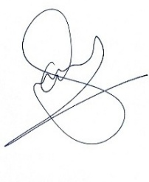  Approved By: Naveed Iqbal  Position: Project Director, C&W PIU  Date: 20/02/2026

Annex 3. Maps and Architectural Drawings

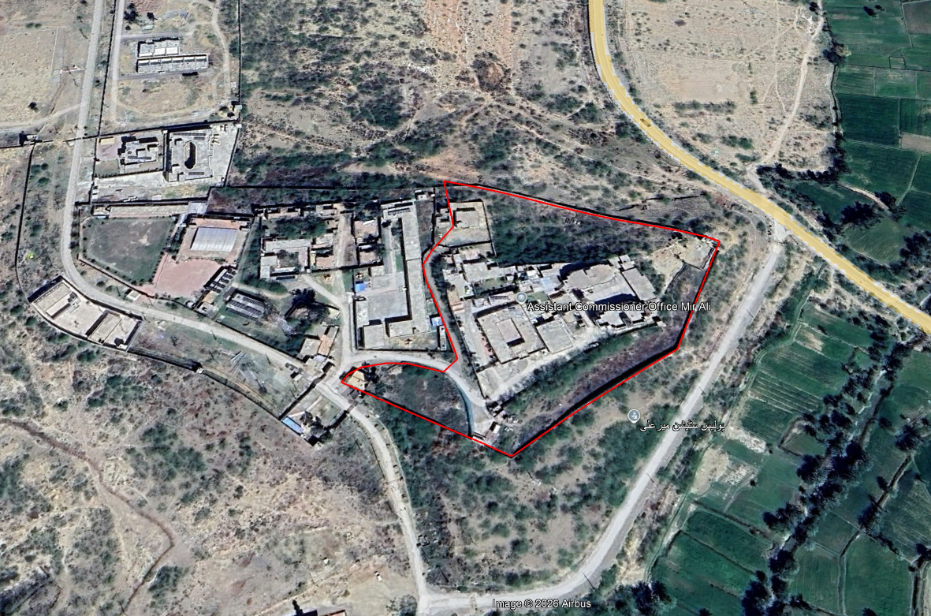
Map 1

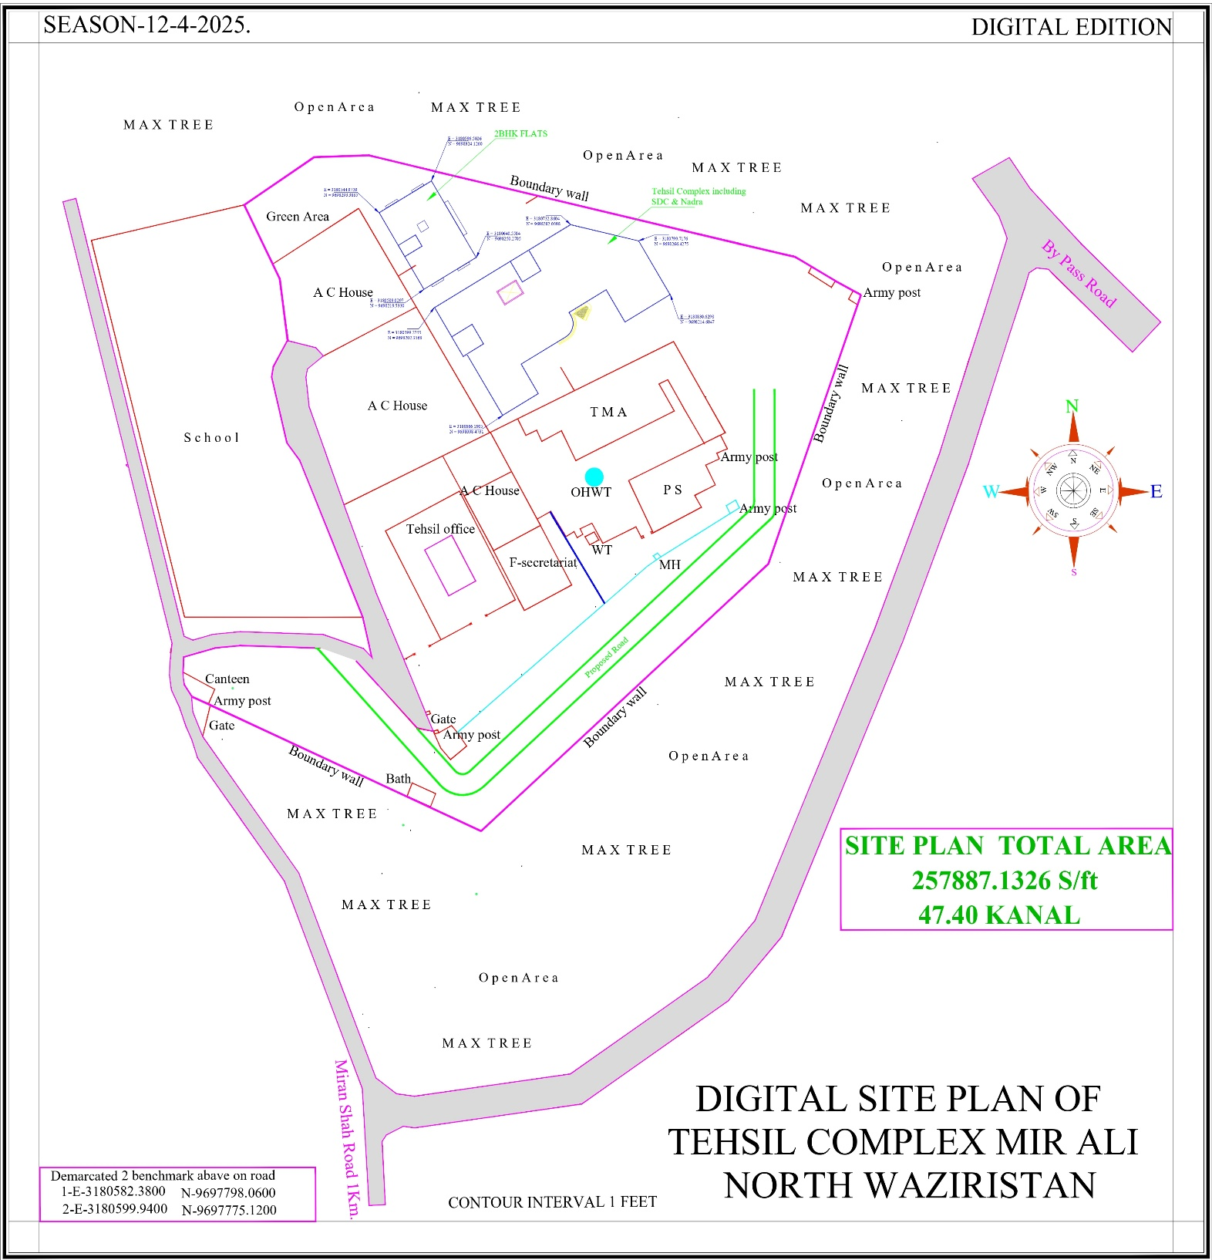
Map 2

- Tehsil Building Complex Mir Ali, NW
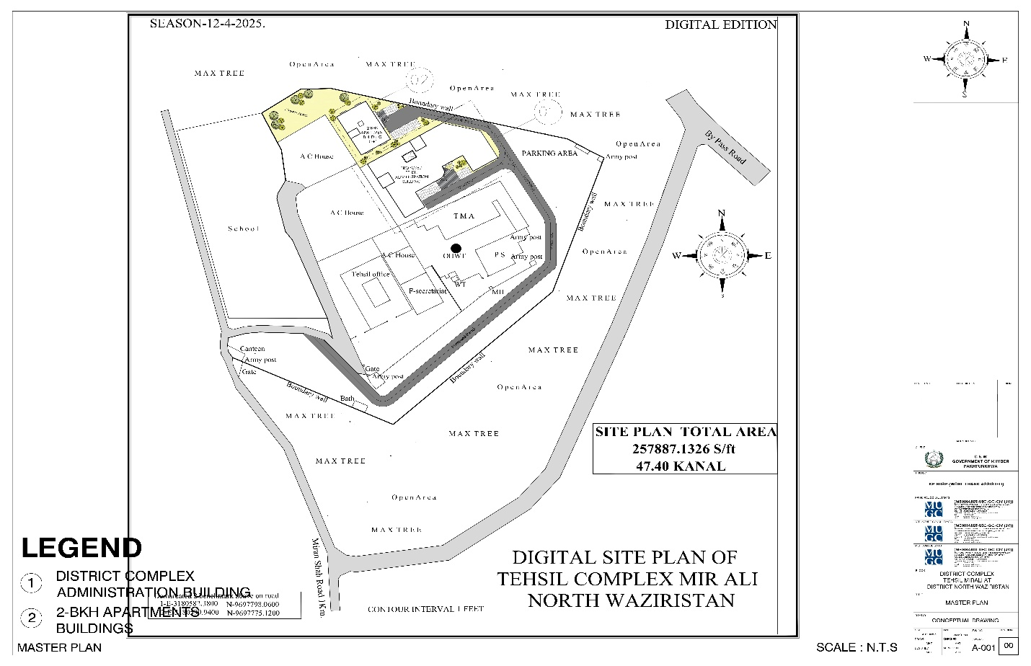
Map 3

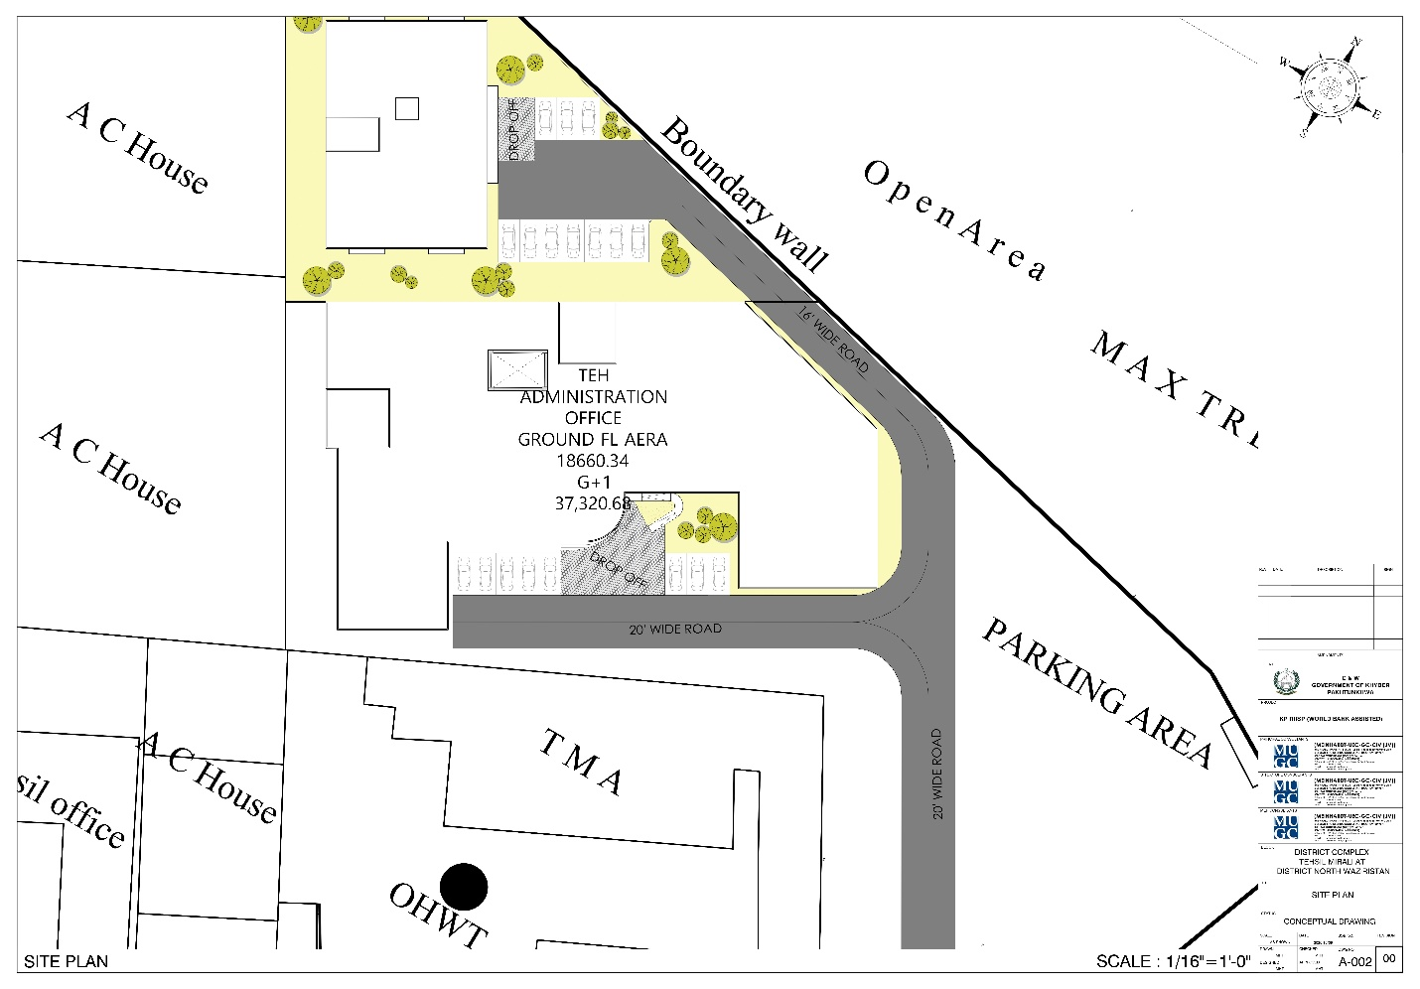
Map 4

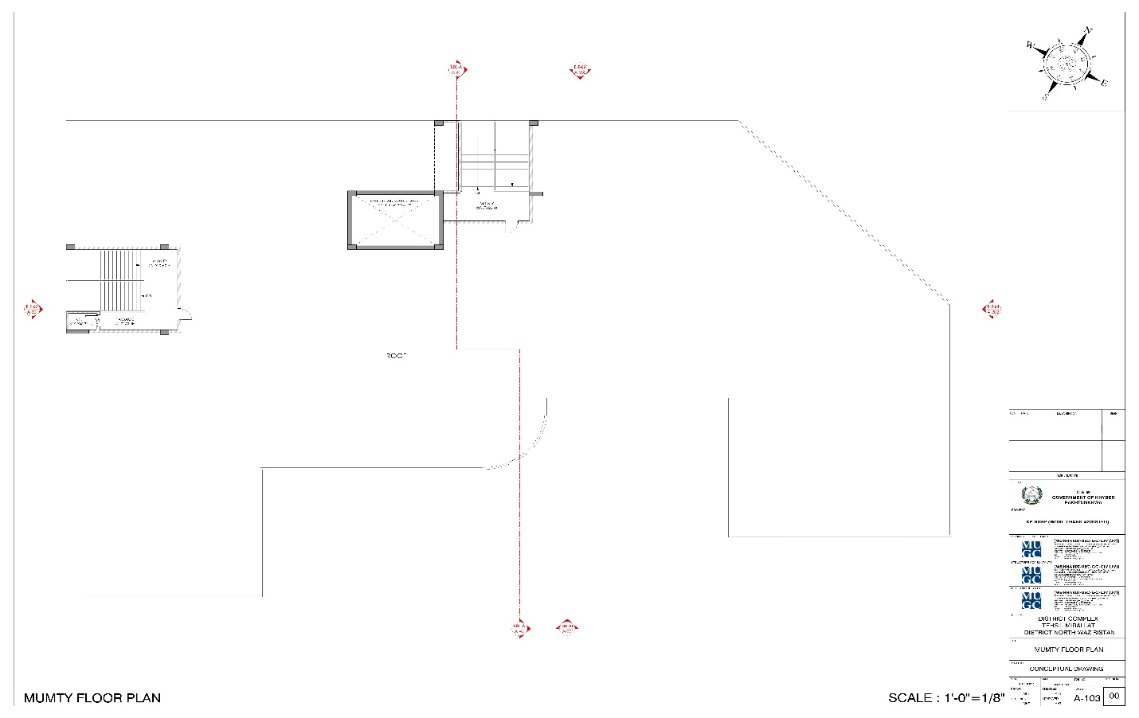
Map 5

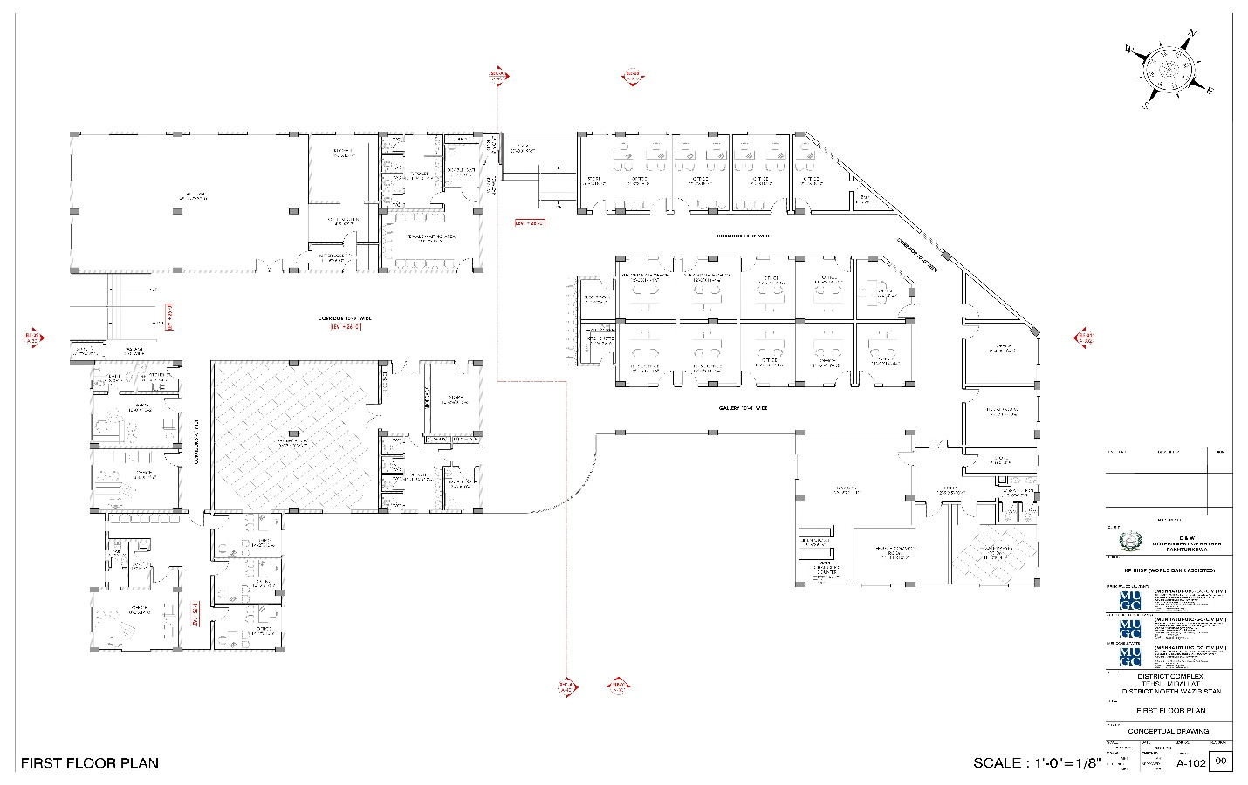
Map 6

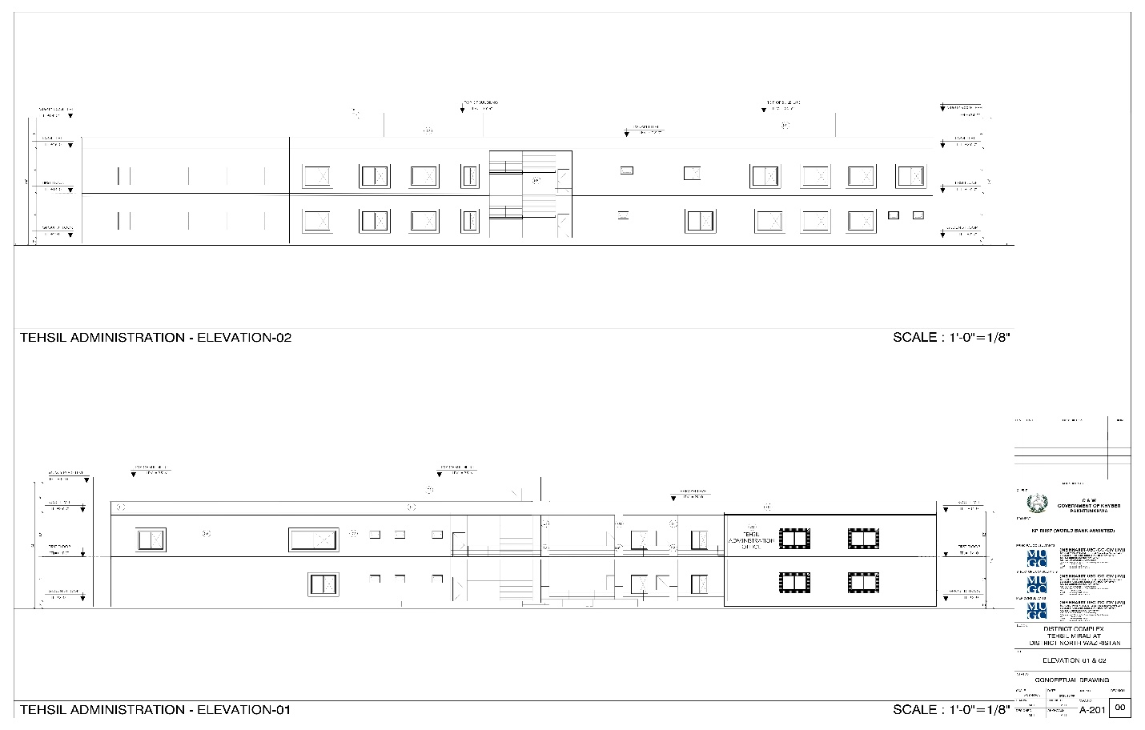
Map 7

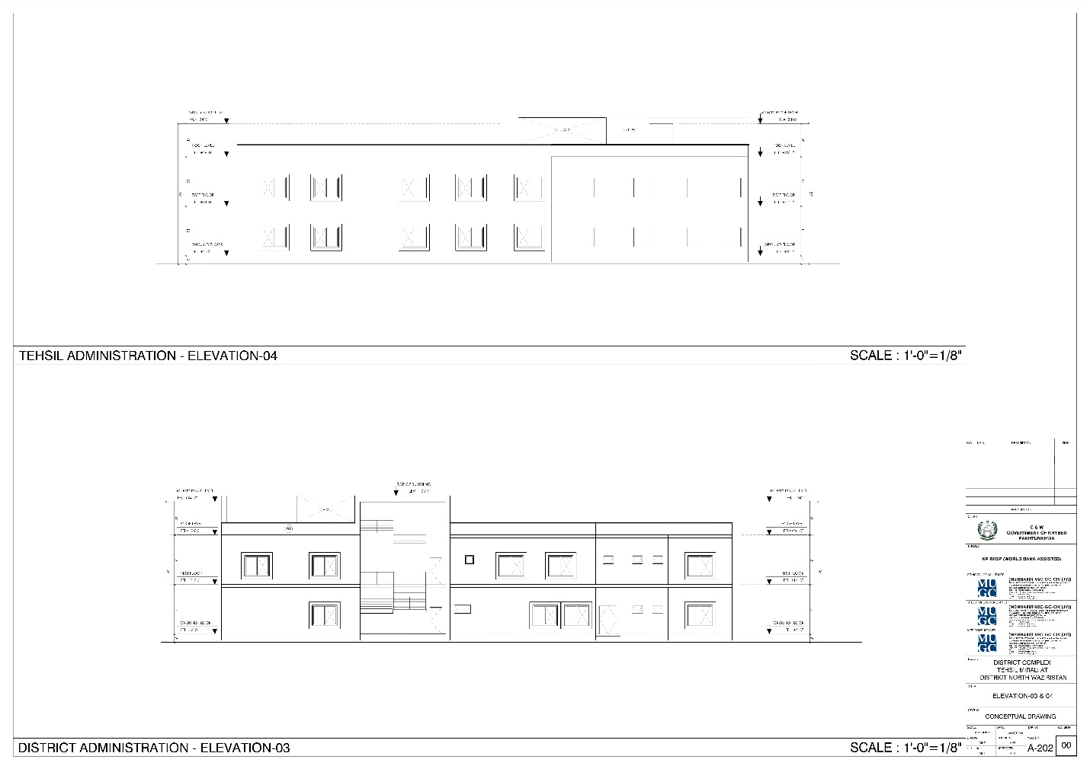
Map 8

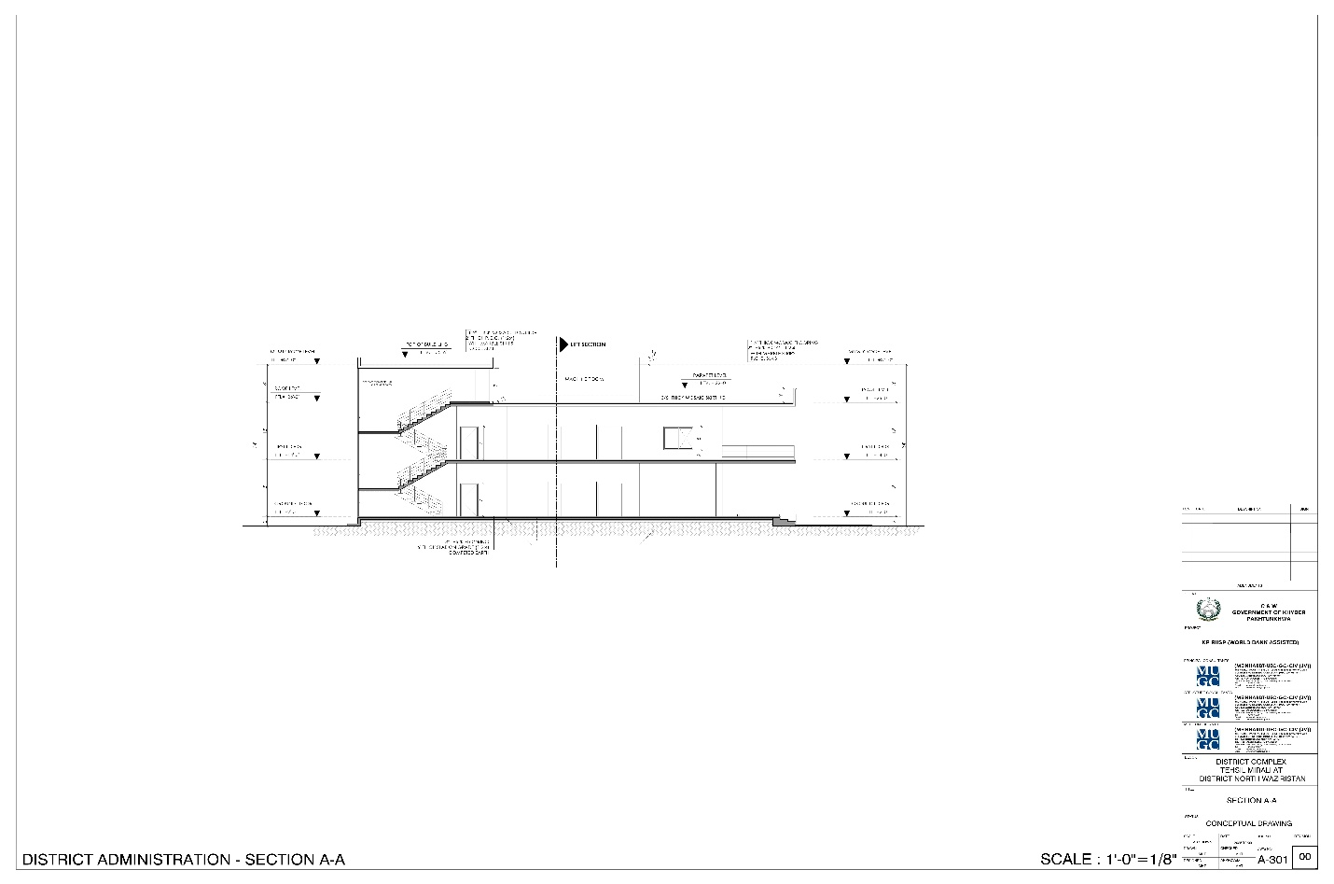
Map 9

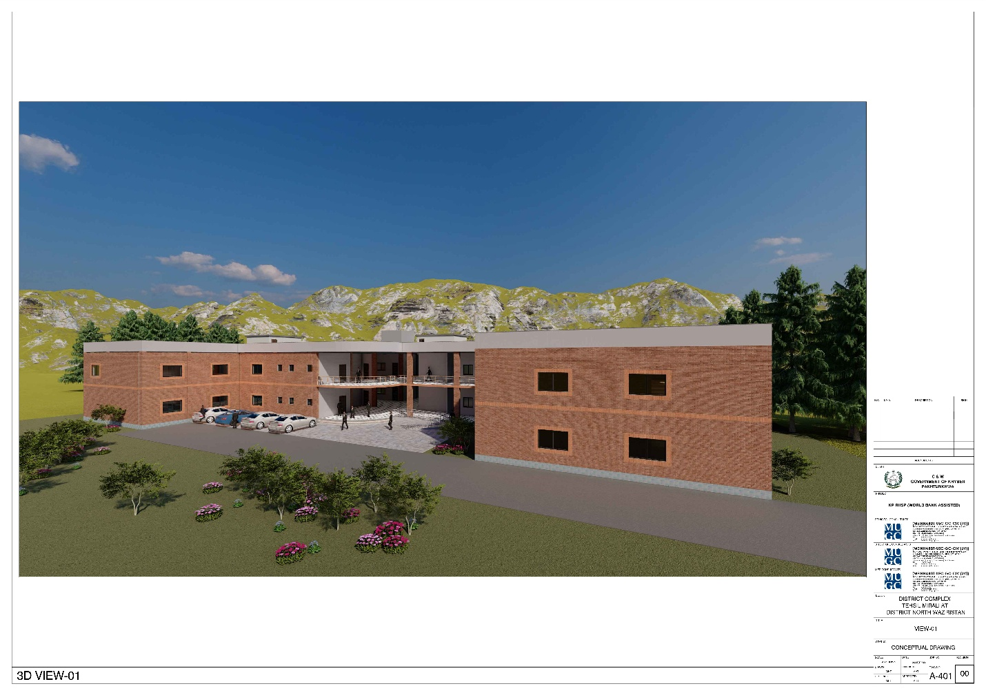
Map 10

ii) Residential Complex 2BHK Mir Ali, NW
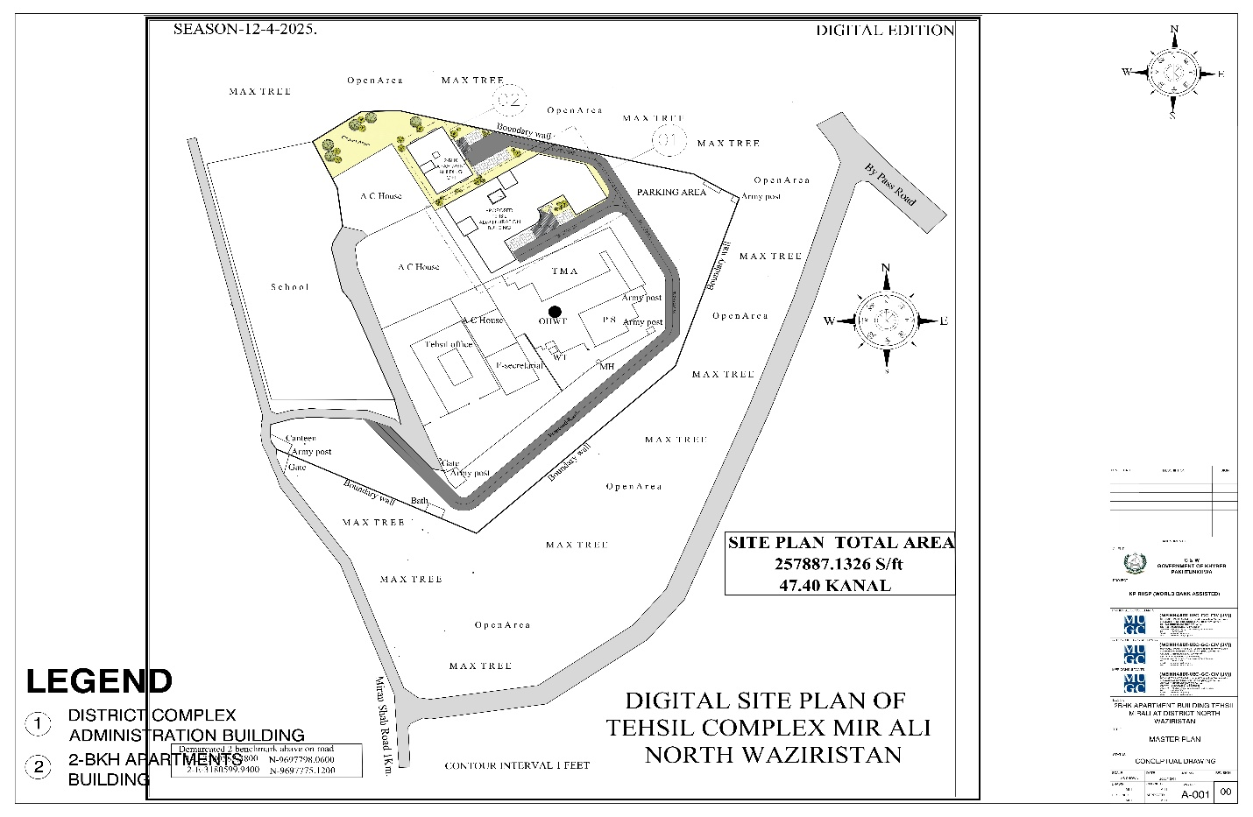
Map 11

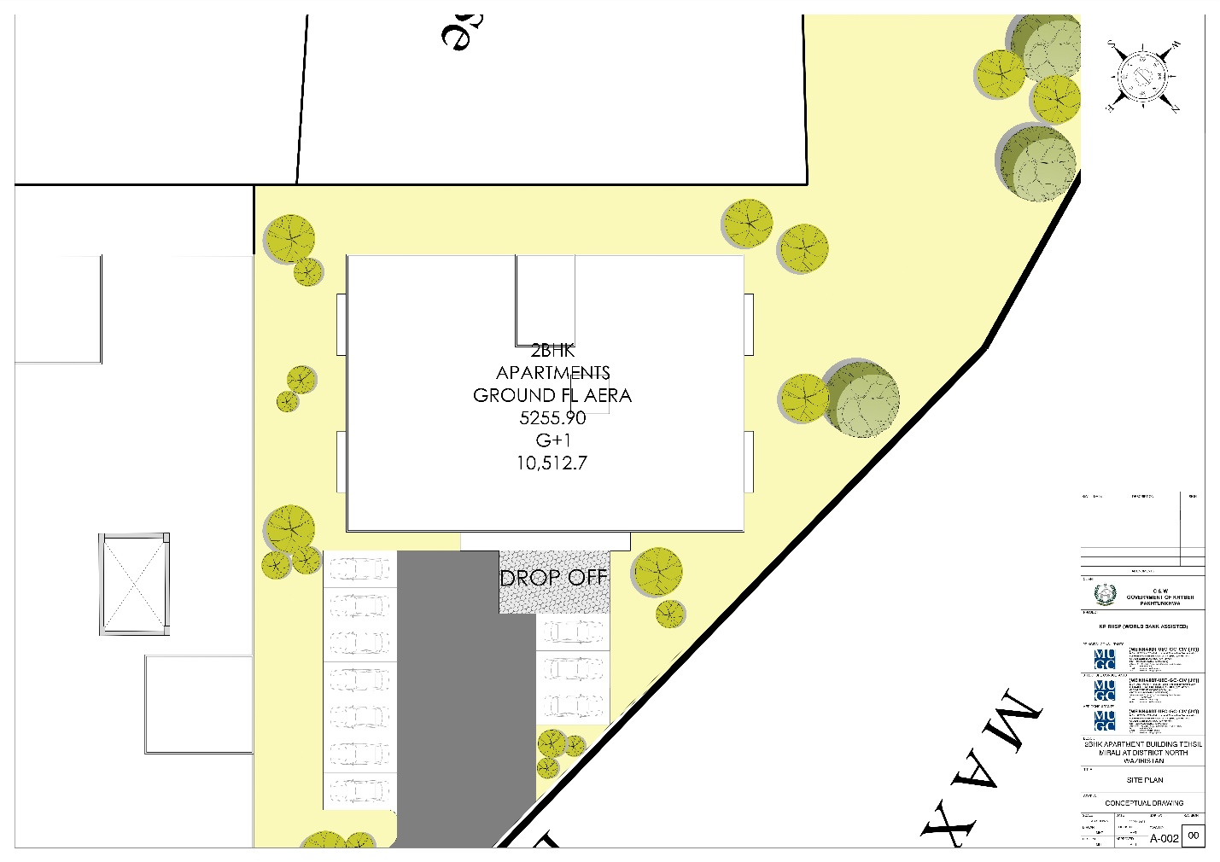
Map 12

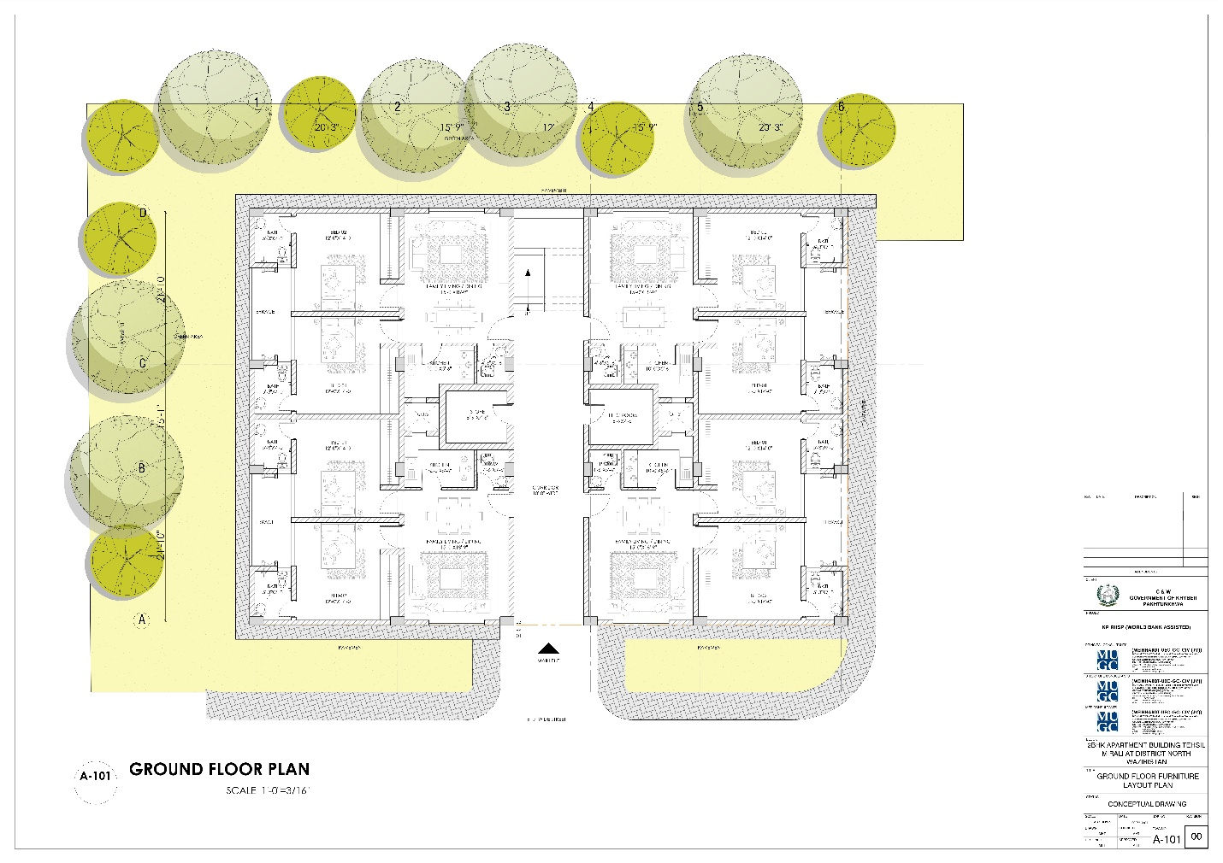
Map 13

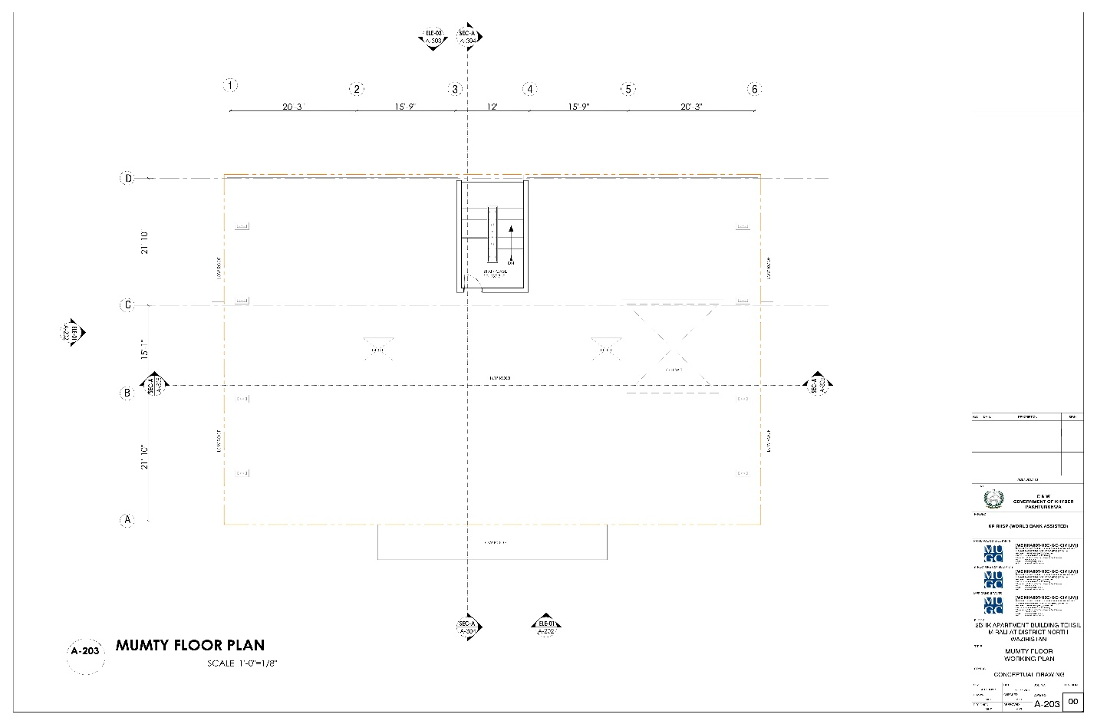
Map 14

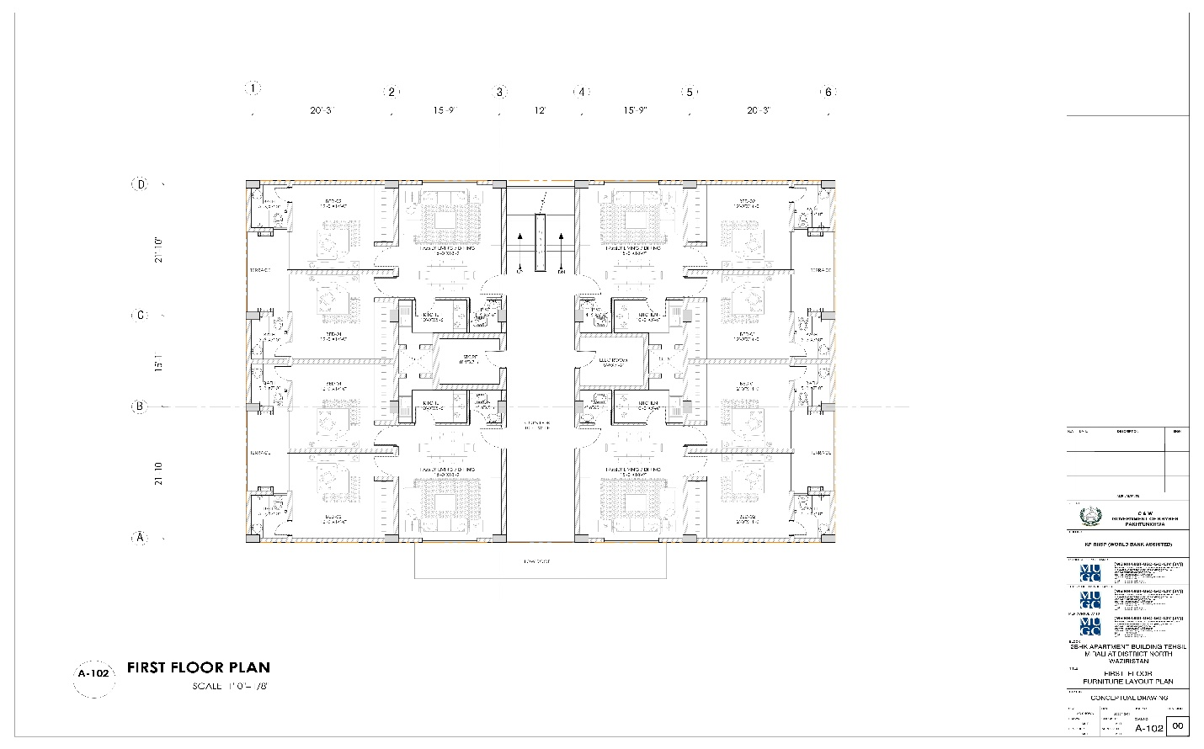
Map 15

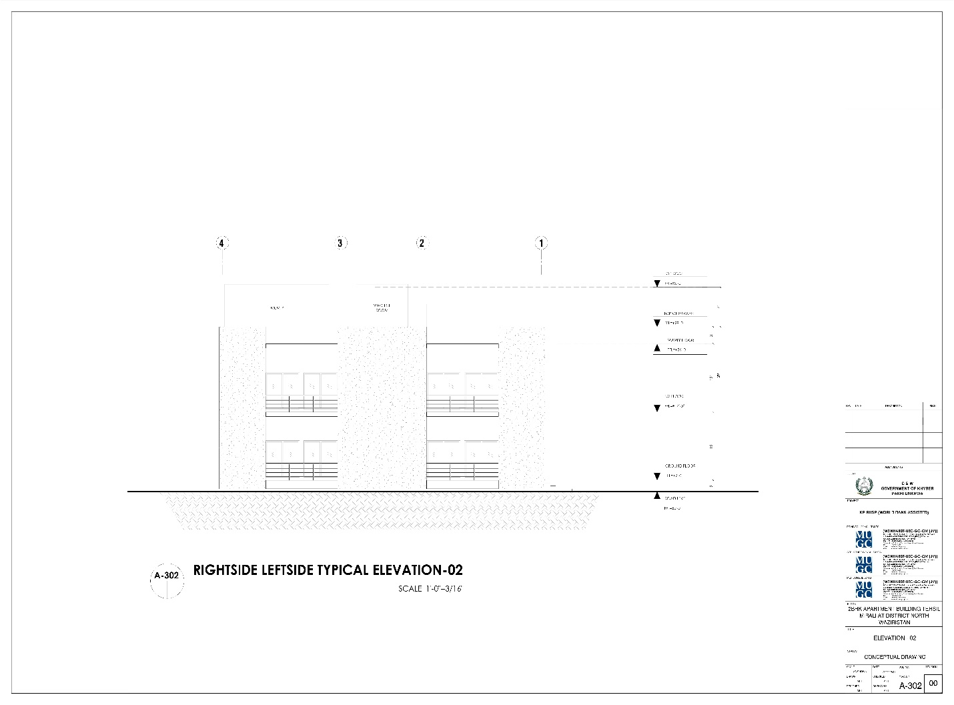
Map 16

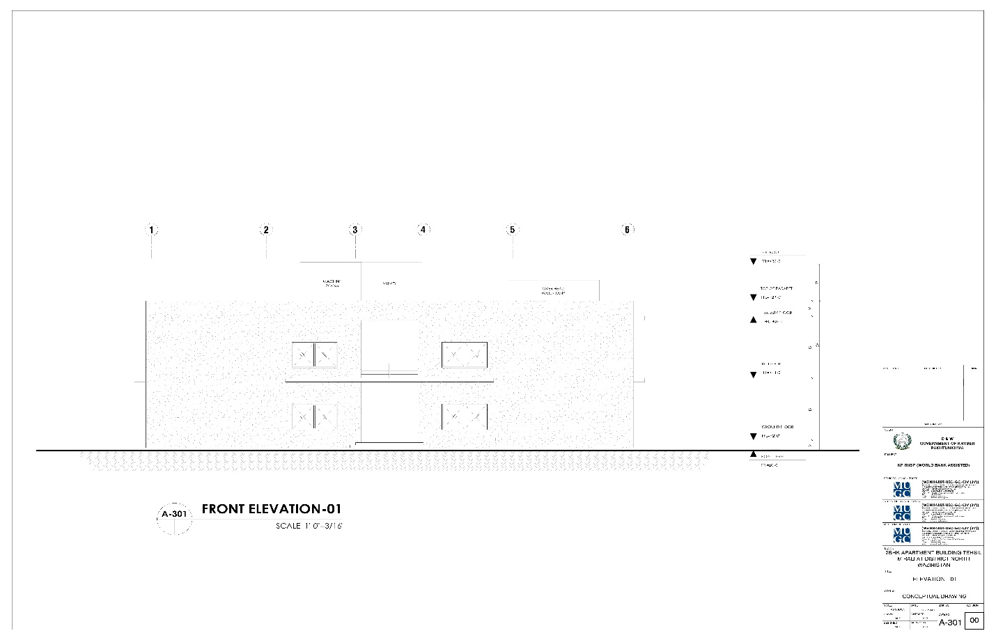
Map 17

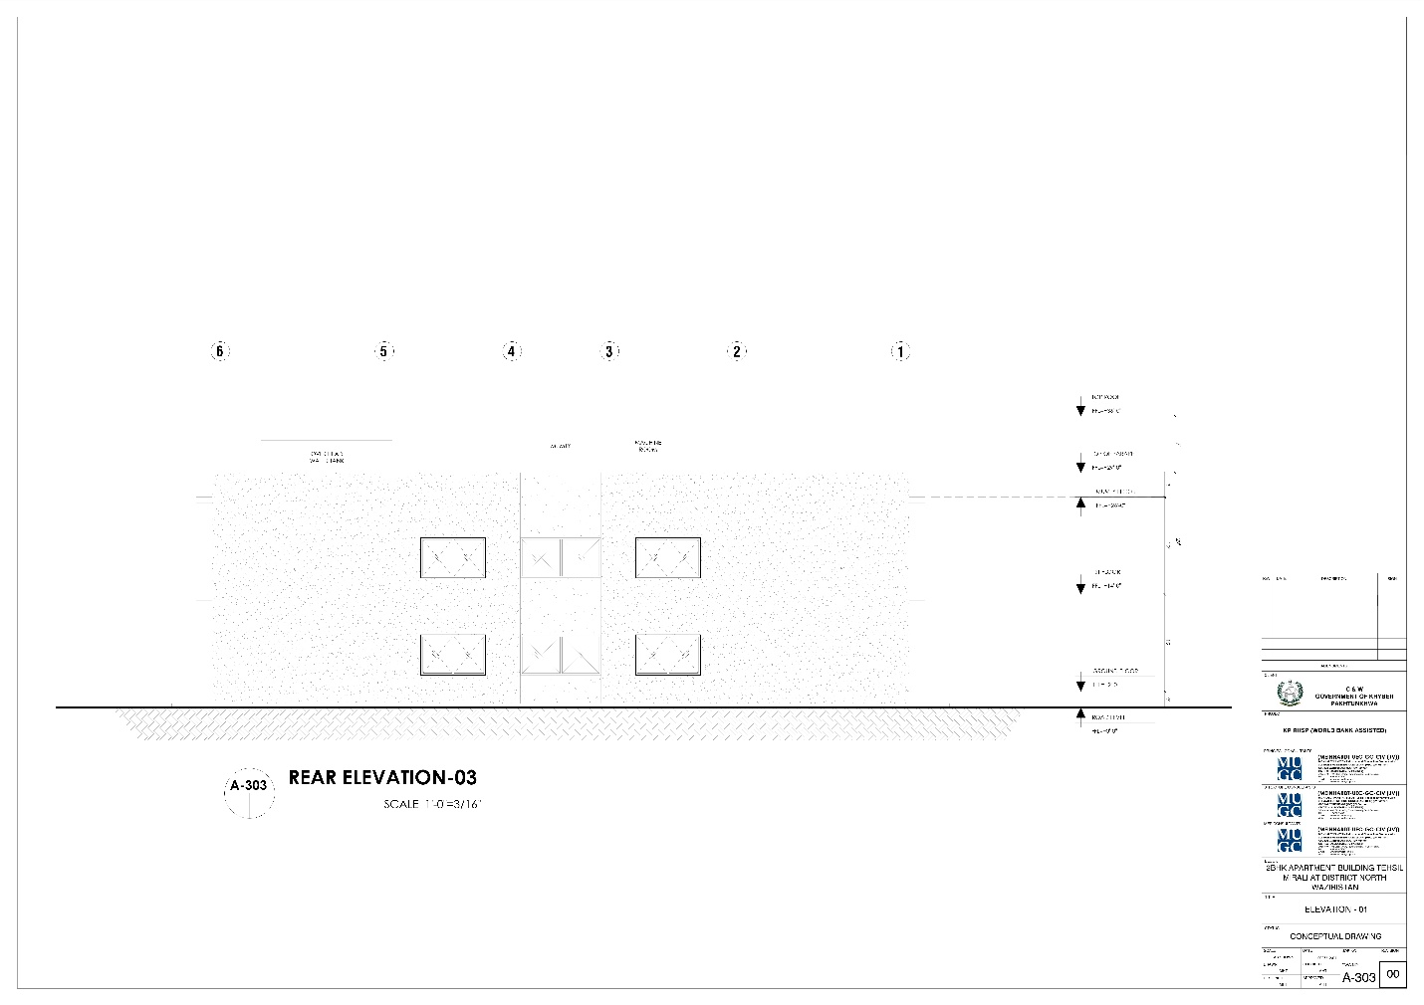
Map 18

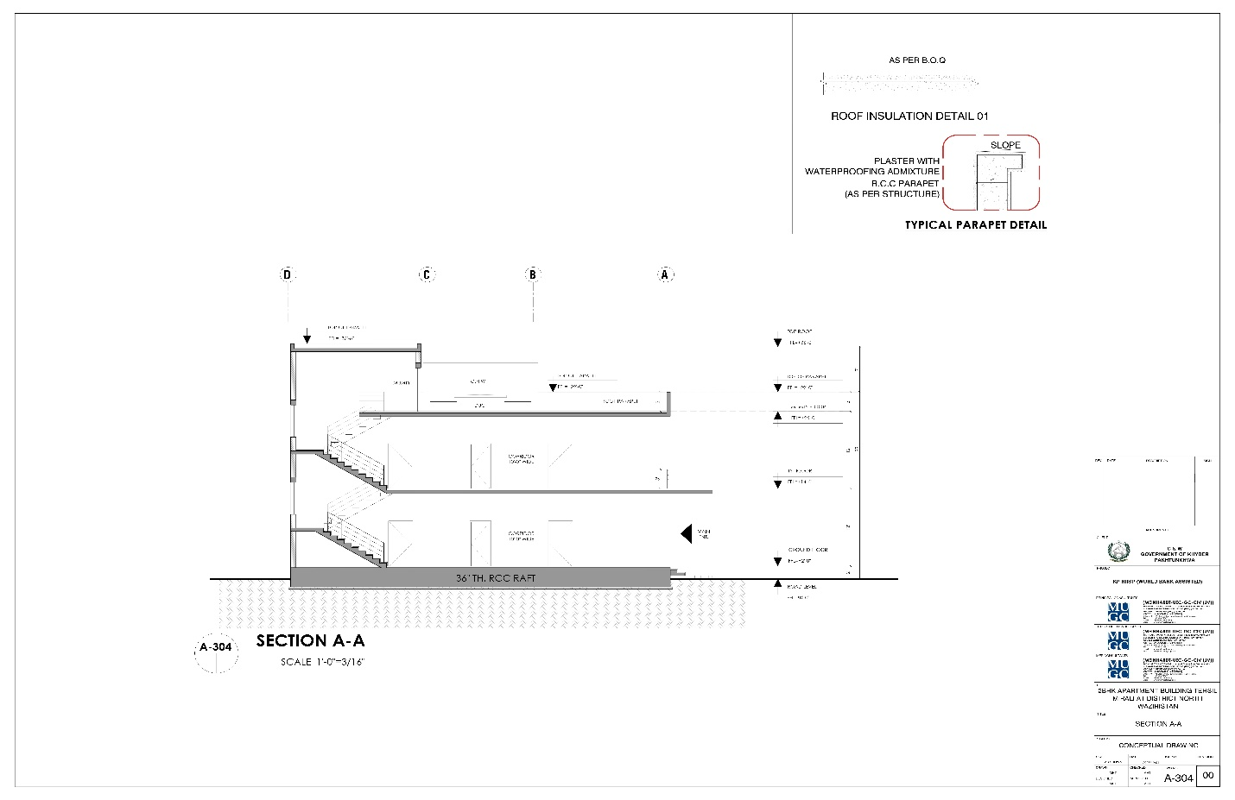
Map 19

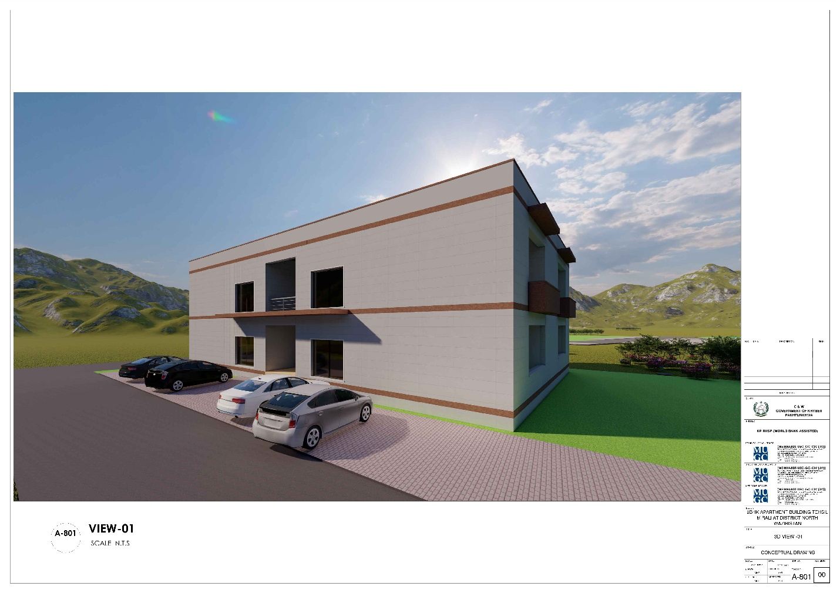
Map 20

Annex 4. EPA No Objection Certificate (NOC)

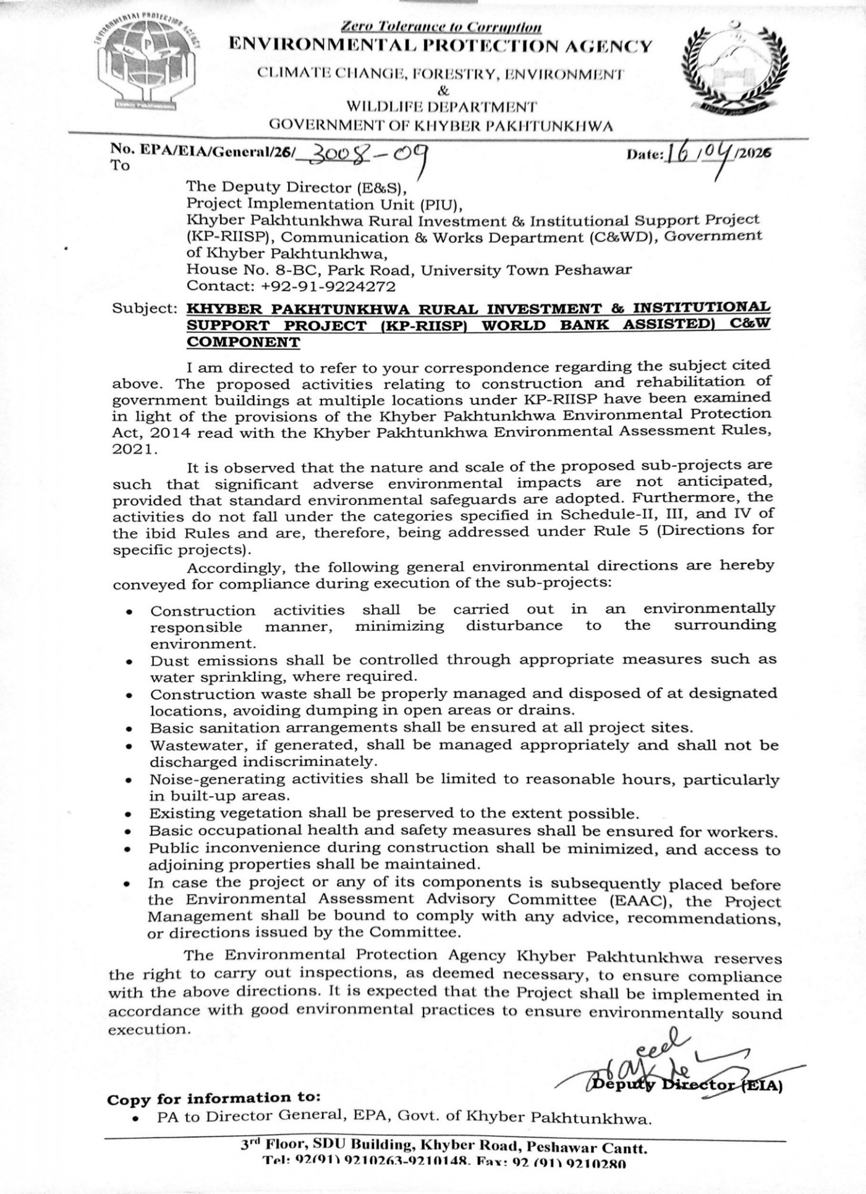

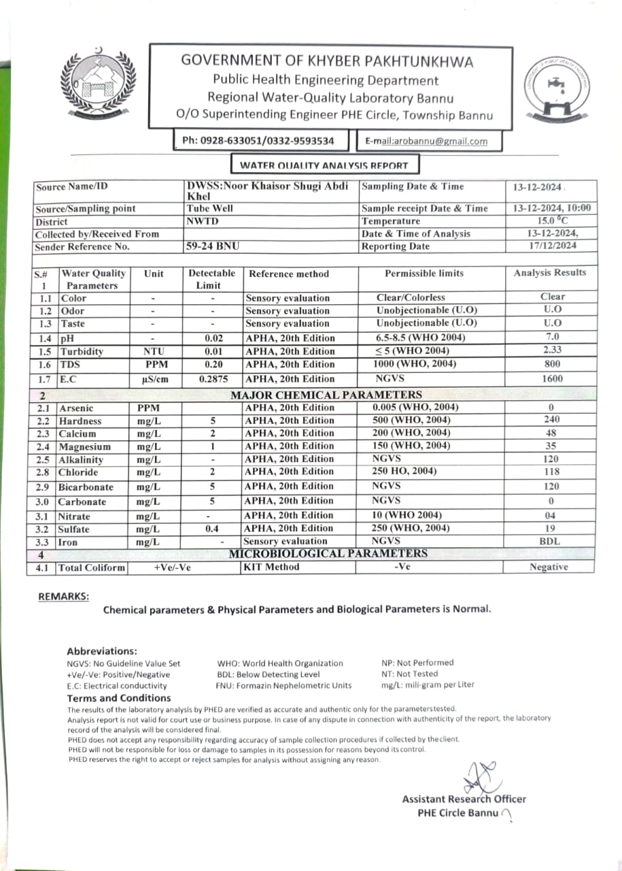
Annex 5. Water Quality, Ambient Air, Noise Level Test Reports

Ambient Air Quality — Results Matrix Mir Ali, District North Waziristan
Sr. | Parameters | Unit | NEQS | Observed Range | Remarks
1 | Nitrogen Dioxide (NO2) | µg/m3 | 80.0 | 1  1 µg/m3 | Good
2 | Sulphur Dioxide (SO2) | µg/m3 | 120.0 | 1  2.36 µg/m3 | Good
3 | Carbon Monoxide (CO) | mg/m3 | 5.0 | 1  166.67 µg/m3 | Good
4 | Ozone (O3) | µg/m3 | 130.0 | 46  109.91 µg/m3 | Good
5 | Particulate Matter (PM2.5) | µg/m3 | 35.0 | 70  20.58 µg/m3 | Moderate
6 | Particulate Matter (PM10) | µg/m3 | 150.0 | 33  39.7 µg/m3 | Good

Source: https://weather.com/en-MU/forecast/air-quality/l/Mir+Ali+Khyber+Pakhtunkhwa+Pakistan

Annex 6. Participants’ List of Stakeholders’ Consultation
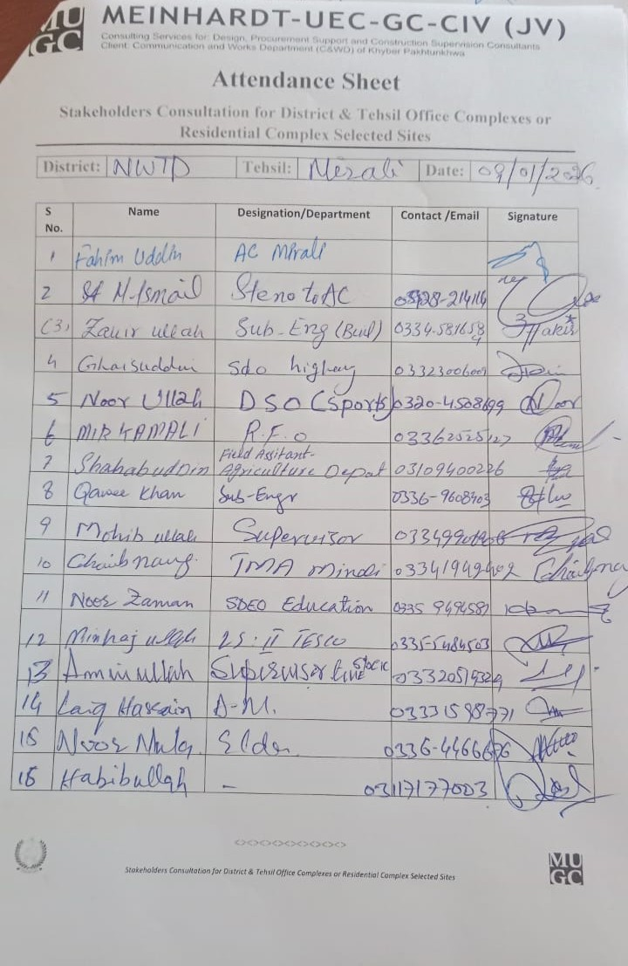

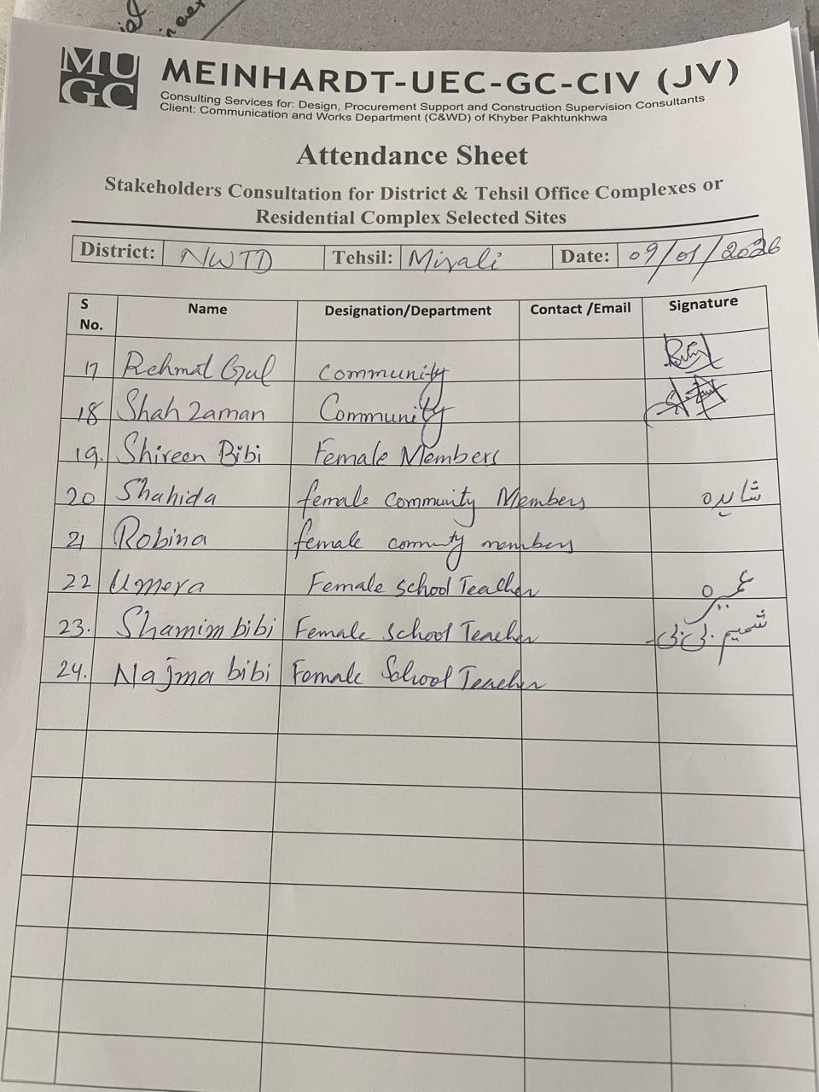

Annex 7. Photos (with captions) of the Site and the Consultations
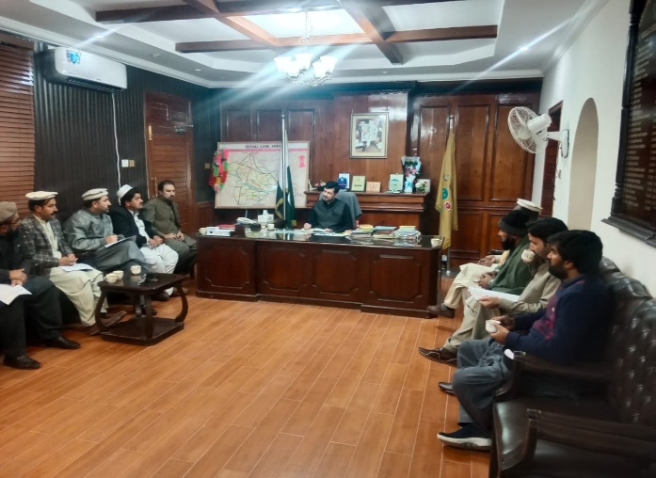
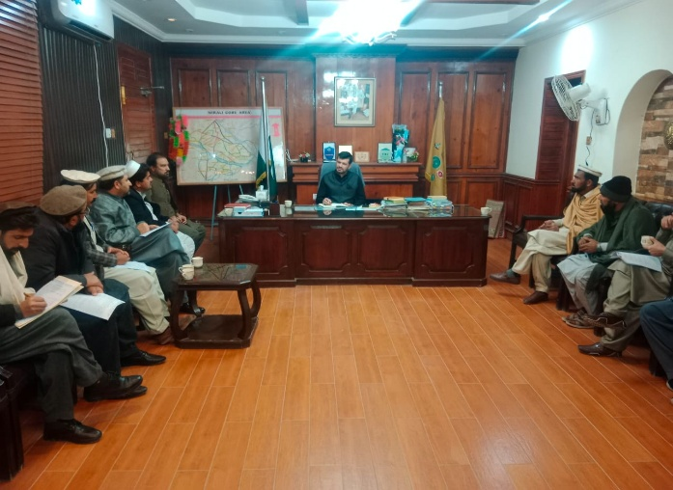

Consultation with the AC, line departments & community elders/members.

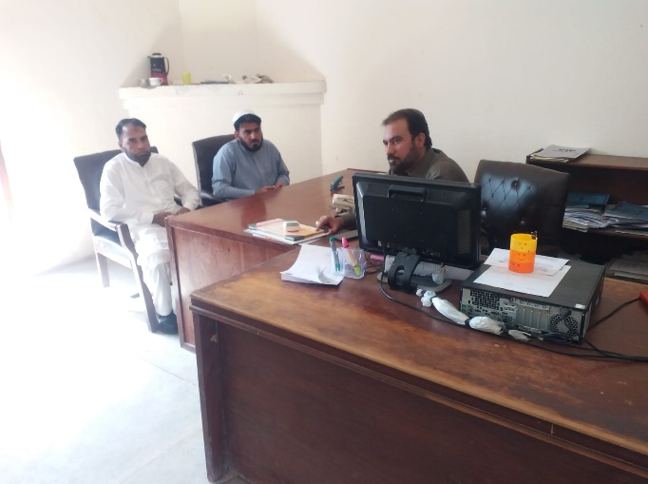
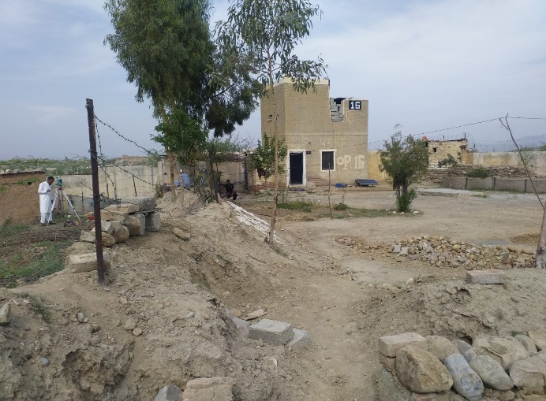

Consultation with the TMA staff & community member.
A view of the proposed Tehsil Complex site.

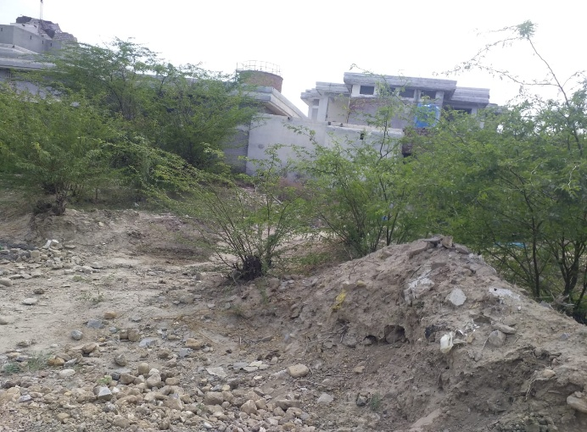
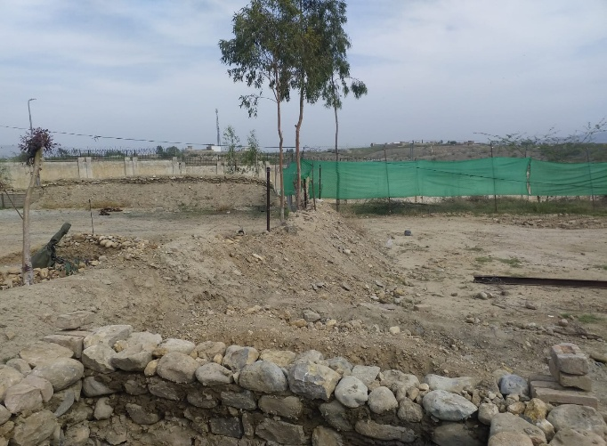

A view of the proposed residential complex site.
A view of the proposed Tehsil Complex site.

Annex 8: Labor Camp Management Details

1. Site Selection & Layout
- Proposed Location: The labor camp will be located within the subproject site, which is an open area within the existing Government Compound, Mir Ali, North Waziristan District, situated along Mir Ali Bazaar near the Mir Ali bypass road.
- Reasoning: The camp is placed within the existing Government-owned land (which has been owned by the District Government for approximately 25 years) to ensure security and minimize community exposure to communicable diseases. The site is approximately 1 km from the Mir Ali Bazaar and far away from the existing village, providing a buffer to minimize disturbance to the local community.
- Layout: The construction area will be fenced or gated to prevent unauthorized entry and ensure public safety. Warning signage will be installed to restrict trespassing on the site.
2. Accommodation Standards
- Capacity: The camp is expected to accommodate a workforce of approximately 15 construction workers.
- Structure & Facilities: The camp will provide a safe, clean, and healthy environment with required amenities.
- Each sleeping room should provide at least 4 to 5.5 square meters of floor space per occupant, with a minimum ceiling height of 2.10 meters.
3. Water Supply & Sanitation
- Water Supply: The contractor will be responsible for making their own arrangements to provide water to the workers. For construction activities, water will be sourced through a temporary arrangement from the nearby surface water source, Tochi River, approximately 6 km from the site.
- Sanitation: The sewage system for the campsite will be properly designed (pit latrines or, as required, septic tanks with soakage pits) to receive all sanitary wastewaters before discharging to the final disposal point to ensure safe wastewater disposal.
- For the labor camp and workplace, the contractor will provide 1 toilet per 7 to 10 workers. If the labor or working staff includes females, the contractor will provide a separate toilet facility at the workplace.
4. Waste Management
- Disposal: Solid and liquid waste should be handled and safely disposed of. The solid waste from the campsite should be safely disposed of at the existing municipal dumping site situated at Tori Mir Ali Wazair area, approximately 5 km from the site.
- Hazardous Materials: The hazardous waste, if it is found at the camp site, shall be stored in closed containers, with proper labelling of containers, including the identification and quantity of the contents, hazard contact information. It will be safely disposed of in an EPA-registered hazardous waste facility within the province.
5. Health & Safety
- Occupational Health and Safety (OHS): The contractor shall provide the necessary means for emergency response on call 24 hours/day, like trained medical staff, First-aid and medical kits, Firefighting equipment (extinguishers, breathing apparatus, ambulance service, etc).
- Layout plan for campsite, indicating safety measures taken by the contractor, e.g., firefighting equipment, safe storage of hazardous material, first aid, security, fencing, and contingency measures in case of accidents.
- Safety: Facilities must have fire safety plans, including wardens, periodic drills, and maintained equipment.
- Medical Facilities: In the event of accidents or emergencies, workers will utilize the existing health facilities present in the area.
- Disease Prevention: The communicable diseases of most concern, such as sexually-transmitted diseases (STDs), HIV/AIDS, should be prevented by successful initiatives, typically involving health awareness, education initiatives, training of workers in disease treatment, immunization programs, regular medical checkups of labor and staff, and providing health services.
- Reducing the impacts of vector-borne diseases should be accomplished through the implementation of diverse interventions, which include prevention of larval and adult propagation of vectors through sanitary improvements and elimination of breeding habitats close to human settlements, and by eliminating any unusable impounding of waste.
6. Food & Nutrition
- Kitchen: A hygienic cooking area/mess will be established separately from sleeping quarters.
- Fuel: The contractor must provide LPG cylinders for cooking. Cutting local trees/bushes (e.g., Acacia, Eucalyptus) for fuel is strictly prohibited.
- Hygiene: Kitchen waste will be disposed of daily to maintain hygiene and prevent pests.
7. Worker Welfare & Social Facilities
- Social Connectivity: Workers will have access to mobile communication (network coverage is available in Safi).
- Transport: Vehicles will be available for emergency transport or material handling.
- Mosque: A prayer area will be designated within the camp, or workers may use the existing prayer facilities in the complex.
8. Security
- Access Control: Construction workers will be camped inside the site for security purposes, subject to prior approval from the administration.
- Safety Measures: Fencing, gating, and safety signage will be maintained to protect the general public and ensure no intrusion into the construction area.
9. Communication & Transport
- Traffic Management: A site-specific Traffic Management Plan will be implemented to ensure safe vehicular movement. Construction-related traffic will be restricted to designated routes and specific time windows to avoid peak community hours.
10. Labor Rights & Compliance
- Hiring Practices: Non-skilled labor will preferably be hired locally to support the community. Skilled labor may be engaged from other areas if not available locally.
- Prohibitions: Forced labor and child labor are strictly prohibited; the contractor must ensure that all laborers possess National Identity Cards (CNICs) at the time of hiring.
- Gender: No female workers are expected to be involved in the construction activities, as is typical for the region.
- Code of Conduct: All workers and contractors must sign a GBV/SEA/SH Code of Conduct to prevent sexual exploitation, abuse, and harassment.

11. Grievance Redress Mechanism (GRM)
- Availability: A Grievance Redress Mechanism (GRM) will be available for community members and workers to register concerns.
- Awareness: Pre-construction awareness campaigns will inform residents and workers about how and where to report violations or complaints.
12. Monitoring & Reporting
- Oversight: The implementation of labor and environmental standards will be strictly monitored by the Construction Supervision Consultants (SC) and the Project Implementation Unit (PIU) of the Communication & Works (C&W) Department.
- Inspections: Regular monitoring will ensure compliance with the Environmental and Social Management Plan (ESMP), including the handling of anti-termite sprays and waste disposal.

Annex 9: Components of Site Specific OH&S Plan

Risk Assessment & Planning
- Hazard Identification:
  - Construction Risks: The subproject involves the construction of a new Tehsil office building (G+1) and a 2-bedroom residential apartment building (G+1). These activities present risks, including excavation hazards, falls from height during building construction, and potential for dust inhalation during earthwork and internal road improvement (100m).
  - Traffic Hazards: The movement of construction machinery and material transport poses risks to the employees working in the compound.
  - Proximity to Community Facilities: The presence of a mosque within the existing compound and Army Public School in the vicinity of the subproject site increases the risk of accidents involving the general public, especially during school and college timings.
  - Excavation & Soil Stability: Earthwork for the building foundations, installation of a new septic tank/soakage pit system, and improvement of internal road poses risks of cave-ins or falls.
  - Climate Hazards: Workers are subject to the temperate climate of North Waziristan, characterized by cold winters, which can lead to weather-related illnesses such as hypothermia during the winter months.
- Planning:
  - Construction Strategy: A systematic, top-down demolition approach will be used. The area will be cordoned off to ensure no unauthorized personnel or community members enter the danger zone.
  - A proper traffic management plan will be prepared in consultation with the PIU staff and implemented to avoid traffic jams/public inconvenience and accidents at the critical timings and potential risk points.
  - Fire prevention plan, controlled storage of flammables, hot-work permits, provision and location of firefighting equipment.

2. Clear Roles & Responsibilities
- Contractor’s Site Environmental Engineer (CEE): Responsible for the daily implementation of this OH&S plan, ensuring all workers use appropriate PPE and conducting safety briefings.
- Site Supervisor: Will oversee the safe operation of heavy machinery and ensure that demolition activities follow the prescribed safety sequence.
- Supervision Consultant (SC) / PIU C&W: Will perform regular audits to verify compliance with the E&S safeguards and OH&S protocols.
3. Training & Awareness
- Induction Training: All workers will undergo safety induction before starting work, focusing on site-specific hazards like demolition and heavy traffic.
- Toolbox Talks: Daily morning briefings will be conducted to discuss specific tasks of the day and associated safety measures.
- Signage: Safety instructions and warning signs will be displayed in Urdu and Pashto at the entrance and near excavation/demolition zones.
4. Personal Protective Equipment (PPE)
- Mandatory Gear: All workers and site visitors must wear high-visibility vests, hard hats, and safety boots.
- Task-Specific PPE: Dust masks and goggles will be mandatory during demolition and excavation. Specialized respiratory protection will be provided if asbestos handling is required.
- Maintenance: The contractor is responsible for the periodic replacement and maintenance of all PPE.
5. General Safety Measures
- Site Security: The construction area will be fenced or gated to prevent community members, especially children from the nearby village, from entering the site.
- Traffic Management: Flagmen will be deployed during the movement of heavy vehicles onto the Mir Ali Bypass Road. Speed limits will be strictly enforced within the site.
- Dust Control: Regular water sprinkling will be carried out on unpaved areas and during digging operations to maintain air quality.
6. Monitoring & Reporting
- Daily Inspections: The Site Supervisor will check for PPE compliance and ensure that excavation areas are properly barricaded.
- Incident Reporting: Any near-miss or minor injury must be recorded and reported to the PIU within 24 hours. Serious accidents must be reported immediately.
- Audits: The Supervision Consultant will use the Environmental Monitoring Checklist (Annex 11) to conduct weekly safety audits.
7. Emergency Preparedness
- Medical Facilities:
  - On-Site: Fully stocked First Aid boxes will be maintained at the site office and labor camp.
  - Referral: In case of serious injury, workers will be transported to the nearest healthcare facility (BHU nearby or the Hospital).
- Emergency Response Plan: A protocol will be established for rapid evacuation in case of structural collapse during construction or fire. A framework for the Emergency Response Plan is given below for reference:
- Regulatory Requirement: National and International Regulatory Requirements were considered, such as
i- Emergency Preparedness Team
ii - Emergency Procedures
iii- Emergency Procedure for Serious Accident
iv- Fire Emergency
v - Fire extinguisher locations
vi- Procedures for Emergencies
- Fire Safety: Fire extinguishers and sand buckets will be placed near the fuel storage area and the labor kitchen.
- Communication: Emergency contact numbers for the local Police Station, FC post, and the nearest hospital will be prominently displayed on-site.


Annex 10. KPRIISP Code of Conduct (GBV/SEA/SH Mitigation Plan)

Code of Conduct (GBV and SEA/SH Prevention)
Khyber Pakhtunkhwa Rural Investment & Institutional Support Project (KP-RIISP)
Responsible Authority: KPRIISP E&S Unit | Applicability: All Staff, Consultants, Contractors
Definitions
To ensure clarity and alignment, basic key terms are defined below:
GBV (Gender-Based Violence):
GBV is an umbrella term for any harmful act that is perpetrated against a person’s will, and that is based on socially-ascribed (i.e., gender) differences between males and females. It includes acts that inflict physical, sexual or mental harm or suffering, threats of such acts, coercion, and other deprivations of liberty. These acts can occur in public or private (2015 Inter-Agency Standing Committee Gender-based Violence Guidelines, pg. 5).
SEA (Sexual Exploitation and Abuse):
Sexual Exploitation: any actual or attempted abuse of a position of vulnerability, differential power or trust for sexual purposes, including, but not limited to, profiting monetarily, socially or politically from the sexual exploitation of another (UN Glossary on Sexual Exploitation and Abuse 2017, pg. 6).
Sexual Abuse: actual or threatened physical intrusion of a sexual nature, whether by force or under unequal or coercive conditions (UN Glossary on Sexual Exploitation and Abuse 2017, pg. 5).
SH (Sexual Harassment):
Any form of unwanted verbal, non-verbal or physical conduct of a sexual nature with the purpose or effect of violating the dignity of a person, in particular when creating an intimidating, hostile, degrading, humiliating or offensive environment. This may include unwelcome sexual advances, requests for sexual favors, and may take place through online activity or mobile communications as well as in person.
GRM (Grievance Redress Mechanism):
The KPRIISP has set up a GRM to respond to the concerned grievances in both community and workplace settings. Under the project’s GRM there will be a dedicated GBV reporting mechanism ensuring confidentiality and survival centered approach. It will further ensure that every report is handled professionally, with the survivor’s safety, dignity, and access to support services as top priorities.

1. General Responsibilities
All personnel must:
· Consent to a security background check.
· Treat all individuals (women, men, children, persons with disabilities, transgenders, etc.) with respect and dignity, free from discrimination.
· Comply with National & Provincial Laws, World Bank’s Good Practice Note, GBV Risk Assessment Tool, and KPRIISP’s GBV and SEA/SH Mitigation Plan.
Maintain a safe environment by:
· Ensuring workplaces are risk-free.
· Following emergency procedures (availability of first aid box, fire extinguishers, displaying of CoC in English, Urdu & local dialect and all mitigation measures must be in effect).
· Report concerns via KPRIISP’s GRM or to the designated focal person.
· Attend mandatory annual GBV and SEA/SH training, with bi-annual refreshers for field teams.
2. GBV/SEA/SH and Child Protection
Prohibited Conduct:
· Inappropriate language/behavior, sexual advances, or transactional sex.
· Any sexual activity with children (consent or mistaken age is no defense).
Mitigation Measures:
· Report suspicions to the GBV Grievance Redress Committee/designated focal person.
· Ensure workplaces/communities are harassment-free as per the Khyber Pakhtunkhwa Protection Against Harassment of Women at Workplace (Amendment) Act, 2020.
· Collaborate with provincial/local authorities/NGOs to support survivors.
3. Contractor/Consultant Obligations
Contractors/consultant must:
· Implement CoC requirements in HR policies, site protocols, and grievance mechanisms.
· Ensure compliance is a condition of contract performance.

4. Accountability & Compliance
· Zero Tolerance: Violations lead to warnings, termination, or legal action.
· Confidentiality: Whistleblowers and survivors are protected.

Signature Section
By signing, I commit to upholding this Code:
Name: _________________________
Designation: ____________________
Organization: ___________________ (for contractors/consultants/staff)
CNIC: __________________________
Signature: ______________________
Date: __________________________

Reporting & Enforcement:
Focal Persons:
· PCMU: Senior Social Development Specialist/Gender Officer
· PIU: Senior Social Development Specialist/Gender Officer/ Established Arrangements
Process:
1. Report to focal persons via GRM (anonymous options available)/direct report to senior management.
2. Preliminary inquiry within 15 days.
3. Outcomes: Verbal/written warnings, disengagement, or legal referral.
4. Confidentiality: Survivor identities protected; retaliation prohibited.
Implementation Requirements
· Visual Display: Mount CoC in English, Urdu, and Pashto across offices.
· Onboarding: Include CoC in orientation kits for all personnel.
Approved by:
Project Director
Project Coordination and Management Unit (PCMU)
Khyber Pakhtunkhwa Rural Investment and Institutional Support Project (KP-RIISP)
Planning and Development Department, Khyber Pakhtunkhwa

Annex 11. Environmental Monitoring Checklist

The Environmental Monitoring will be carried out as per Table 4: the Environmental Management Plan’s given targets and mitigation measures, and in line with Table 6: Construction Phase Monitoring Requirements parameters provided in the ESMP document.

Project Name: ___________________________
Location: _______________________________
Date of Monitoring: ______________________
Monitoring Team: _______________________

A. Air Quality and Dust Control
Parameter | Yes/No | Observations/Comments | Action Required
Dust suppression measures are in place (e.g., water sprinkling)
Vehicles and machinery are well-maintained (no excessive smoke)
Construction materials are properly covered during transport
Ambient air quality monitored (PM10, PM2.5) if required

B. Noise and Vibration
Parameter | Yes/No | Observations/Comments | Action Required
Noise levels within acceptable limits (dB)
Use of silencers/mufflers on machinery and equipment
Noise-sensitive receptors (schools, hospitals) identified and protected

C. Soil and Erosion Control
Parameter | Yes/No | Observations/Comments | Action Required
Topsoil is stripped and stored properly
Erosion control measures in place (e.g., silt fences, bunds)
Excavation and filling carried out as per plan

D. Water Resource Protection
Parameter | Yes/No | Observations/Comments | Action Required
No discharge of wastewater into water bodies
Sanitation facilities for workers are provided
Drinking water sources are protected from contamination
Proper drainage and runoff management
E. Waste Management
Parameter | Yes/No | Observations/Comments | Action Required
Solid waste is collected and disposed of properly
Hazardous waste (oil, chemicals) is handled safely
Reuse/recycling practices in place (if any)
F. Biodiversity and Vegetation
Parameter | Yes/No | Observations/Comments | Action Required
Vegetation clearance minimized
Replantation or landscaping measures planned/implemented
No disturbance to local fauna/habitats
G. Occupational Health & Safety
Parameter | Yes/No | Observations/Comments | Action Required
PPE provided and used by workers
Safety signage is posted at the site
Emergency response procedures are in place
Medical screenings for laborers are conducted by the contractor every four months times
H. Social Considerations
Parameter | Yes/No | Observations/Comments | Action Required
Community grievances mechanism in place
Local community consulted
No child labor or forced labor observed

I. Labor Camp Management
Parameter | Yes/No | Observations/Comments | Action Required
Labor camp area is clean and solid waste is properly managed
Adequate safety and security measures in place (lighting, gates/locks, boundary, guards)
Labor camp located at a safe distance from nearby communities
Clean and adequate living accommodations provided (ventilation, space, bedding)
Clean and adequate washroom and bathing facilities available and functional
Adequate and hygienic kitchen/cooking facilities available
Clean and safe drinking water provided
Separate facilities for male and female workers (if applicable)
Camp rules and grievance mechanism communicated to workers

Signature of Monitor: ___________________________ Date: ___________________________

Annex 12. Incident Reporting Format (ESIRT) Form

Details of Incident (e.g., to a worker or visitor) and Treatment

Date of incident
Time of incident
Nature of incident | ☐ Near miss ☐ First aid ☐ Medical treatment/doctor
Name of injured person
Address
Occupation
Date of birth
Telephone
Employer
Activity in which the person was engaged at the time of injury
Exact site location where injury occurred
Nature of injury–e.g. fracture, burn, sprain, foreign body in eye etc.
Body location of injury
Treatment given onsite and Name of Treating Person
Referral for further treatment?  ☐ Yes ☐ No | Name of doctor or hospital | Medical certificate received?  ☐ Yes ☐ No
Injury management required?  ☐ Yes ☐ No | Return date

Witness to Incident (Include all witnesses)
Witness name and contact

Details of Incident
Date of incident
Time of incident
Details of damage to equipment or property
Name of person who received the report
Description of incident

“Disadvantaged or vulnerable” refers to those individuals or groups who, by virtue of, for example, their age, gender, ethnicity, religion, physical, mental or other disability, social, civic or health status, sexual orientation, gender identity, economic disadvantages or ethnic peoples status, and/or dependence on unique natural resources, may be more likely to be adversely affected by the project impacts and/or more limited than others in their ability to take advantage of a project’s benefits.
Environmental and Social Standard 6, paragraph 23: “Critical habitat is defined as areas with high biodiversity importance or value, including (a) Habitat of significant importance to Critically Endangered or Endangered species, as listed in the IUCN Red List of threatened species or equivalent national approaches; (b) Habitat of significant importance to endemic or restricted-range species; (c) Habitat supporting globally or nationally significant concentrations of migratory or congregatory species; (d) Highly threatened or unique ecosystems; and (e) Ecological functions or characteristics that are needed to maintain the viability of the biodiversity values described above in (a) to (d).”
Environmental and Social Standard 6, paragraph 21: “Natural habitats are areas composed of viable assemblages of plant and/or animal species of largely native origin, and/or where human activity has not essentially modified an area’s primary ecological functions and species composition.”

